**SQL**

**Session 1**

* Once we design the Database, we will look at what are the various activities we need to design the database and in order to implement the database (see Normalized Skemas under Database Design Phases or Activities), we make use of SQL
* SQL is the language used to implement Databases – using this query language, its possible for us to interact with the database - The data will be in the database and in order to talk to database, we need to know SQL
* SQL is one of the query language. Ex. Quell, QBE.. these are all query language
* To make decisions we must analyze the data and in order to analyse the data, we need to extract the data and look into the data – for this, we need DBMS
* As a Data Analyst, our job is to analyze the data, generate the reports and make decisions
* **Data** is collection of Raw Facts and figures that must be stored for further processing which could may or may not be meaningful by itself
* **Database:**
* The storage/repository/place where we store the raw facts and figures is Database
* Database is a collection of inter-related data – In the database, any data we store must be meaningful
* Any data or data fragment cant be stored that’s meaningless
* Database is like a Secondary Storage area/like Hard disk – its Non-Volatile (if we store the data in this storage, it will get saved permanently) (*RAM is volatile - which is a primary memory and tends to lose data as soon as the computer reboots or loses power*)
* The secondary storage can either be a **File Storage or Database**
* **File Storage**: Where there is no database – We can store data that’s meaningless (opp. To Database) – As a user, he can directly access the 2nd storage area – Ex. Notepad, Doc, Excel.. – User can access this File Storage without an intermediary (like DBMS) – The search type happens in this file system is linear or sequential search
* **Database Storage:** If we have installed oracle or DBMS in your laptop, then your memory will have both type of storage area. When we installed oracle in your system, some part of the memory will be dedicated to store the data in the database. The way we store the data is a bit different when compared to File storage – The data fragments/data elements must be related to one another – If there is some kind of inter-relation existing b/w data elements, only this is stored in the database - The search type happens in this Database is Binary search (you key-in Yes, the data is organized, its going to divide into data into two halves and search our requirement in the division)
* When you associate/relate data elements, you are deriving a meaning to data elements
* **DBMS:**
* DBMS is a System Software that manages and controls the access to database
* DBMS acts as an interface or insulation between the Application (User access this application) and the Database
* Whatever the changes that user makes to the application is not going to affect the database and vice versa
* User manages the Database and User will make use of the DBMS
* User will send a request to DBMS and this Management System does the job for me and store data elements in the database
* DBMS has the flexibility of storing only 1 copy of the data and sharing this data with multiple applications (see Database Management system screenshot below)(file systems are single-user system – doesn’t support sharing of data)
* DBMS is multi-user system
* ***DBMS is an interface between end user and the underlying database***
* DBMS is a means through which the end user interacts with the database
* Once you’ve installed the database in system and without logging on to the DBMS, its not possible to access the database (but we can access any part of file storage) – Manages = Insert, select, retrieve, update, remove
* Who manages the database – User
* How the user manages the database – DBMS
* What the user manager through DBMS – Data
* Why do we need organized data – To management to take decisions
* DBMS is something similar to system software (collection of programs where we have various programs from OS, to linkers to loaders, compilers, editors… they are used to exploit the underlying hardware) – There will be a program to insert, select, retrieve, update, remove the data in the DBMS
* The way the memory is organized in the Database part of the secondary storage is.. the **smallest area/fragment where data can be stored** is either called a Page or a Block and **the size is each block can be defined by the DBA (DB Administrator)**
* Data is stored in the Secondary Storage (Disks), the track is divided into equal-sized Disk Blocks or Pages – When needed, data is fetched from Disk to Main Memory in units of Blocks or Pages – Typically blocks memory range from 512 Bytes to 4096 bytes – This block size is fixed during the initialization and cant be changed dynamically - A block/page holds one or more RECORDS (Files is a sequence of Records)
* The only reason we build database is to Access the data in Faster and Simpler way
* The cost of implementing Database is very less compared with the operating and Managing the Database
* **File Manager component in the DBMS**: Job is to manage the file space – responsible to allocate space – As and when the data is given to DBMS, its going to look for File Manager (as File manager maintains the file space) and it allocates the file space
* You cant store the data which is not related in the database, if you store these unrelated data, the database size will get increased and the time to retrieve the data will also be more
* When we give data, this data is going to sit in the blocks and another data will go and sit in another block and the **connection information between these two inter-related blocks will be specified in the Meta Data** – If the link is not established, then that data cant exist in the database
* When you install oracle, the secondary memory get structured like Blocks, Extents, Segments and Table spaces..
* A set of **Blocks** together formed is called **Extent** - a set of extents together formed is called as **Segment** – A set of segments together formed is called as **Table Space (**ETR: BEST**)**
* **Logical Structure of database**: BEST
* Database has 2 fragments:
* **Data Part:** Keeps track of or stores only the Data Values
* **Meta Data/Data Dictionary/Data Catalog**: maintains the data **about the data –** Doesn’t talk about the absence of the relations b/w data – Since data elements are related to one another, these relationships will be stored in the Meta data – Ex. Shankar is stored in 1 block, but what is this shankar is defined in the meta data
* There are 6 normal form levels, but we Normalize only up to 3rd normal form and not beyond that for building practical databases – we use only 3 because, by the time we perform 3rd normal form, the database would be optimally (simple and quick) designed
* When user key-in a name, this request is sent to DBMS and DBMS will send this request to File Manager and File manager knows where the name is stored
* Every authorized user of the database may be allocated a table space and all the objects or data or B.E.S.T this user create, will be stored in his table space and only this authorized user can access it
* Each Authorized User will be allotted a Table Space and without proper authorization, the other user cant access the table space of other user
* One Database can have 100s of users and each user have dedicated work area where they can create their objects and store – these users are created by DBA (sole custodian of database)
* Since data is stored in bits and pieces and its possible for us to retrieve the data in bits and pieces
* The block size, no. of extents.. everything can be defined by DBA **based on the type of data the has to be stored in the database** and the size of these BEST can be redefined by DBA as per the requirements of the applications to which you are building the databases
* After DBA defines the space for each block (10kb) and user tries to give data in the blocks (>10kb), then the info that more than 10kb will be stored in another block and these two blocks will be associated – when user needs data, then the info present in these two blocks will be pulled (see Meta Data definition above)
* **Designing/structuring the database**: defining the spaces for each BEST, after checking the volume of data that has to be stored
* The physical structuring of the database is the last thing we do after we build the databases
* Before implementing, we will have to understand what data to be stored, what database it is, size of data = everything will be analyzed firstly
* **Performance Tunin**g: Re-designing the blocks extents – DBA will have privilege of doing this
* First level managers are responsible for Gathering the data, Mid-level managers are responsible for the Information and the top level managers are responsible for Knowledge
* Data base analyst will work in the Mid-level – they are not bothered who gathers the data – Data base analyst are responsible to generate the information (processed data - meaningful)
* Knowledge is derived from information and the information is derived from the data
* The outcome of Data Analyst analysis is the trend or pattern

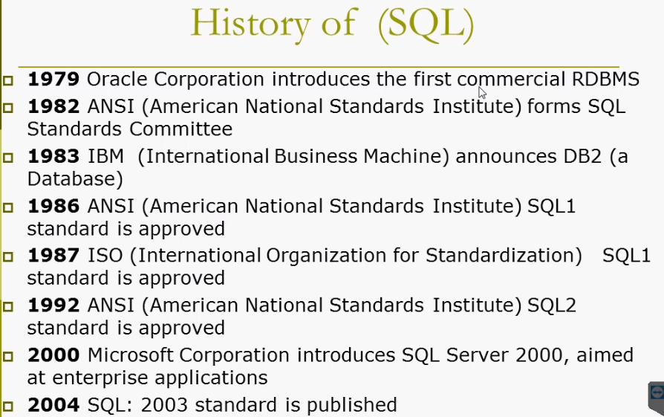

**Session 2**

* **Traditional File Structure:**
* For each team/dept. we need separate files
* Data Redundancy or Duplicity is present in all of the files (usn and Name)
* If data redundant, we need more space to store the data
* If there is any update in the redundant columns, then we need to update all the files and if missed to update, there will be data inconsistency
* Time consuming process
* Multiple people cant access the main file at the same time
* No intermediary in the file storage (like DBMS who takes the responsibility of sharing the data when it comes to Database)
* In Traditional file storage, you cant have 3 fields in the Application and 4 fields in the File (also vice versa), because application USN is mapped to USN in file, Application Name is mapped to Name in file..
* The face or the view of the file as well as the face or view of the application should be the same, because of the absence of the intermediatory
* Any updates/inclusion of the fields in the file should reflect in the application too
* Application and file should be tightly coercive or coupled
* Too much of inter-dependence
* Application program is dependent on file system and vice versa
* Since there is inter-dependency, we need to maintain separate files for separate applications

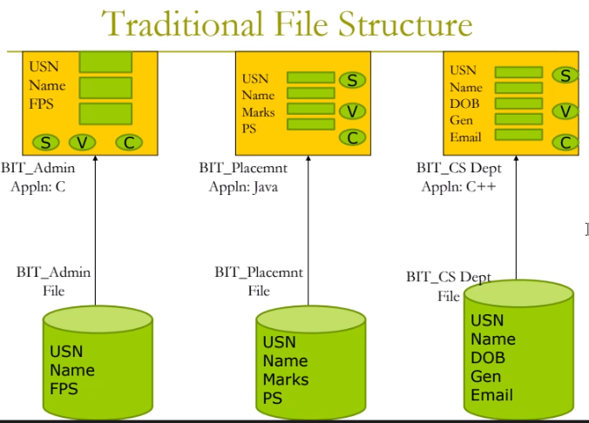

* In the DBMS screenshot, the view of the database (the list of fields in Database) is totally different from the view of any of the applications above in the same screenshot (opp. to Traditional File structure)
* None of the applications (C, Java, C++..) are having the same view as that of the database and these applications are not bothered as well. They don’t get to see whats the view of the database, because these apps cant directly access the database, they are giving request to DBMS and DBMS provides the services they need – because DBMS is an intermediary – DBMS takes the responsibility of sharing the common data among multiple applications – DBMS takes the responsibility of having multiple view of the same data
* Ex. If we are booking movie ticket or flight ticket from different applications, the dbms will receive the request and fetches the info from the Movie or Flight database respectively, we are not the only person who’s doing the booking at that point of time
* DBMS has a program called Data Abstraction – job is to abstract the data and give it to the user which is absent in file system
* DBMS has flexibility to share the data, give multiple views of data, abstract the data and hide the data
* In DBMS, we can have only 1 copy of data and can have multiple applications accessing the data simultaneously is possible
* The end user interacts with the file/database using an application like c, C++, Java – Application program is used to build the front-end application through which the user interacts
* In order to process the queries from these aforementioned front-end apps, we need to have **compiler or interpreter** (high-level languages not understood by the file system – it understand only 0s and 1s machine language) and in order to process this high-level language, we have compiler or interpreter – end user will interact with file system via operating system (responsible for file access, memory access and memory structuring – has various components file mgr, disk mgr)
* In DBMS, user is interacting with the system using the apps, he might have built his apps using Java or VBA.. in order to process these front-end apps, they also need compiler or interpreter, along with this, since we are talking about Databases (which will understand only query language – unlike file systems which understand only 0s and 1s), so you must query that database. DBMS understands query languages, so as a user, we are querying the database, for querying, user should make use of query language – SQL is one of the query languages used to interact with databases
* User is embedding the SQL queries to interact with database (the form might have built using java language or any other front-end language)
* To build a Page, we use Java, and, SQL come into picture in the **action buttons** (in the app form we give info and click on **Insert**) = in this case we are embedding SQL along with the Java Language in order to interact with Databases, so its heterogenous
* SQL commands are embedded with high-level language, in order to interact with the databases, so you need a SQL interface as well
* SQL commands must be again compiled and they must be converted to native language, native language of query language is not 0s and 1s, its either **relational algebraic notations /expressions or relational calculus expressions or objectaries**
* The various operations are implemented using relational algebraic expressions like sigma, pie, star etc.. these are the notations we use to implement the operations of DBMS
* If we write a query “Select * from Employee” – Database doesnot understand this English language command and this English language must be converted to this notational representation by a component, this is done by **SQL engine or DBMS**
* These instructions are sent to DBMS and in turn DBMS will convert this high-level language into the native language of databases and in turn send it to Operating system – whether its database or file storage, memory has to be accessed via OS only. But in case of DBMS, File Manager (manages file space) is taken care by or now the job of DBMS
* File manager will be there with respect to OS, but it is taken over by DBMS in case of database part for the 2nd storage and its going to access the database
* Structurally there is no difference between file and DBMS operations except DBMS component in DBMS interface

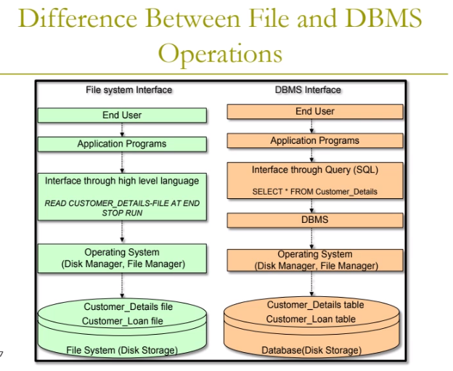

*High-level languages are designed to be used by the human operator or the programmer. They are referred to as "closer to humans." In other words, their programming style and context is easier to learn and implement than low-level languages, and the entire code generally focuses on the specific program to be created. Phython, Javascript, Ruby, Perl, PHP, GO, Rust, BASIC, C/C++ and Java are popular examples of high-level languages. A high-level language (HLL) is a programming language such as C, FORTRAN, or Pascal that enables a programmer to write programs that are more or less independent of a particular type of computer. Such languages are considered high-level because they are closer to human languages and further from machine languages. In computer science, a high-level programming language is a programming language with strong abstraction from the details of the computer. In contrast to low-level programming languages, it may use natural language elements, be easier to use, or may automate (or even hide entirely) significant areas of computing systems (e.g. memory management), making the process of developing a program simpler and more understandable than when using a lower-level language. The amount of abstraction provided defines how "high-level" a programming language is. High-level languages allow programmers to write instructions in a language that is easier to understand than low-level languages. Translators are needed to translate programs written in high-level languages into the machine code that a computer understands.*

*Low-level languages are languages that sit close to the computer's instruction set. An instruction set is the set of instructions that the processor understands. 2 types: Machine Code and Assembly Language.* *A low-level language, often known as a computer's native language, is a sort of programming language. It is very close to writing actual machine instructions, and it deals with a computer's hardware components and constraints. It works to control a computer's operational semantics and provides little or no abstraction of programming ideas. In contrast to high-level language that used for developing software, low-level code is not human-readable, and it is often cryptic. Assembly language and machine language are two examples of low-level programming languages.*

* If any storage area has the below characteristics, then it is DBMS:
* **Self-describing nature of database system:** it self-describes using Meta Data (every DBMS has Meta data)
* **Insulation b/w data and programs and data abstraction**: Ex. The database is built and implemented using the windows environment (the underlying OS is windows) and for some reason, we want to migrate to Linux OS (if we migrate, apps will not change and will not bother about the OS), because DBMS will observe the change of OS and it will be taken care by DBMS without affecting the user – Also, when you are splitting the database, the user will not get concerned (this will be taken care by DBMS and happens background on a database level – Dbms will not allow the OS changes to affect the end user)
* **Support for multiple views of data**:
* **Sharing of data and multi-user transaction processing**

**Architecture of DBMS:**

* **Ex: Architecture of a computer**: Input Devices 🡪 CPU (Memory and Peripheral Devices) 🡪 Output Devices

1. **Architecture =** What are the components the system is made up of and how are these components linked to one another and how these components are interacting with each other. Besides Layered Architecture, we have another known as ‘***Client-Server Architecture***’

* Based on who’s accessing the database, this database architecture has been structured
* **In case of DBMS, DBMS is having a Layered Architecture where there are 3 layers/levels (its not the components – what DBMS is made up of)**

1. **The Physical Layer/The Physical View/The Internal Layer of Database**: The level which is close to the database which interacts with d/b
2. **The Intermediate Layer/The Conceptual Layer/View of Database**: The one in the middle
3. **The User View/The Logical View/The External View of D/b:** The other layer which interacts with user – There can be multiple logical views – Close to the User

* **The users of the D/b is the basis for Structuring or coming up with these layers. The Users of Database (basically 3 – exclude App Developers)**:

1. ***End User*** – Can only view the data and access the data – In order for user to access the data, somebody should have created the data (this is job of Database Designer)
2. ***Database Designers*** – Designs the database – have privilege of defining and creating the database – For this person to create the data, somebody should authorize (this is the job of DBA)
3. ***DBAs*** – Sole custodian of entire d/b – As a owner, he creates this designers and he gives them the privilege of DDL commands, altering the d/b, dropping the d/b - have privilege to access every detail or every bit of data from the d/b, decides the sizes of BEST, decides the search criteria of user, decides where the data has to be stored in the d/b (actually done by File Manager but its under the resp. of DBA) – Works closely with the D/b
4. ***Application Developers*** – Who build the front-end application

*****************

* From D/b administrator (The Physical Layer), all the physical storage details of data (A,B,C,D,E) has been abstracted to the D/b Designer (The Intermediate Layer). Similarly, some amount of data (A,B,C,D) has been abstracted from the Conceptual level to the User level (only required data – A & B is visible in the application based on the requirement) - In order to appropately give access privilges to the various class of users, the dbms has been structured or architecture in a Layered Structure – This is called **ANSI/SPARC 3-Level D/b Structure**

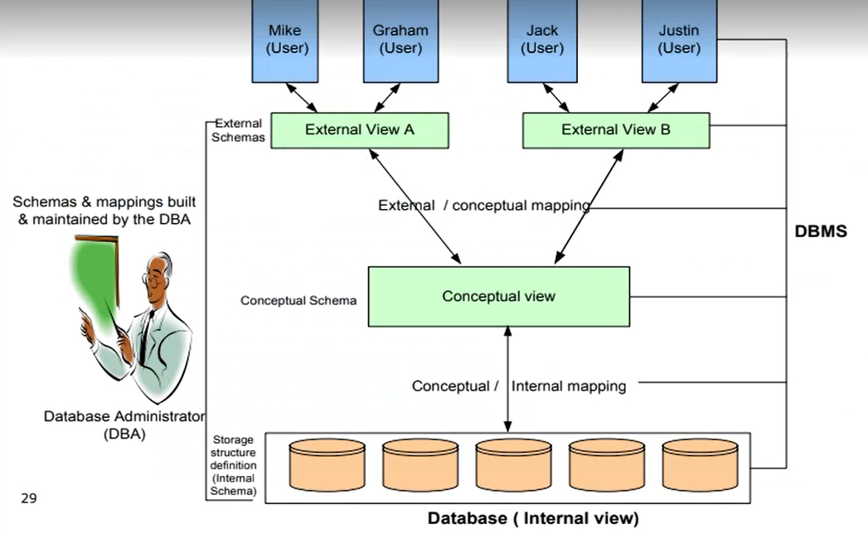

* For these users, they responsible for performing appropriate operations and the access privileges for these class of users must be appropriately given based on the nature of job they do (in case of File system, users can do anything to the file system)
* **Data Abstraction:** DBA can see all the info including, the name of the table, the index (on which attribute the index is created, it is created on EMP number, used to searching of data – frequency we get emp info from emp table based on the emp id), who’s the owner, when was this created, (attributes are Emp id, SSN, Ename..) – All these info may not be known to the Database Designer and should know only few. He can do his job of creating a table, if he knows the name of table, what attribute and what is the datatype – As a end user, who needs only even few details
* Users can see limited info, Designer can see a bit more info and DBA can see everything.

**Session 3:**

1. **DBMS Structure**

* As a DBA, I have the privilege of defining or creating objects in the Database – DBA is one class of user who is able to create the d/b object in the database
* DBA wants the emp structure to be created in the d/b - DBA writes a command to define a structure like “Create Table Employee(EID Character 4, EName, Variable character 20)” – Syntax/Command Create Table TableName (Attribute Datatype Size, Attribute2 Datatype size) – Use comma separator to segregate the columns
* This Definition goes to a component called **DDL Compiler** (Data Definition Language) – SQL is built using 100 odd engligh words and these words are grouped appropriately. Ex. DDL command like Create (which used to define the d/b, its DDL), Drop, Truncate, Drop are the various DDL commands
* DBA has the privilege of executing DDL commands – End User cant execute these commands but can execute DML commands
* This Definition comes to a component called DDL Compiler (it’s a program and component of DBMS, its job is to get the description from D/B designer, do the checks and convert it into the native language of DBMS and send it to a component called D/b manager) 🡪 DDL compiler will break down this complex query into smaller fragments (this is known as Parsing) like checking the syntax, symmantics, whether all commas are present (which is used to segregate two columns) and any missing braces/brackets if something is missing, then it cant be compiled 🡪 break down into manageable fragments and **convert this English query into the Native Language of D/b** (Relational Algebraic Notation) 🡪 Send this description to a component called Database Manager 🡪 Give it to a component called File Manager (responsible for managing file space in the d/b, this know how many BEST are there) 🡪 Says go and store this structure in the d/b 🡪 File Manager will generate the address to store the data and gives it to another component called Disk Manager (its not a component of DBMS, its part of OS) 🡪 DM takes the structure, goes to d/b and dumps this structure in the d/b 🡪 This structure will be in the Meta Data part (because we have not yet inserted the data – we just defined a structure) 🡪 We call the structure as the Skema 🡪 Emp Skema is now in the D/b 🡪
* Like Control Unit component of the computer (its job is to coordinate every other component of the computer system), we have component called D/b manager, its job is to control and coordinate every other component of the DBMS

1. **User Perspective**:

* An user, who wants to store data or perform the DML operations (Data Manipulation Language commands such as Insert, Update, Delete, select etc) 🡪 Insert will add a row 🡪 in case of Relational D/b (see the types of Implementable DBMS below) 🡪 When we say Employee Relational Skema, it means that the implementation is done in RDBMS and if we refer Object Skema, the implementation is done in ODBMS 🡪Skema is the description of the d/b item with respect to the data model
* When we say Employee skemas, it means that Emp relation skema will have Emp id an Emp Name as attributes and its describing the d/b item (whats column names, data types, size..) and this description is stored in the Metadata
* When user wants to know all the names of employees (this data is stored in the Data part of the d/b) 🡪 he writes a query and this query will be sent to a component called DML Compiler (job is to take the query, check the syntax, symmantics, parse the query) 🡪 DML compile will convert the query into the native language of DBMS and generate relational algebraic equivalent of the English language query give it to a component called Query Processor 🡪 QP will come up with alternative strategy of retrieving the same data 🡪 QP will check the cost of executing the query you have written, generate the alternative strategies and compare the cost of executing each of the strategy and choose the best strategy 🡪 Send this query to the Database Manager and D/b manager will forward the query to File Manager 🡪 FM interacts with Meta Data 🡪 FM knows where the data is stored (in BEST), it generates the address of each of database and gives that address to Disk Manager 🡪 Disk Manager takes the address, goes to d/b, pulls the required data from that given location and gives it back to File manager 🡪 FM will give this fetched data to DB manger and to query processor and to DML compiler (it now takes the native language and converts to English language) and now the user will see the required data
* **Transaction Manager**: Concurrently no. of users are assessing the same data and this component will takes the responsibility of managing the concurrent trans
* **Lock Manager**: Job is to managing the resources – if multiple users tries to access the same info (book ticket), this component will lock the other users (this privilege is given to the agent/seller of tickets)
* **Recovery Manager**: Job is to recover if failure
* **Log Manager**: job is to logging transactions and data in the database
* **Checks done by DML compiler**: The name of table stored or created is EMP but if user writes as EMPLOYEE, the query will not be executed, because there is no EMPLOYEE existing in the d/b – Checks whether the table exist in the d/b by interacting with the Meta Data and check if the structure is present in the d/b and if there is no sturucte in the meta data, it wont do any further processing and it throws an error ‘d/b item not found’ 🡪 if the table is present in the d/b, it will check whether in the Emp Table, is there a attribute by name ENAME? (but in the d/b, if we would have created name column as just NAME, then again it will throw an error)
* Types of DBMS (dbms is only a concept or a technology): The below are the various implementable DBMS models:

1. **HDBMS:** Hierarchical DBMS – Built in 1960 by IBM and existed till 1970 – Data is represented/stored in the form of Records
2. **NDBMS:** Network DBMS – In 1971 a group called Codasil built NDBMS – Existed till 1980 - Data is represented/stored in the form of Records
3. **RDBMS:** Relational DBMS – Built by Cord in 1980, the most widely used DBMS – Data is represented in the form of Two-dimensional table structure – Data is stored in bits and pieces only in the memory – Only for the user it is displayed in the form of Table – The data is extracted from those blocks and its going to be represented/organized in the form of 2-dimentional table
4. **ODBMS:** Object DBMS

**Relational Database**: A collection of relations or 2-dimentional tables (columns and rows)

**Database Design Phases/Activities:**

1. **Identify the StakeHolders** (who are benefitting from the system that you’re building)
2. **Requirement Gathering Activity** (we pen down all these requirements in the paper – Textual Description) – Account, Customer name, Employees, Loans.. (in case of Bank, these are called Data Fragments) – All these data fragments are inter-related – First, we need to understand and establish what kind of the relationship exist between data fragments, to analyze or understand we need to perform the 3rd step

* What Data Elements to be stored
* What type of data regarding these fragments needs to be stored in the database
* What data about these data elements needs to be stored
* What is the r/s b/w data elements

1. **Conceptual Database Design**: To understand the above bullet points, we perform Conceptual Database design – In order to do the Analysis, we use Graphical Representations – In case of d/b, we use ER Diagram (Entity Relation model/diagram) to understand or Analyze how the data flows from source to destination – ER model is a graphical representation of the data flow – Its not possible to implement the Analysis models like ER model
2. **Convert Conceptual model to Implementable Data model (in our case its Relational Data Model):** This is called ER to Relational mapping – It’s a logical D/b design – in this stage, ER diagram (in picture form) will be converted to a Table Structure (aka relational skemas) – This table structure can be implemented using a query language i.e. SQL after normalization
3. **Normalization:** We need to normalize the Skemas (table structures), once we get the table structures, if we implement directly, there may be redundancies that may be present in the logical design/Table format – till we prepare table structure, we have not checked the quality of design – Coming to conclusiton that which table structure is the best (if prepared by multiple designers) will not be done without Normalization – The output of Normalizatin will only be 1 – because normalization is a formal way of analysis where we are subjecting our design to some rules, we check wth qualigyt of design agains a set of defined rules - This consistent solution (normalized Skemas) will be implemented in the next step
4. **Implement the Normalized Skemas using Query Language (SQL)**

**Data Models are 2 types:**

1. Implementable Data Models (HDBMS, NDBMS, RDBMS & ODBMS)
2. Conceptual Data Models (ER Model)

**Session 4:**

* Query languages (SQL, QUEL, QBE) are independent of DBMS on which we want to write the queries – the only thing that changes is Syntax (ex. If we are writing sql wrt sequel server, then we need to make use of : in order to segregate and need not use ; to terminate and if we are writing a sql command on mysql, then instead of trunk we should use truncate etc)
* **Various DBMS**: These are the products these can implement all types of implementable data models. In order to interact with any of the below dbms, we will use of query languages – The commands in these query languages will remain the same irrespective of what type of dbms but there will be change in the symantics (SQl in oracle syntax requires every command to be terminated using a semi-colon and every attribute to be segreagated by comma, but in MySql may not have the same requirements)
* Oracle
* MySql
* SequelServer
* Access
* Ingris
* DBase
* DB2…
* **SQL in Oracle Syntax**: The commands in SQL are categorized into 6 groups

1. **DDL Commands**: Data Definition Language – Define/describe the Database/structure – DDL commands play a role in the Meta data part of database – all DDL commands operate on Skema/structure – DDL commands should have the term **Table** while carrying out the command (we need to specify the Object type while carryout out the DDL commands – unlike DML commands) - commands work on columns of table – All DML commands work on Rows of table – DDL commands are auto-commit commands and they do not support roll back – after executing ddl commands the very next command to be executed by dbms is by itself is Commit

* **Create** – create the tables and columns of table
* **Alter** – alter the structure/skema (can also add or edit the structure or columns/attributes) – with Alter command we perform 3 operations, Add, Drop and Modify
* **Drop** – Remove structure of database – when we use Alter command to drop a PK column, it will throw an error -- drop will remove the entire table or drop all the columns of the table from the database (see dif. below) - *The DROP command is a type of SQL DDL command, that is used to delete an existing database or an object within a database. –* ***Drop is DDL and so we need to mention Object type after DROP in syntax and ADD, MODIFY are DML commands and so we don’t need to specify Object type in the syntax.***
* **Truncate** – The structure is there but we don’t want the details of it – just want the skema, it is used to convert a table into skema (ex. Employees’ skema, it means employee’s attributes and data types and Employee’s Table means the table will have the details also) – Skema is the structure and once you add values is a Table - going to retain the columns of table

**Dif. b/w Truncate and Delete**: Delete will delete the values/data and structure will be intact (3X3) whereas Truncate will remove the all the data and structure

1. **DML Commands**: Data Manipulation Language – work on manipulating the structures what was defined using DDL commands – DML commands play a role in the data part of database - DDL commands work on columns of table – All DML commands work on Rows of table – DML commands work only on Tables but not on other Object Types (trigger, index, cluster…) - These support RollBack (Undo)

* **Insert** – Inputting the values to the skema – once we insert values, the structure will become a table – inserts 1 row of a table – **Always give column names after table name so that in future if DBA changes the order of column names, it will not impact while inserting**
* **Select** – select the data from one or more rows of a table
* **Update** – update the value/data of either 1 row or many rows in a table
* **Delete** – remove row/rows from table – When you delete a table, the table will be still 3X3 but when you Truncate, it will be 1X3 – Meaning, the file manager is still holding on to the emp table and for truncate, the memory will be taken back by the file manager (no way to get back the table)
* **Rename** – change the name of the structure/skema or name of the columns/attributes
* **Other DML commands are CALL, EXPLAIN PLAN, LOCK TABLE, MERGE Etc**

1. **DCL Commands**: Data Control Language – when we want to give access privilege other to access my objects that I have created in my table space, we give them permission by using DCL commands

* **Grant** – Grant the privilege
* **Revoke** – take back the privilege

1. **TCL Commands**: Transaction Control Language – Application side of d/b where we go and perform transactions –

* **Commit**
* **Rollback** – All the values which were deleted earlier will be recovered till the previous/last commit - Supported by DML – Revert the changes since the last commit
* **Savepoint**
* **Checkpoint**
* **Begin &**
* **Read**
* **Write**
* **Lock**
* **Unlock**

1. **SCC Commands**: Session Control Commands – 5th and 6th are beyond the control of Users – these are DBA commands – once you start a trans and till you end the session
2. **SCC Commands**: System Control Commands -

|  |  |  |  |  |
| --- | --- | --- | --- | --- |
| **Command** | **Data** | **Structure \*** | **Schema^** | **Columns** |
| Drop | X | X | X | X |
| Truncate | X | X | / | / |
| Delete | X | / | / | / |

**\*Structure**: Memory allocated for a value in a table – ETR for delete: even when you delete someone from your memory, their STRUCTURE will be in your mind.

**^Schema**: Table column names and their respective data types

* String/Text and Date type of data must be specified in single quotes in syntax (apart from number or integer type of data, all other data types must be specified in single quotes)
* **Integer Datatype**: An integer is a whole number (not a fraction) that can be positive, negative, or zero. Therefore, the numbers 10, 0, -25, and 5,148 are all integer
* **Varchar Datatype:** As the name suggests, varchar means character data that is varying. Also known as Variable Character, it is an indeterminate length string data type. It can hold numbers, letters and special characters – Accept alpha-numeric values – varchar values must be specified in single quote
* Comma is the separator used to segregate the attributes
* Syntax to insert values in the table that contains ‘Emp id, name and salary’ attributes
* INSERT INTO EMPLOYEE <Table name> VALUES (‘Employee1’,’Name’,10000)
* If you give more attribute data in the syntax, then it will throw an error – Too Many values
* If you specify (emp1, 10000, name), then error will come as you have specified string data type in the 3rd attribute
* If you specify (emp1, 10000) – then error will come saying “insufficient no. of values specified”
* If you want to specify for only 1st and 3rd fields then… (emp1,,10000)
* **Deleting the table**: Delete will only be successful if there is no dependency (of child table on this parent table) – if we try to delete the values in the parent table, then the corresponding values in the child table will become an orphan (a parent cant be killed if there is a child – it will throw an error ‘Can’t delete, child record found’) – Therefore, first kill the child/delete values from child table and then you can kill the parent/delete the values in the parent table
* **Primary Key**: Has the ability to uniquely identify – In B/b every table must have primary key – can only be 1 primary key for a table (rule of relational database) – shouldn’t be null – No matter how many attributes have got the ability to uniquely identify, a table can have utmost only 1 primary key – we may combine more than 1 attribute which is unique to be a primary key (this is called as Composite Primary Key – if a table has 3 PK attributes eg EmpID, Pan and aadhar, we will combine these 3 values and make it 1 value) – if we don’t specify primary key, a default PK will be created by DBMS itself (normally be the row id or row number) – if you want to make any attribute as PK, then type PRIMARY KEY after the max no of characters an put comma (we don’t create PK like this in reality) – PK comes into the play when we convert ER diagram into Schema structure – PK table is called as Parent Table - **Has the ability to uniquely identify every column & row of the table**
* **Foreign Key**: A FK should be PK in other table and this FK must always refer the values of PK of parent table – The FK table is called as Child Table – FK aka Reference Key or Link key – FK accepts null values - ***A FOREIGN KEY is a field (or collection of fields) in one table, that refers to the PRIMARY KEY in another table.***

When you write references in the FK constraint (while defining the parent table), then first create the child table otherwise, it will throw an error (as we reference the child table which is yet to be created) – When you create a child table also, then you are good to reference the parent table in the constraint that you will write while defining the child table – Once you create the child table also, then we can use Alter command to add constraint for the parent table referencing the col (as FK) in the child table

The minimal requirement for linking 2 tables is **the domain should be same** – if 2 tables have at least 1 column which is of the same data type/Domain, that should be sufficient for us to link the table – there need not be PK and FK r/s – even though its possible to link the tables with 2 columns in both the tables with same data type, do NOT do that, as it is going to generate Spurious Tuples or Illogical values – if you want to link/join the tables, always link them by PK an FK R/s only, even though there is a possibility and provision for you to link the tables using a non-PK and non-FK.

* **Syntax for creating the table**
* CREATE TABLE SUPPLIER <table name> (Supplier# <attribute> Character <datatype>(3) <the max no. of characters that this supplier can have/the size>, SupplierName Varchar(20), SupplierRating Character (5), City Varchar (20));

**Column Level constraint specification**: Specifying the term ‘primary key’ after the size part in the create command (doesn’t work always – see below for syntax for creating the constraint) – within the d/b, the constraint name has to be unique and cant be used for another time – This should be specified right after the above CREATE syntax

**Ex:** CREATE TABLE SUPPLIER <table name> (Supplier# <attribute> Character <datatype>(3) <size>, SupplierName Varchar(20), SupplierRating Character (5), City Varchar (20), CONSTRAINT PK_SUP PRIMARY KEY(Supplier#));

* CONSTRAINT PK_SUP <name of constraint> PRIMARY KEY (Sno. <supplier#>));
* The General syntax for creating any database object is given below. Database item types such as, Table, View, Sequence, Index, Trigger, Cluster, Snapshot etc – Every d/b item/entity/table should have name and this should be unique within the database (in our table space we cant create 2 supplier tables) – Mention the name of columns that you want to specify in the table in the brackets/braces – Size in the square brackets implies that its not mandatory, datatype will have a default size and dbms is going to take default size of the datatype, if we don’t specify – Once you specify all the attributes, then specify the CONSTRAINT – a table can have only 1 PK and if we want to specify a FK, put a comma separator (this is optional and so we mentioned square braces) – You can also give ‘NOT NULL’ (to make it unique constraint and if you want to ensure that a column has to take a value), you can specify this not null before you give the next attribute name – If you want a column to accept decimal values then mention ‘.2’ in size part
* CREATE <Database Item Type> <D/b Item Name> ( <Attribute1Name> <DataType of Attribute> <[size]> NOT NULL, <Attribute2> <DataType>[size]…. CONSTRAINT <ConstraintName> <ConstraintType> <(Attributes)>, [CONSTRAINT <ConstraintName> <ConstraintType> <(Attribute)> <REFERENCES> );

**Database Item**: Table, View, Sequence, Index etc

**Database Item Name**: Table name, view name…

**Attribute name**: Column/field name

* Syntax to see how many tables are created in your table space by you
* SELECT * FROM TAB;
* **Syntax to see the structure/skema**: SQL DESCRIBE TABLE is a SQL statement that is accountable for telling something about a specific table in the database. If we want to show the structure of a database table or tables in the server then, we will use the SQL command DESCRIBE or other keyword DESC, which is identical to DESCRIBE one.

FROM is executed first in the Select command (1st in order of sequence) and then WHERE is executed and then SELECT clause.

* DESC/DESCRIBE Supplier <table name>;
* In the above screenshot, the composite PK’s data types are different but the table got created
* Requirement for creating PK and FK is to have the same Data types for both the tables (parent and child)
* The names of the attributes/columns can be same in different entities, but the entity/table name should be unique from the rest of the entities/tables
* Constraint name in the CONSTRAINT command should be unique and should not have used in any other table
* Child cant be an orphan – orphan cant exist in databases
* **Syntax to ALTER a table**: *The ALTER TABLE statement is used to add, delete, or modify columns in an existing table -- The ALTER TABLE statement is also used to add and drop various constraints on an existing table -* ***Drop is DDL and so we need to mention Object type after DROP in syntax and ADD, MODIFY are DML commands and so we don’t need to specify Object type in the syntax.***
* ALTER TABLE <TableName> DROP CONSTRANT <ConstraintName>
* When you don’t know the constraint name (while creating the table you would have given ‘PRIMARY KEY’ after defining the attributename, datatype&size), then use the below Syntax – As the result shown multiple CONSTRAINT_NAMES, its always best practice to define PK constraint by giving the constraint name after defining all the attributes while creating the table

**Session 1 – 20 Nov 2018 at 9:02**

**Components of ER Diagram – Entity, Attribute and Relationship**

* **Entity**: Entity is an object in real world which has some properties that can be name, place, animal.. which may have logical or physical existence – Object which must be modelled and has some properties – Can be logically present (if we enrolled for a course, its logically present) and physically present (students and faculty) – Every entity must have an identifying attribute (the one which uniquely identifies every instance of that particular entity) – Any such entity which has a identifying attribute is called as Strong entity – **2 types**: Strong Entity aka Parent entity and Weak Entity aka child entity (that does not have at least 1 identifying attribute, ex Dependents table – when company offers insurance to the employee’s dependents, then this dependent table will not have PK – we represent this weak entity with a doubled rectangle) - *A weak entity is one that can only exist when owned by another one.*

**Strong-Weak entity set always has parent-child relationship.**

* **Attribute**: That describes the entity – properties of entities – characterize or describe an entity

**Types of Attribute:**

* **Simple/Atomic** **Attribute** – An Attribute which can’t be broken down any further – Simplest form – ex Gender
* **Complex/Composite Attribute** – An Attribute which can be broken further – made up of more than 1 simple attribute
* **Single Valued Attribute** – An attribute which can take only 1 value ex. EmpId, Gender, DOB..
* **Multi-valued Attribute** – An attribute which can take >1 values ex. – Ph. Number, qualification,
* **Derived Attribute** – ex. age, which can be computed using DOB – using a dotted or broken oval, we represent this type of attribute
* **Stored Attribute** – if age is derived attribute, then DOB has to be a stored attribute – we are calculating value of some other attribute based on this attribute
* **Key Attribute –** An attribute which has the ability to uniquely identify every other attribute or every instance of that particular entity – we represent by underlining this attribute
* **Relationship**: The association that exist b/w the entities
* Student and Faculty are entities
* USN, DOB, Name, Qualification of faculty are the attributes
* Student TAUGHT BY Faculty is the relationship
* **Cardinality of Relationship**: This specifies the connectedness b/w the instances or values of one entity with the values of other entity
* **Instance**: the value we specify for the student – Student is one entity and each one of student are instances
* One instance of faculty is connected to many instances of students and vice versa – the connectedness between instances between 2 entities is called Many-to-Many instances
* **3 types**: 1 to 1, 1 to many and many to many cardinalities

**All 1:N cardinality relationships (the relation in diamond) will end up becoming an attribute on the N side.**

**Recursive Relationship**: Self-reference - *This is a nonidentifying, nonmandatory relationship in which the same entity is both the parent and the child.*

**ER Diagram for the below Textual Description:**

**Steps for ER Diagram:**

1. Identify Entities
2. Identify Attributes of those entities (attributes do not have any r/s, only entities do)
3. Identify the relationships b/w entities

* **Identify Entities:**
* Employee
* Department
* Dependents
* Project
* **Identify Attributes:**
* **Employee Attributes**: Name, SSN, Address, Salary, Sex and DOB, Supervisor, hrs worked
* **Department Attributes**: Name, Number and Locations (multi-valued)
* **Dependents attributes:** First name, sex, birth date and relationship with employee
* **Project attributes:** Department, Name, Number and location (single-valued)
* **Identify R/s -- Cardinality:**
* Emp has dependents – 1 to many
* Emp manages Dept – 1 to 1 cardinality
* Dept controls Projects – 1 to many (dept controls many projects and each project is controlled by 1 dept)
* Emp works on Projects – Many to many (an emp works on multiple projects and 1 project has many employees)
* Emp works for Dept – many to one (an emp works for 1 dept and 1 dept can have many employees)
* Emp supervisors Emp – 1 to many (an emp supervises many sub-ordinates and a sub-ordinate have only 1 supervisor)

**Questions can be answered through ER diagram:**

1. What entities must be modelled or stored in the database (we cant model the un-relational entity in the d/b)
2. What data about those entities – attributes
3. What relationship exist

Relation Schema is a 2-dimentional table structure with names, rows and columns

* To convert ER diagram to Table Skema/skema structure, (skema will have name and columns), each of the components of ER diagram should become either name or column – All the entities of ER diagram will become the name of the skema/table

**1: M Cardinality:**

* All simple/single-valued/stored attributes would be represented as the columns (not multi-valued attributes)
* Multi-valued attributes must be represented as a separate table, because if I make it as a column with the same table, then it leads to data redundancy/too many null values (see ex below), so we need to make it as separate table
* If Dept table has multiple locations of each dept, then if, out of 40 dept., if only one dept has 10 locations, then the location columns for the rest of the 39 depts (that has only 1 location) will be null – So we need to create a separate table and make the dept column (in this new table) as FK (ensure we create the dept column and location column as a composite PK – because PK should not be repetitive) and link this FK to the PK of the dept table
* Ensure that Data shouldn’t be repetitive/redundant in rows
* We can generalize that the r/s (has/works/manager/controls) should become an attribute on the M/N side entity (eg 1 to ‘M’any) – if we make it on the 1 side, then it becomes multi-valued
* If the entity is weak entity, we have to make it strong entity by making the composite PK and also it becomes a FK

**M: M Cardinality:**

* Make it as a separate table (emp works on multiple projects and multiple emp works on 1 project)
* Make the relationship as a separate table (works on) – if r/s becomes a separate table, it needs to have attributes and so the emp no and project no will become attributes and make these both columns as composite PK and establish a link b/w emp and project
  + Emp_table
    - Emp_id
    - Emp_name
  + Project_table
    - Project_id
    - Project_name
  + Emp_project_table
    - Emp_id
    - Project_id

Now that we have converted ER diagram to relational skemas structures based on our understanding, if we implement this, there could be some anomalies or redundancies which we don’t know and to avoid this, we need to NORMALIZE before implementing (penultimate step in the database design process)

**Session 2- 20 November 2018 at 11:24:34**

**Normalization:**

* *The purpose of Normalisation in SQL is to eliminate redundant (repetitive) data and ensure data is stored logically.*
* Process of checking the quality of design apart from the intuition of the user/designer
* Process of synthesis (breaking down) of a complex relation into simple relations so as to eliminate any data redundancies or anomalies or inconsistencies that may be present - once we have the relation skemas, subject these to normalization forms – we will only perform up to 3 NF
* How to normalize: There are rules called as **Normal Forms (against which we perform we normalization)**
* If we directly implement the below table by giving “INSERT INTO <tablename> VALUES (S3,’Sita’,’f’,,,,);” 🡪 then there will be blanks from CourseNumber column till the end 🡪 but as we have created composite PK using USN and CourseNumber, the CourseNumber column will be blank 🡪 But as per rule neither PK nor part of PK (course#) should not be blank and Vice versa (if we try to insert only course details without student, it will not accept as the part of the PK (USN) should not be blank) = we call this as Insertion Anomaly problem

**The inventor of the relational model Edgar Codd proposed the theory of normalization of data with the introduction of the First Normal Form, and he continued to extend theory with Second and Third Normal Form. Later he joined Raymond F. Boyce to develop the theory of Boyce-Codd Normal Form (BCNF).**

**1 NF**

1. **Rule 1:** Every attribute of the relation subjected to 1 NF shall be atomic/simple (there should not be composite or multi-valued or derived attributes) – Once you convert an ER diagram to R/s schema, we would have eliminated/simplified (like we created separate table for dept locations and made it a composite PK) - ***To satisfy First normal form, each column of a table must have a single value. Columns which contain sets of values or nested records are not allowed***.
2. **Rule 2**: Identify the Primary Key of each of the Relation – once the PK is identified, we can go for 2 NF

**2 NF**

1. **Rule 1:** Every relation subjected to 2 NF shall be in 1st NF
2. **Rule 2:** Remove partial functions dependent attributes from the relation and form a separate table **AKA** Retain fully functional dependent attributes in the table

**Partial Dependency**: In the below table, we figured out that Usn and CourseNumber will be composite Primary key 🡪 the column StudentName and Gender are partially dependent on the Composite PK (we can derive the SName and Gender with the help of only USN, in other words, SName and Gender are dependent on the part of PK (USN), so its partial dependency) 🡪 similarly, CourseName is partly dependent on the PK (CourseNumber, not on composite PK)

**Full Dependency**: Marks column is fully dependent on the Composite PK (USN and CourseNumber) – Based on marks, the Grades will get calculated accordingly (so Grade is fully dependent on the Marks column and therefore Grade will be in the table wherever Marks column is there)

Based on the above we need to break down the below table based on the 2NF

**Output of 2NF:**

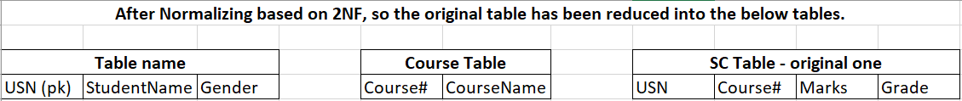

**3 NF**

1. **Rule 1: Relation subjected to 3NF should be in 2 NF**
2. **Rule 2: Remove any Transitive Dependencies**

**Transitive Dependency:** ex. If R is a table with X,Y & Z as attributes, if X determines Y and Y determines Z (there is an indirect dependency) – if such kind of dependency exist, remove them. In the Output of 2NF screenshot, the first 2 tables do not have any Transitive dependent attributes, but in the 3rd table, USN, Course# determines Marks and Marks determines Grade, so there is transitive or indirect functional dependency exist and so we need to remove Grade from this 3rd table, then grade becomes an attribute along with Marks attribute (Marks is the PK for this 4th table)

**BCNF**

**4 NF &**

**5 NF**

Once we normalize, we call the output as Normalized relations or Refined Skemas and we can implement this refined skemas using the Query Language

PK attribute determines other attributes in the table and similarly, Non-PK attributes of a table are dependents of PK field

**Functional Dependency**: Dependency of non-pk fields on PK for identification (son <non pk> is functionally dependent on Father<PK field> for his identification) – Determinant is PK field and non-pk fields are Dependents – When we group the attributes together, the fields should be having dependency or determination

**Session 3- 20 November 2018 at 13:37:39**

**Practical:**

* **Insert:**
* INSERT INTO TableName VALUES (‘&ColumnName1’,’&ColumnName2’…)**;** press Enter (and give just values without any quotations <as we have already defined in the insert command>)
* S1 <value in column1> (Press Enter - it will prompt you to enter a value for the column2)
* Ram <Value in column 2> (Press enter - it will prompt you to enter a value for the column3)
* …………

If everything is correct and appropriate, it says ‘1 row is created/inserted’ and press “/” without any quotes and Enter (which will re-execute previously executed query (**insert** in this case))

* **Multiple Insertion**: We use “&” for inserting multiple values - Use &, it is for specifying the address (in reality, we wont insert values in 1 row at a time, we need to insert 100 of rows at a time) - all textual data should be in single quotes and no quotes for numerical

**Another way of inserting values row by row:** When you do this and press ‘/’ (which executes previously-executed command), it will throw an error (as we have defined PK – shown in below 2nd screenshot)

In the below screenshot, we tried to create a row with the same value in the Sno. (PK column), but since it has throwed an error ‘Quoted String not properly terminated’, we ran it again and the row has created.

**To look at the values that you’ve inserted**: Select command is going to filter the columns

* SELECT * FROM SUPPLIER <table name>;

Either * or the list of attributes – the attributes cant necessarily be the same sequence that is present in the table

**SQL commands in the above syntax**: SELECT & FROM

**Logical name given by user for a d/b item**: SUPPLIER

*Star is an operator in SQL, which specifies all the attributes

* The SQL engine needs 2 cycles for executing the above query – 1 cycle for each command (Select and From) – **From** is always the first command (etr the characters in these two words <From and First> is “F”) to be executed in the sql and select is the last command to execute
* **Where** is second command to be executed after from

To change/update any data type, use ALTER command + Modify

To remove the quantity column, use DROP command

***Drop is DDL and so we need to mention Object type after DROP in syntax and ADD, MODIFY are DML commands and so we don’t need to specify Object type in the syntax.***

If you want to add the column:

1. **Insert is used to insert value for a new row but UPDATE is used to add values to the existing rows (ex. If a row has 5 columns and while inserting, we gave only values related to those 4 columns and if, any other time, we want to update that remaining 5th column, then we use Update)**

**Syntax**: UPDATE Supplier <tablename> SET Phone <colname>=1212121;

The above update syntax is going to update for all the rows, because we didn’t specify to which row the no. needs to be updated – below is the screenshot.

1. To set which row to be updated, see the below screenshot

**Command:**

**Result:**

* If you want to drop only 1 column, we can use COLUMN keywork and to drop multiple columns,

Alter table supplier drop (column1,column2..)

**With Alter command we perform 2 operations, Add (column/constraint), Drop (column/constraint) and Modify (column/constraint)**

Code:

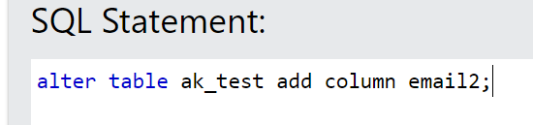

Result:

* In the below screenshot, the error says ‘Unique constraint violated’ because Sno and Pno is a composite primary key and if we insert S1 in sno column and P1 in Pno column, this error comes up

**Code;**

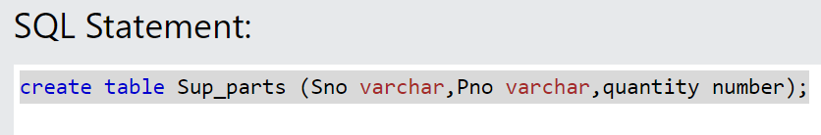

**Result: Table will just create with no rows.**

* In the below screenshot, the names/logical names in EMP and DEPT tables can be different but the data types of DEPTNO (in Emp table) and DeptNo (in Dept table) should be the same – the PK and FK r/s is established based on the common domain attribute (two col of the table must have same data type and the name of col can be different)
* **Select Command** – aka Data Retrieval command – Pull data from d/b
* SELECT * FROM SUPPLIER <table name>;

Either * or the list of attributes – the attributes cant necessarily be the same sequence that is present in the table

SQL commands in the above syntax: SELECT & FROM

**Filtering:**

* Select is a column filter and Where is row filter
* If you want to filter the data based on rows, use WHERE clause
* If you want to filter the data based on columns, use SELECT clause

1. **Equals to/= is a comparison operator (>,<,>=,<=) which is used to compare single value and so the below command will not fetch any values – Thus, we need to use multi-value operator (i.e., OR operator) – see the 2nd screenshot below**
2. OR is the second least used operator in SQL after cartician product as it consumes lot of resources and thus, we can also make use of UNION operator but this is also not multi-value operators – See screenshot below
3. **Multi-value comparator**: IN

**Syntax**: select <ColumnNames> CustomerID, CustomerName, City from <TableName> customers where country IN ('Germany','Spain','USA');

The end-result is same for = or union or IN and the amount of resource used to execute is varying (least being IN) and so DBMS will execute IN operator (no limit in values in IN Operator)

* **Order By** Operator:

**Syntax: Select * from <tablename> ORDER BY <columnname>**

By default, the data will get ascending order (we can use ‘ASC’ after the column name as well ) and if we want to order in descending order then..

Order By is the last operator to be executed – it should always be there in the outer query (not in sub-query)

**Syntax: Select * from <tablename> ORDER BY <columnname> DESC**

We can sort the data based on any no. of attributes. By default, the data will be sorted based on the PK column.

* In the below screenshot we have just mentioned 3 – which means 3rd column
* In the below screenshot Weight+50 is a derived attribute
* **AND Operator**: whenever we want to specify more than 1 condition – conditions are specified with the where clause - we must always use logical operations in the Where clause to specify condition/s

There is no limitation on the no. of conditions we can specify using a **where clause** – these conditions must be specified using the logical operator such as AND, OR, NOT (whereas the Arithmetical operators should be used in the SELECT command)

* **NOT Operator**: either <> OR !=

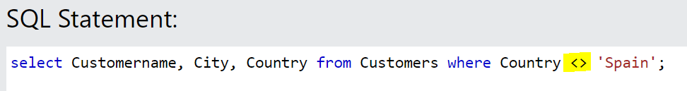

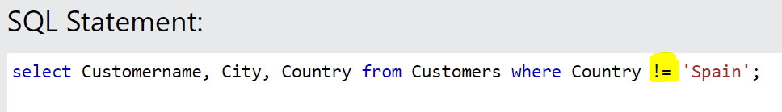

**When you are using the multi-valued comparator, use NOT as mentioned in the below screenshot.**

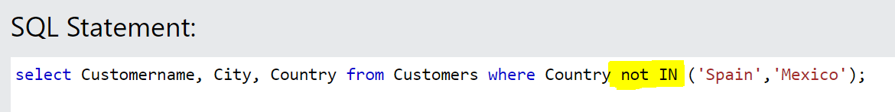

* To find the items whose quantity is less than 100.

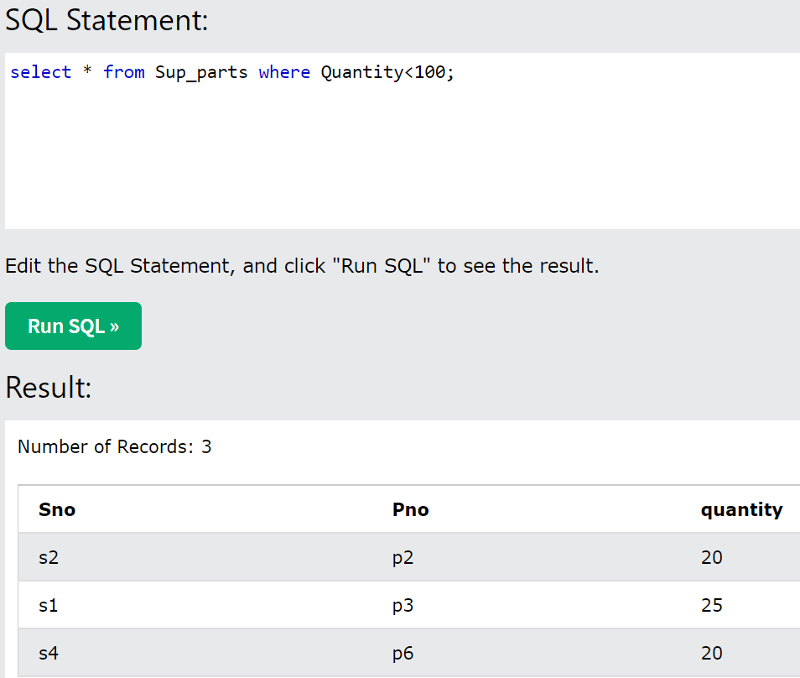

* Whenever we need to specify the range values, we use BETWEEN and AND command – we use Between and AND Operator when we want to compare the range for ONLY 1 column

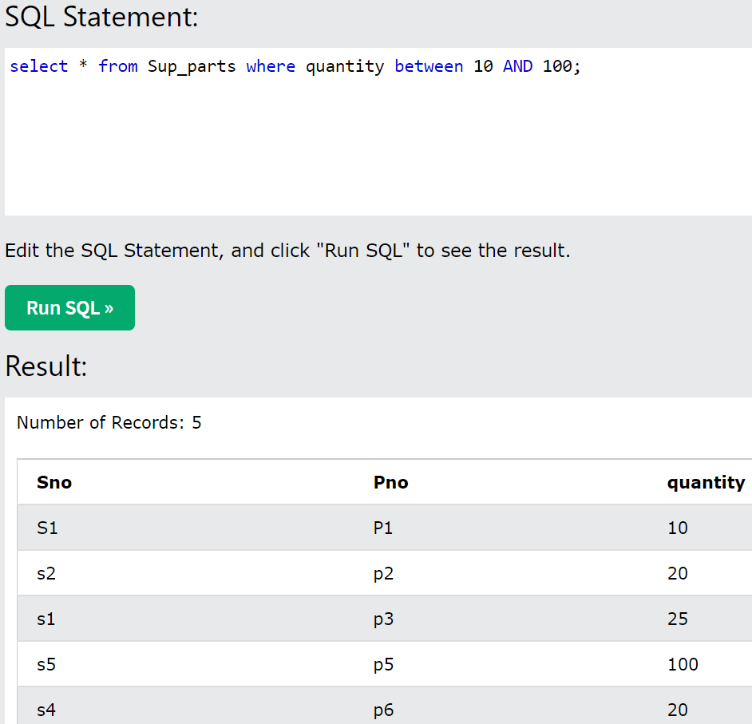

**3 Types of Operators:**

1. **Arithmetic Operator**: +, -, *, /… (to be used in the Select clause with the attributes) – ETR: S is next to A in keyboard
2. **Logical Operators**: AND, OR, NOT (to be used in the Where clause to specify more than 1 condition) – **ETR**: if you rotate L to 90%, it will look like more than symbol.
3. **Relational Operators**: =,<>,>=,<=… (to be used in the Where Clause especially to specify the conditions)

**Order of execution**: 1. **Relational** (as WHERE is the first in executing order) followed by 2. **Logical** followed by 3. **Arithmetic**

**One type of creating Alias** is specify anything in double quotes: Anything mentioned in single quotes is String and anything mentioned in the double quotation is Constant.

* **Pattern Matcher**: the operator LIKE is used to match the pattern and this operator comes with 2 special wildcard characters – we cant use = with LIKE operator (its alternative to =)
* % - % specify any no. of Characters
* _ - _ specify specified no. of characters
* To get all the values that starts with A use the below pattern matcher operator and if we want the names that end with A, use the % before the character A – see 2nd screenshot below.

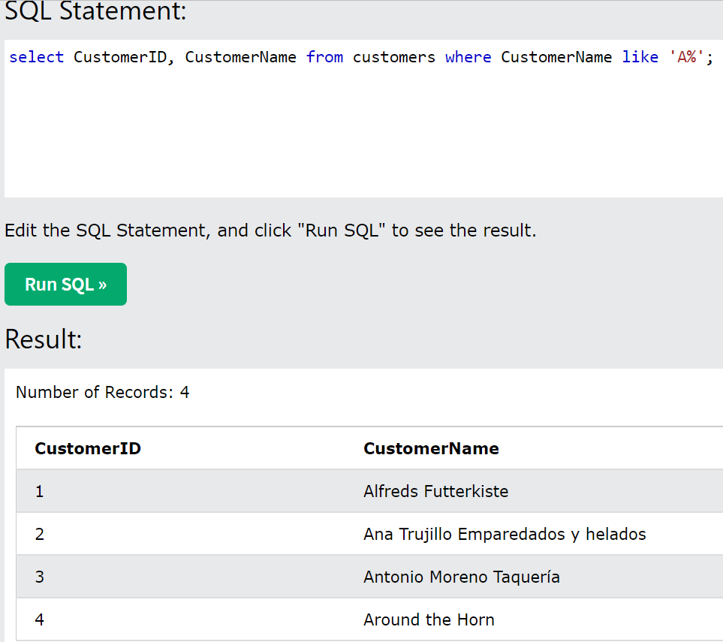

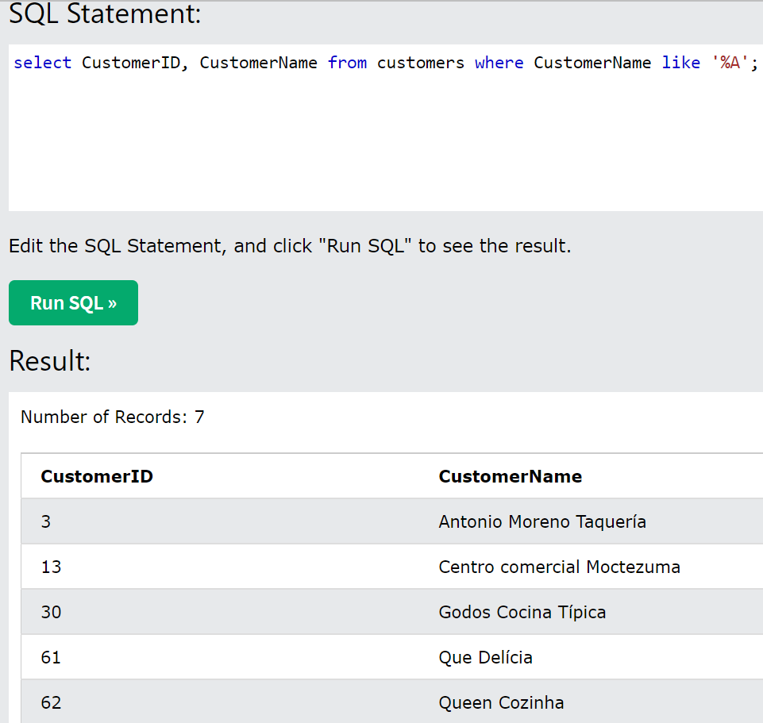

* If we want the list of customer names whose name contains A anywhere – use %A%.
* If we want the 2nd character to be A – use ‘_A%’;

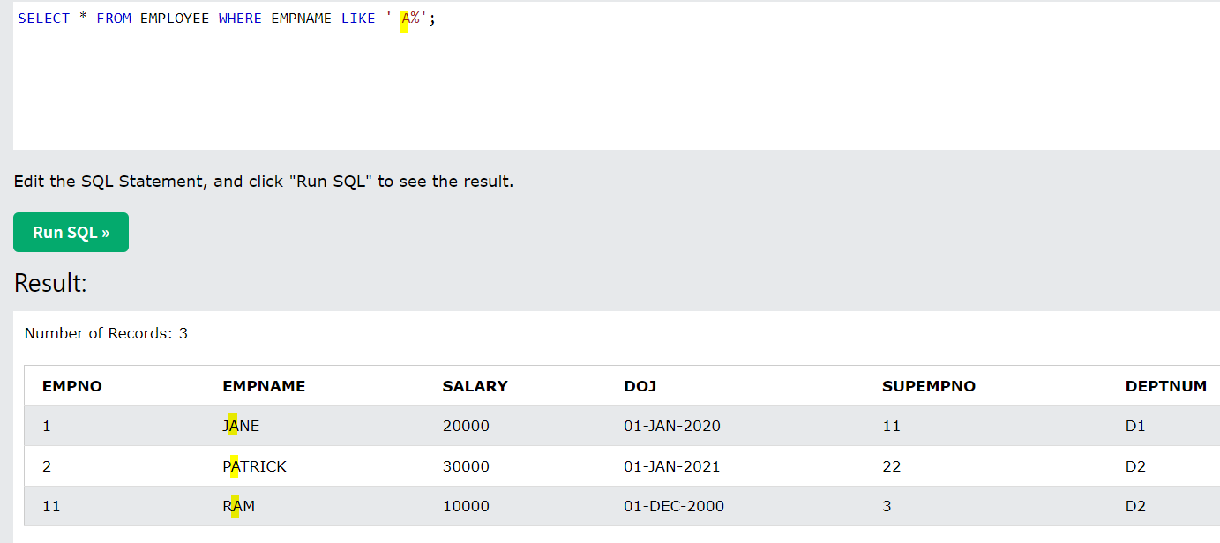

* What if we want those names which are having only 5 characters - give 5 underscores (as in the below screenshot)

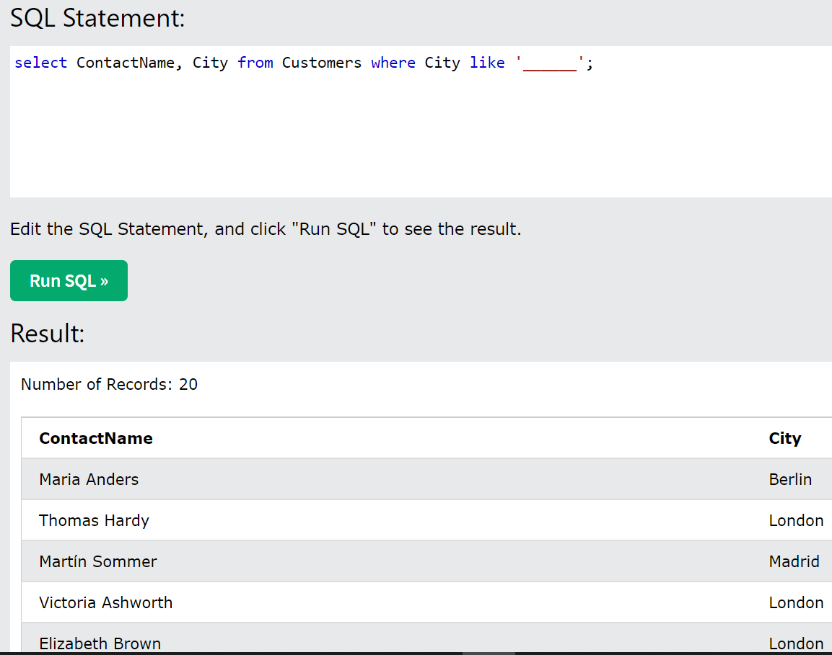

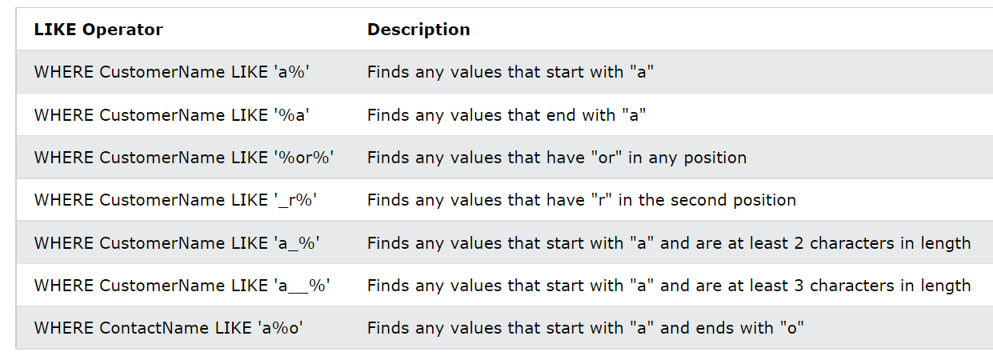

* By default, whatever the values we populate/inserted either in upper case or lower case, its going to get converted to Upper case and stored in the database.

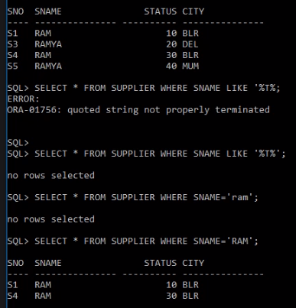

* If you want to convert lower case to upper case:

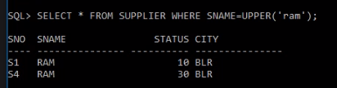

A tuple is a row in a table. A field or attribute of a table is a column.

***Video 8:***

***Session 1- 21 November 2018 at 08:52:17***

* **Constraint**: As a user and designer, we must specify the constraint/condition on the data to be present in the database
* **3 Levels of Constraints specification**:

1. **Data Model Level aka Built-in Constrains**: These are the constraints that DBAs or Users are not defining, but when we choose the implementable DBMS model, these constraints come with the data model

**Constraints ex for RDBMS:**

* The name of the table/database object has to be unique within the database
* the names of attributes within the table have also to be unique (the attribute name can be same in other table)
* A table can have only 1 Primary Key
* A table can have any number of Foreign Keys (when we need to link 1 or more tables so for linking we must use FK)
* A table must have 1 column and may not have any rows, we still call it as table
* The Constraint name has to be unique within the database

1. **Database Design-level Constrain**t: Constraints that are defined by DBA – If we are not defining the constraints at this back-end level, we can also do this at the Application-level (front-end) – Two classes of D/b design-level constraints
2. **Primary Constraints**: Should be specified at the bottom of the defining the table – aka Table-level constraint specification/definition

* **Candidate Key**: This is the key which is having the ability to uniquely identity every other attribute or every column or every row of the table –
* **Primary Key**: The successful candidate key which has been named as the identifying attribute is a PK. *There can be more than one candidate key in relation out of which one can be chosen as the primary key.*
* **Alternate Key**: The other candidate keys which has the ability to be named as PK are called Alt Keys
* **Super Key/Super PK**: Combining the other candidate key and making it a composite PK
* **Composite Key:** Combination of a Candidate key and non-candidate key
* **Foreign Key aka Link Key aka Reference Key**
* **Unique Key:** An attribute where you have specified it to be unique, it ensures that the column takes only unique values
* **Check constraint:** Condition specified for checking the value before the values are inserted into the table (ex. DOB cant be future date) – We can also mention in ALTER command if not defined while creating the table

**Syntax: CONSTRAINT <ConstraintName> <ConstraintType> <ColName & Condition>**

1. **Secondary Constraints**: These are the constraints, unlike Primary Constraints, we should not mention separately – These must be specified corresponding to the column itself (cant be specified at the table level – while defining the table structure) – AKA column-level constraint specification

* Not Null:
* Default: While inserting values if I don’t specify value for salary, then consider it as 50k – Must be defined at the column level only

1. **Application-level Constraints**:

**Adding Unique constraint**: Unique constraint can accept any number of Null/Blank values (as per this, 2 null values are not the same, as these 2 null values gets stored in different blocks) – Unique and NotNull are not same.

**Syntax: ALTER TABLE <TableName> ADD CONSTRAINT <UniqueConstraintName> UNIQUE (ColName);**

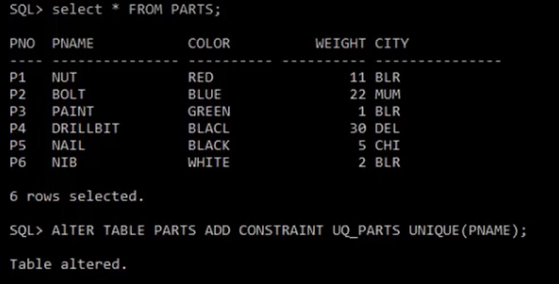

* If you want to insert a blank value (if its string), ensure you give single quotations in the Insert command – see the screenshot below:

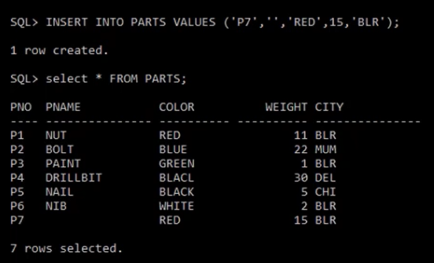

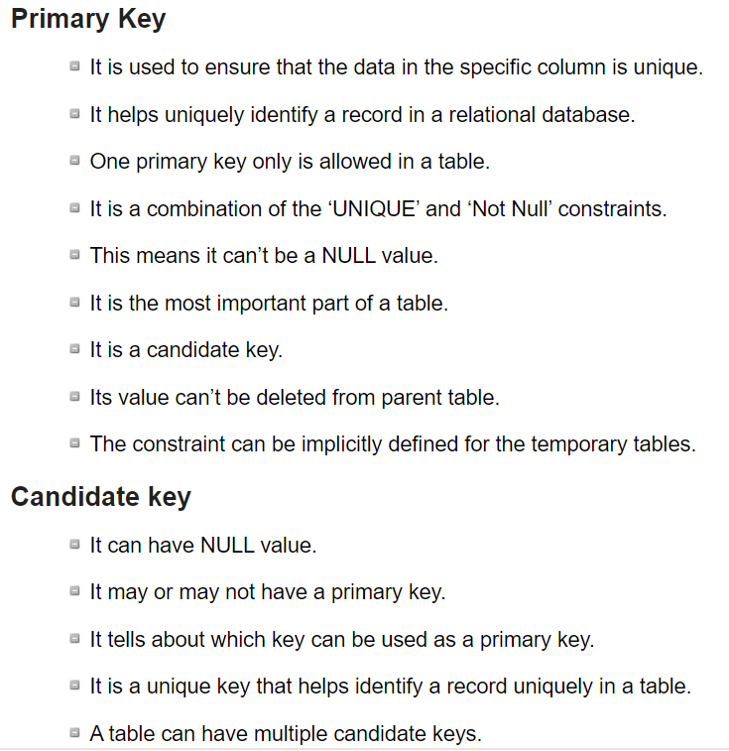

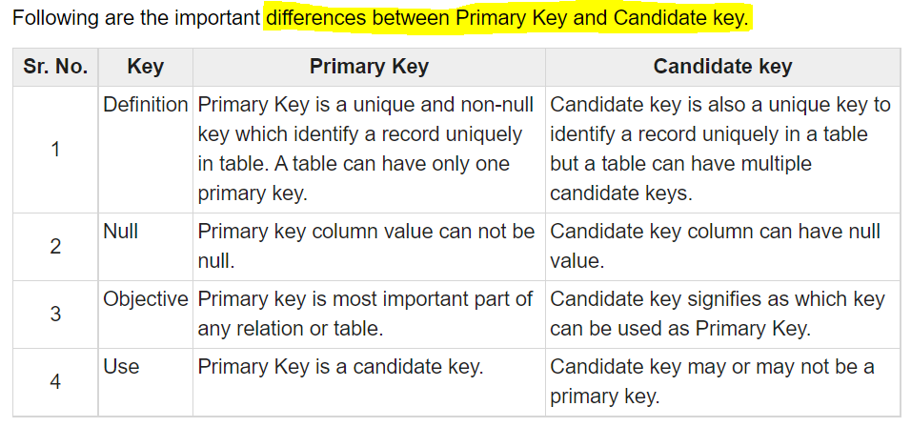

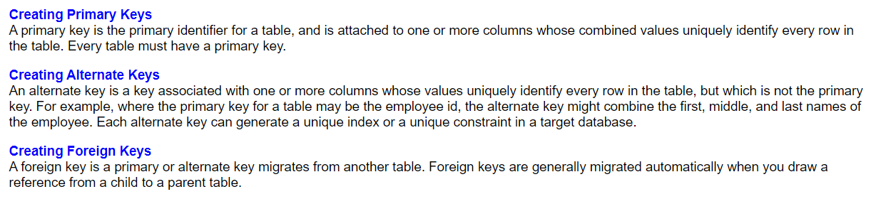

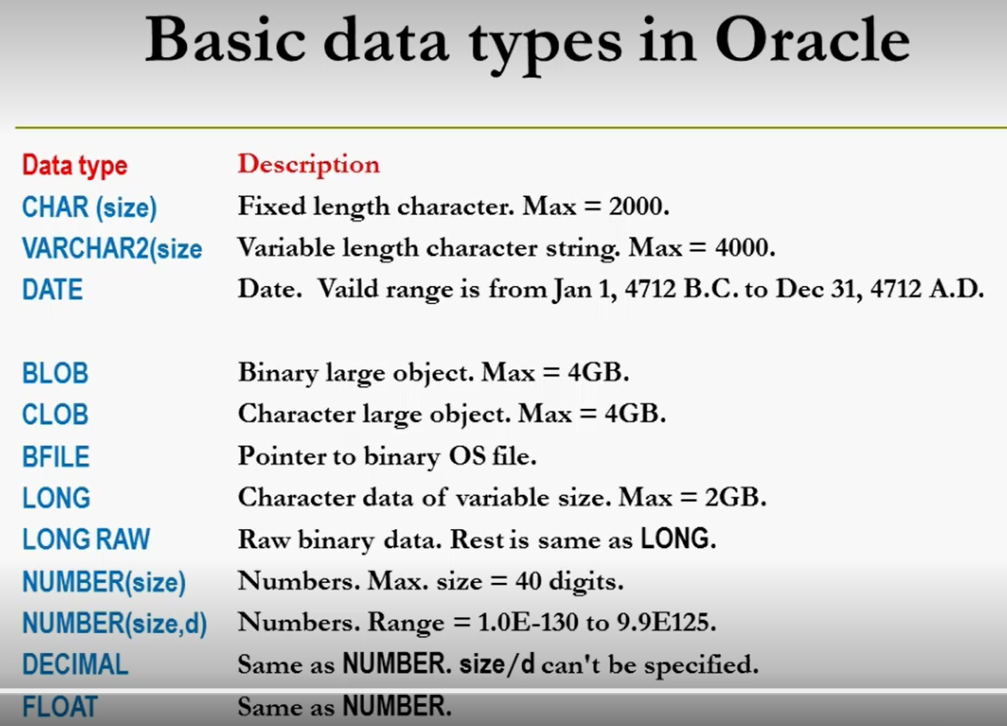

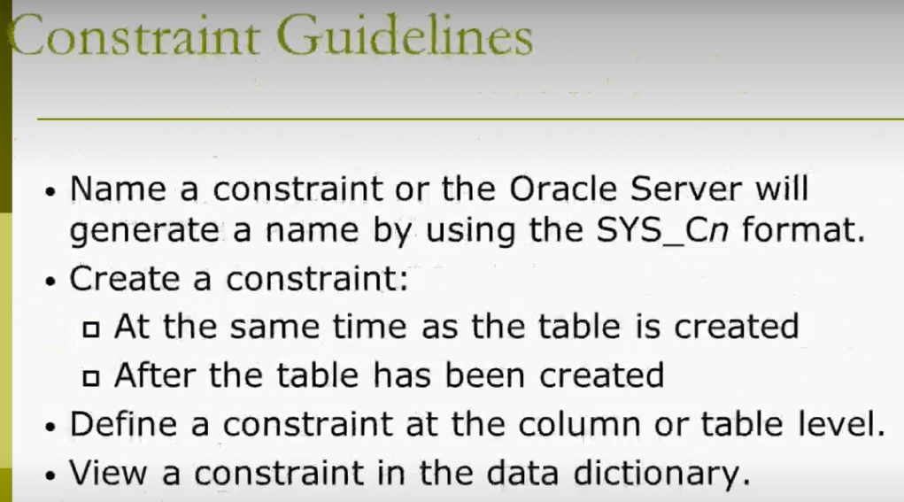

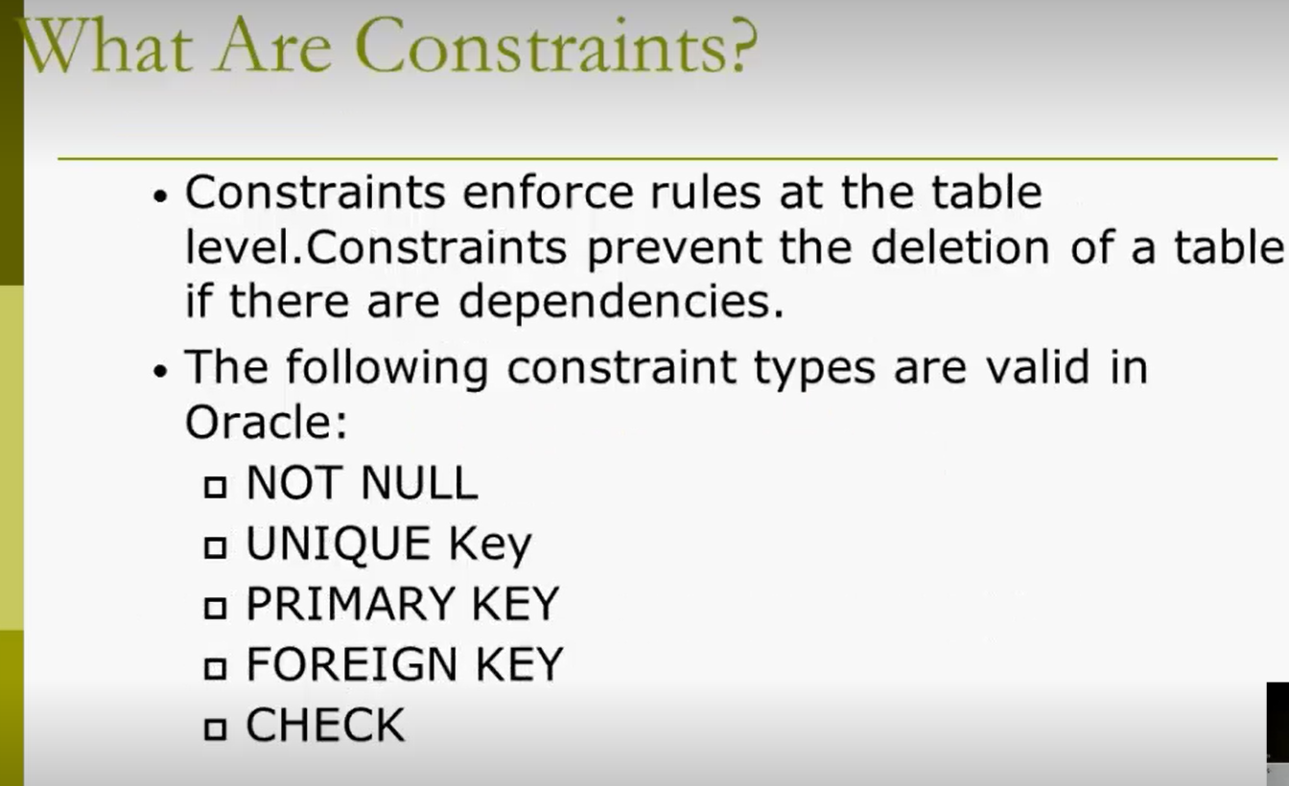

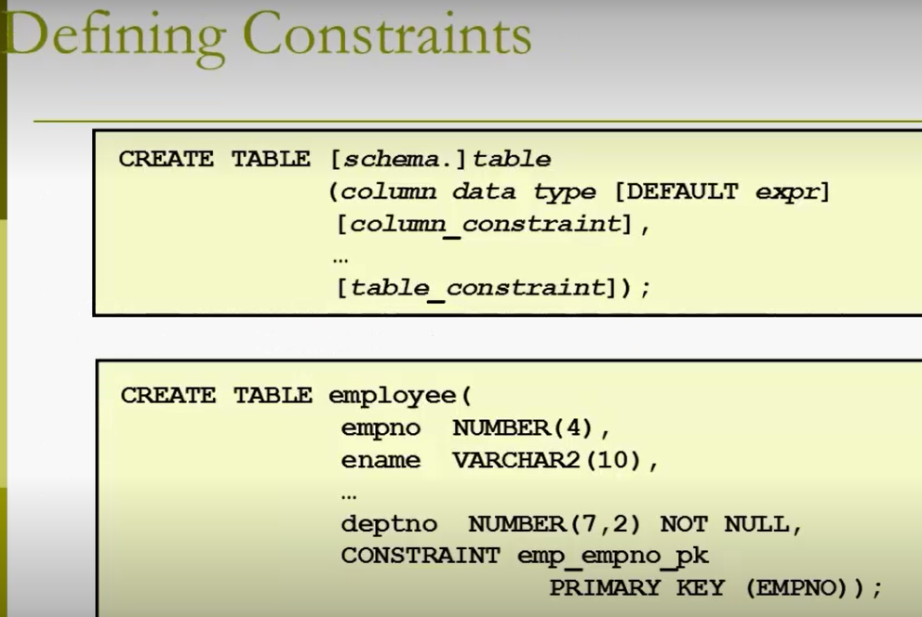

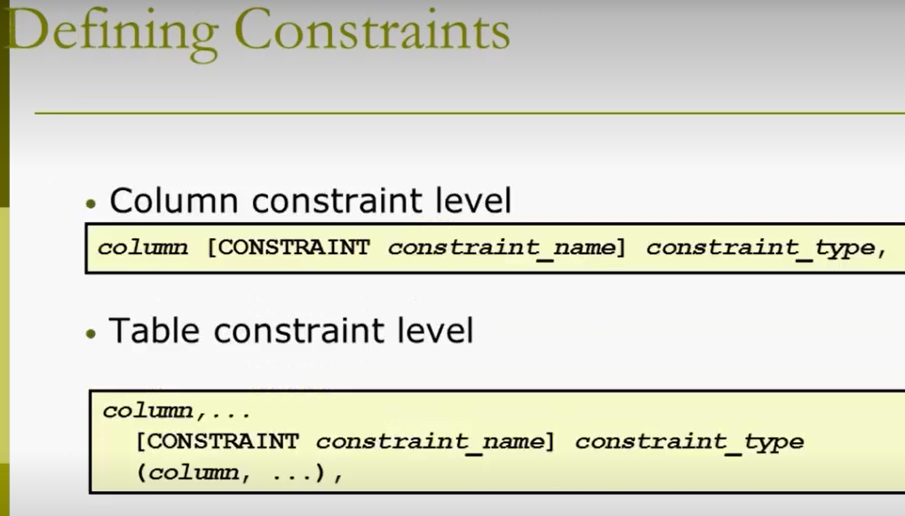

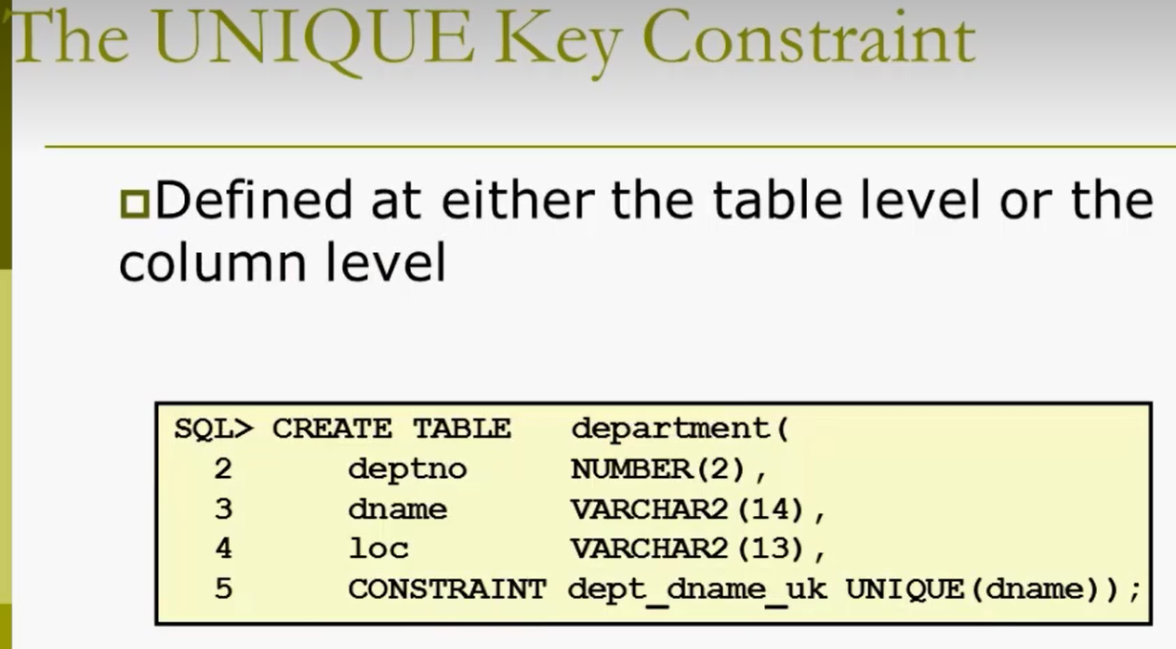

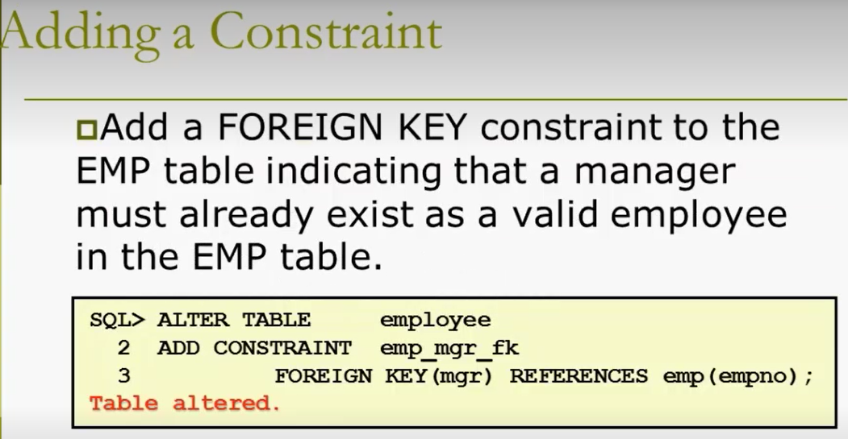

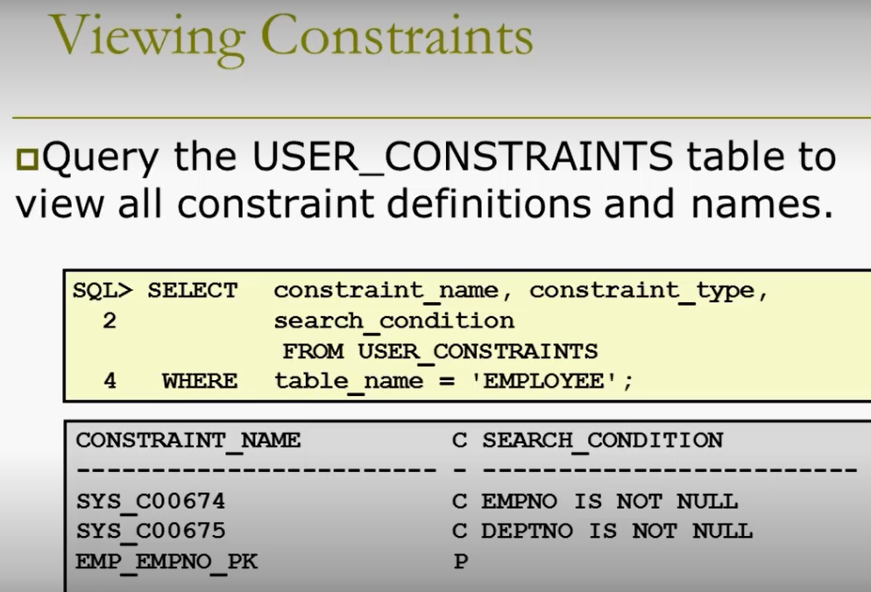

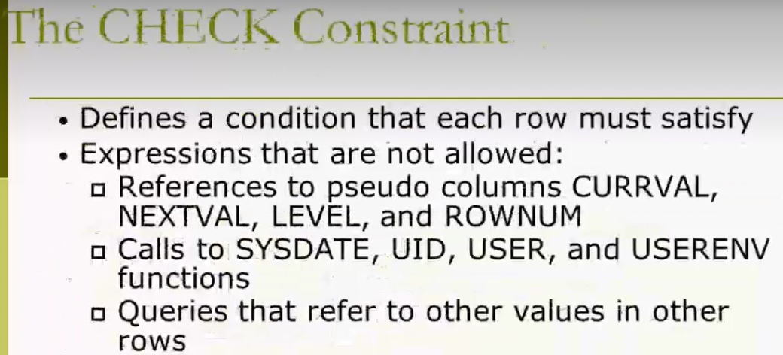

Session 9:

**Session 2- 21 November 2018 at 11:16:48**

**Recursive Relationship**: Self-reference - *This is a nonidentifying, nonmandatory relationship in which the same entity is both the parent and the child.*

**Insert Date like this:**



When you define the column datatype as 3 (1st screenshot below) and if we select, the data we will see is restricted to 3 (2nd screenshot below)



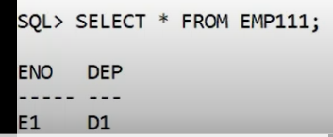

* When we use Alter command to drop a PK column, it will throw an error (if this PK has corresponding FK) - Primary key can be dropped ONLY IF the corresponding FK is not present – In other words, we can delete PK after deleting the FK column
* We can’t drop all the columns in a table: see the screenshot below

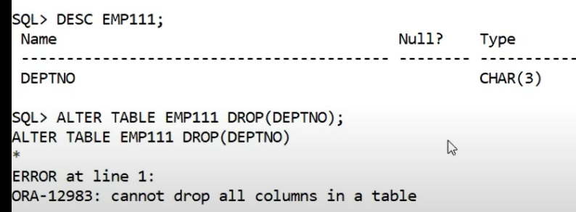

* Copying another table and creating new table:

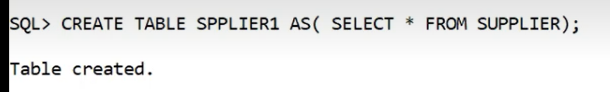

* **Truncate**: Since Truncate is a DDL command, in the below screenshot we were not able to use rollback command.

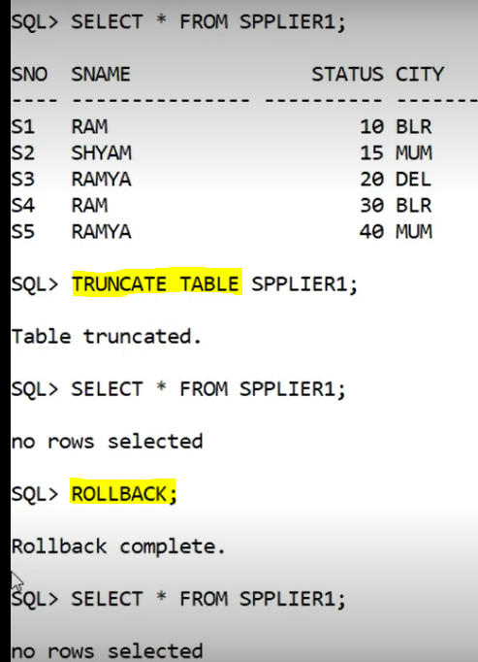

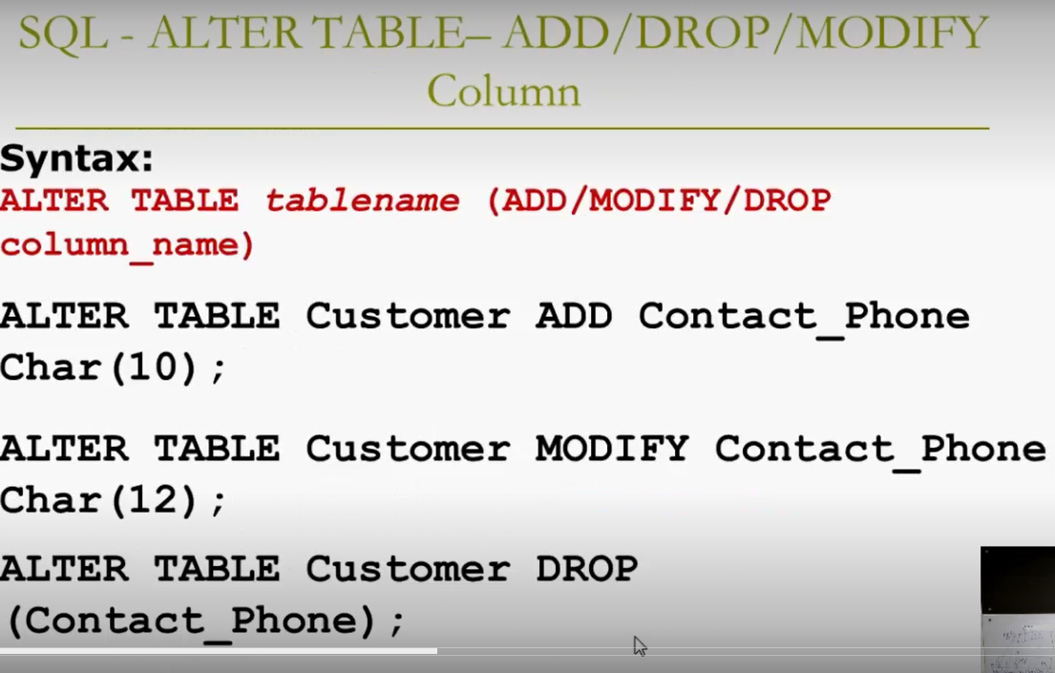

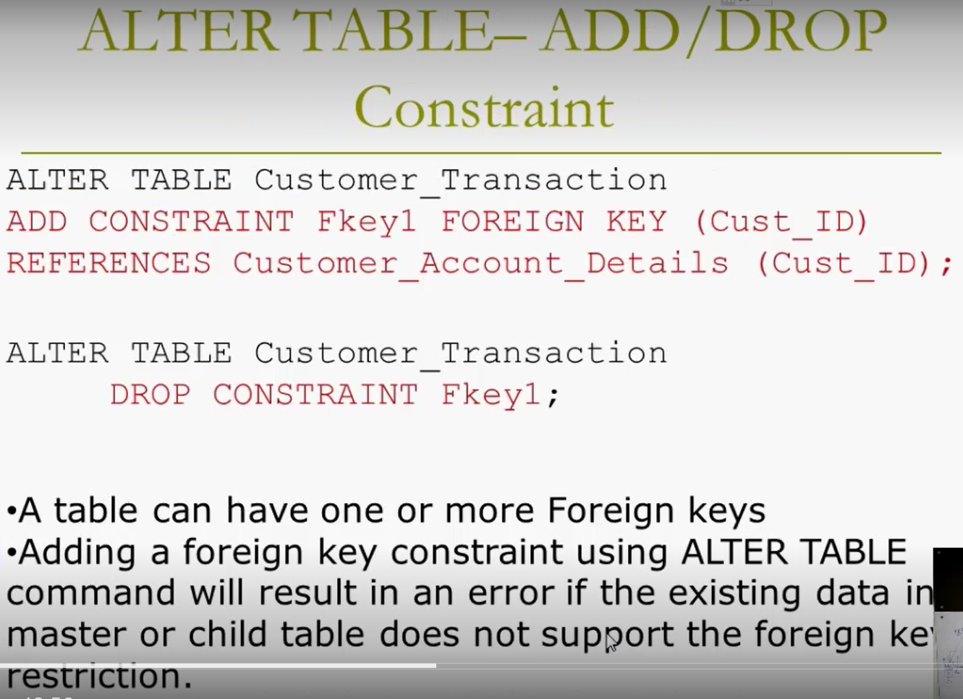

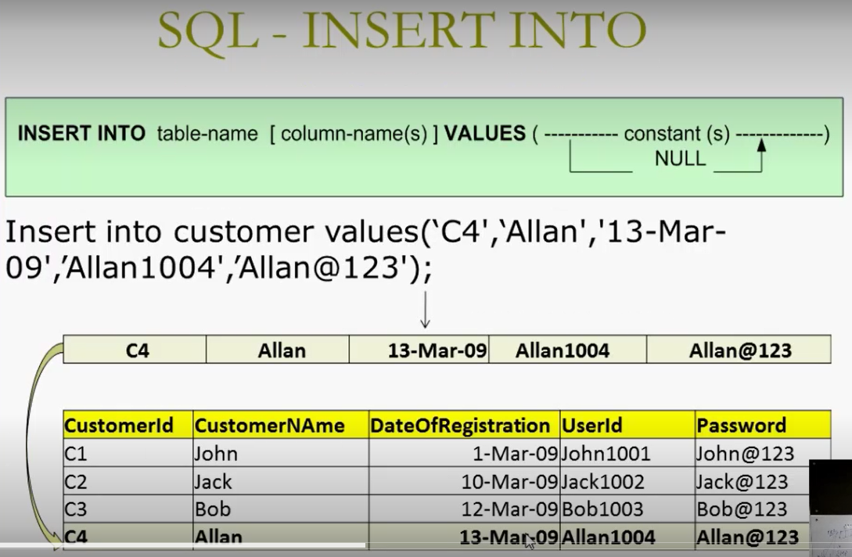

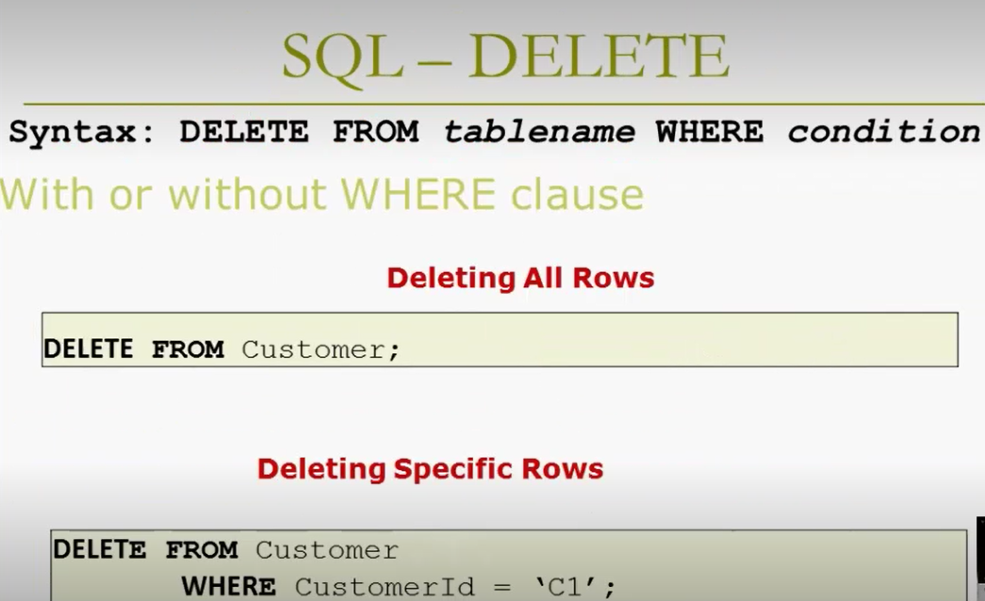

* If our query is to retrieve the unique supplier names or list the unique supplier names, we use Distinct in Select command – we need to use distinct on only 1 column

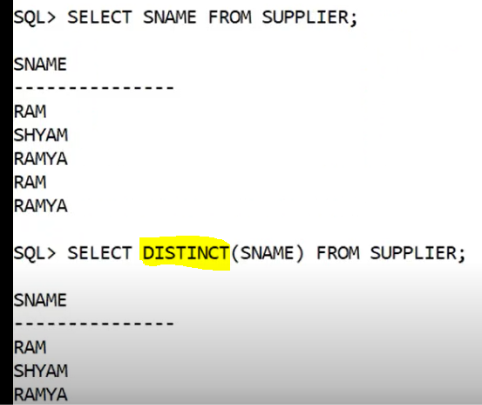

* BODMAS is applies to database commands too (Braces, Orders, Division, multiplication, addition and subtraction) – see the below weight example

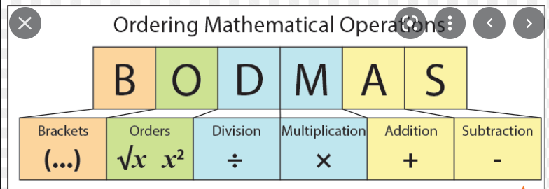

* Logical operators (And, or, not) are to be used in the WHERE clause and the Arithmetic operators (+,-,/,*) are to be used in the SELECT clause

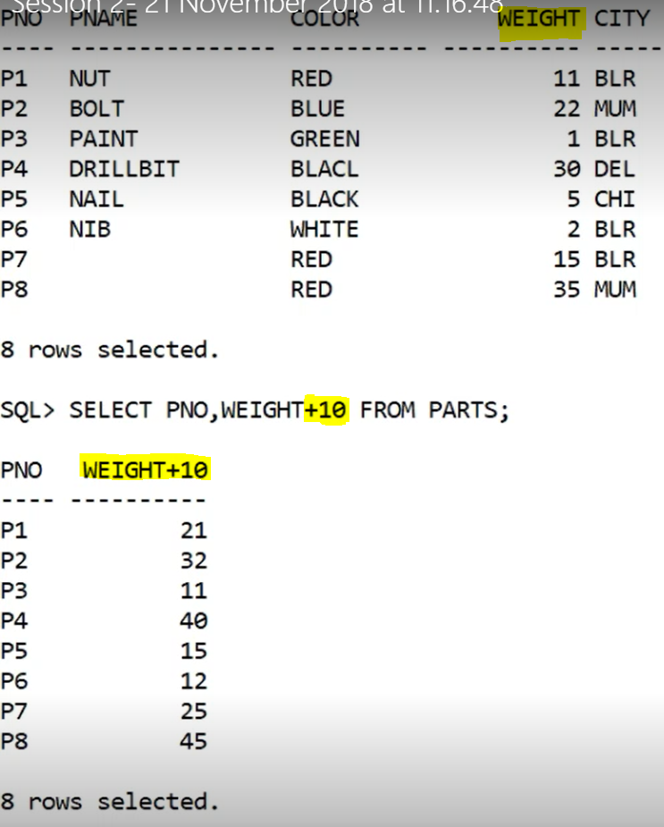

* In the below screenshot, in the 3rd column, the multiplication will happen first (10*2), then the weight will be added to the product of the multiplication. Similarly in the column 4, weight will be first multiplied with 10 and then the 2 is added to the product of the multiplication

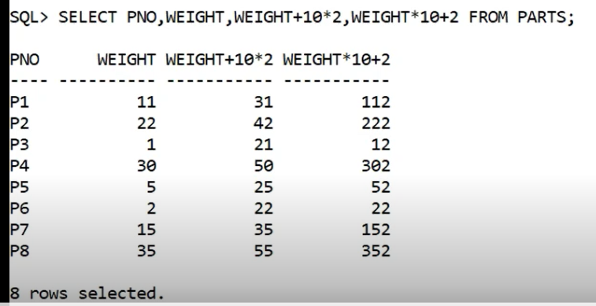

**3 Types of Operators:**

1. Arithmetic Operator: +, -, *, /… (to be used in the Select clause with the attributes)
2. Logical Operators: AND, OR, NOT (to be used in the Where clause to specify more than 1 condition)
3. Relational Operators: =,<>,>=,<=… (to be used in the Where Clause especially to specify the conditions)

**Order of execution**: 1. **Relational** (as WHERE is the first in executing order) followed by 2. **Logical** followed by 3. **Arithmetic**

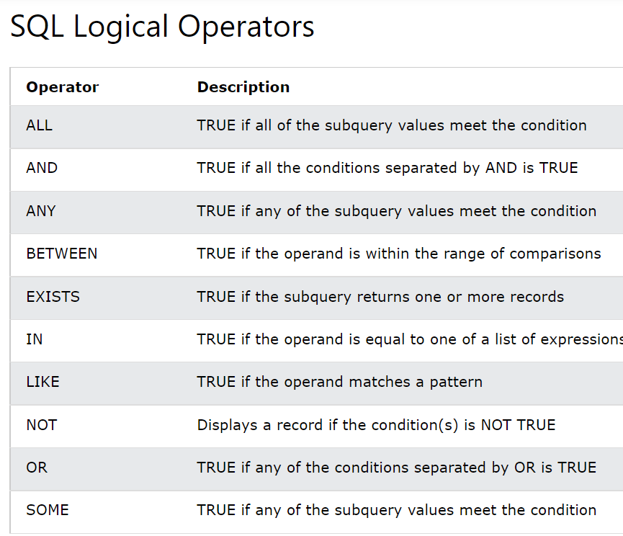

FROM is executed first in the Select command (1st in order of executing sequence) and then WHERE is executed and then SELECT clause.

* To Select the values that has null use the yellow-highlighted command

AS is an operator the used to create the aliases/duplicates and IS is the operator to retrieve the null values.

‘ ’ & ‘ “ & NULL are different

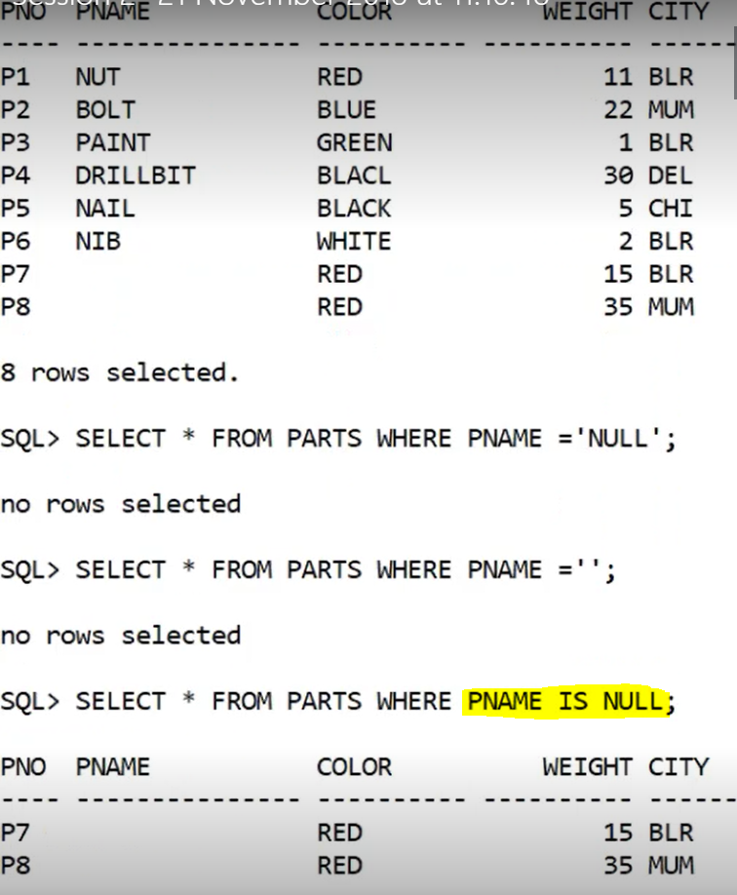

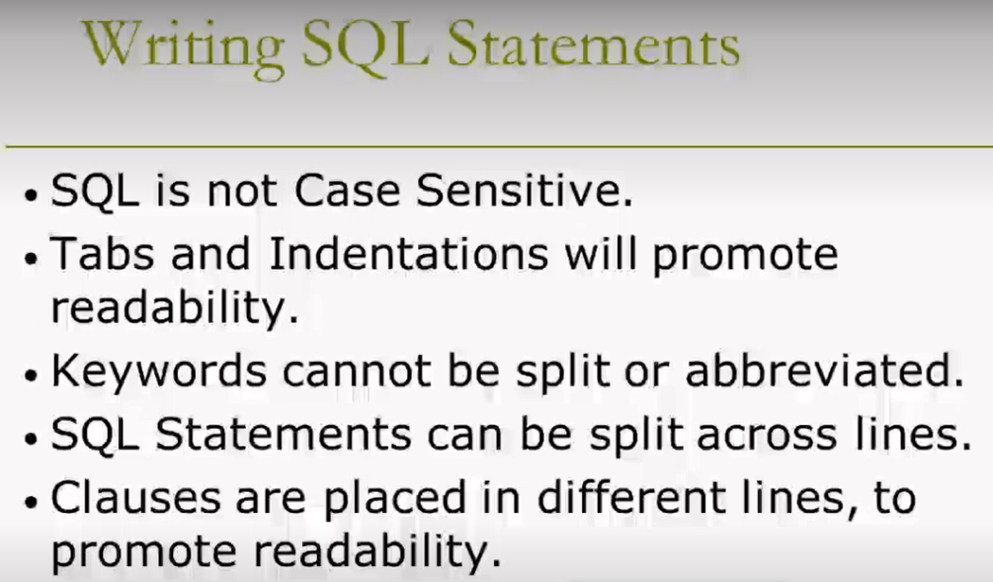

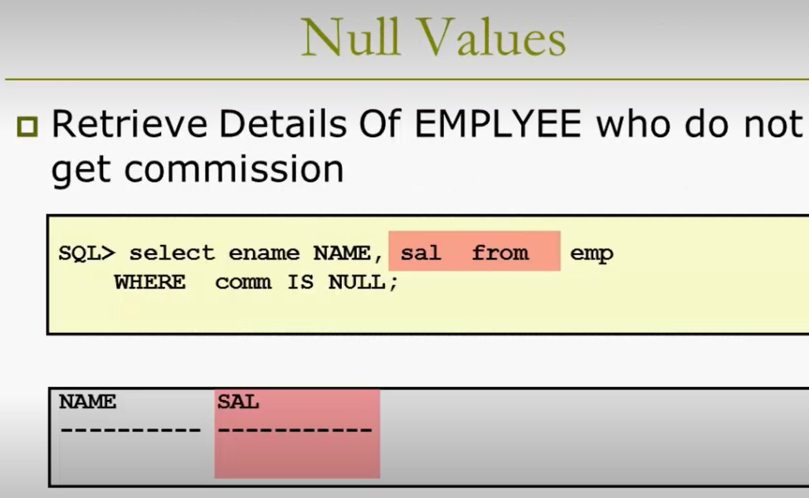

**Session 10**

**Session 3- 21 November 2018 at 13:28:38**

* **Null values**: To retrieve the null value we need to use IS operator – If we use Avg in null column values, this Avg operator will not consider the null values
* Reasons why do don’t maintain Null valued columns:

1. Although we didn’t supply any value, it has dedicated memory allocated (some block is specified for it)
2. Its not possible for us to perform **Aggregate Operations (the output of these functions is always 1 value ex. Total, max, min, ave… these functions operate on the column of the table)** on null columns – in select command, do NOT try to fetch the whole column and aggregate count/sum

**3 Types of Operators:**

1. **Arithmetic Operator**: +, -, *, /… (to be used in the Select clause with the attributes)
2. **Logical Operators**: AND, OR, NOT (to be used in the Where clause to specify more than 1 condition) – Order of precedence is Not, And, Or
3. **Relational Operators**: =,<>,>=,<=… (to be used in the Where Clause especially to specify the conditions) – These are all single-value comparators (the right hand side should be having only 1 value and if there are >1 value to compare, we need to use multi-valued comparator like IN)

**Order of execution**: 1. **Relational** (as WHERE is the first in executing order) followed by 2. **Logical** followed by 3. **Arithmetic**

FROM is executed first in the Select command (1st in order of executing sequence) and then WHERE is executed and then SELECT clause.

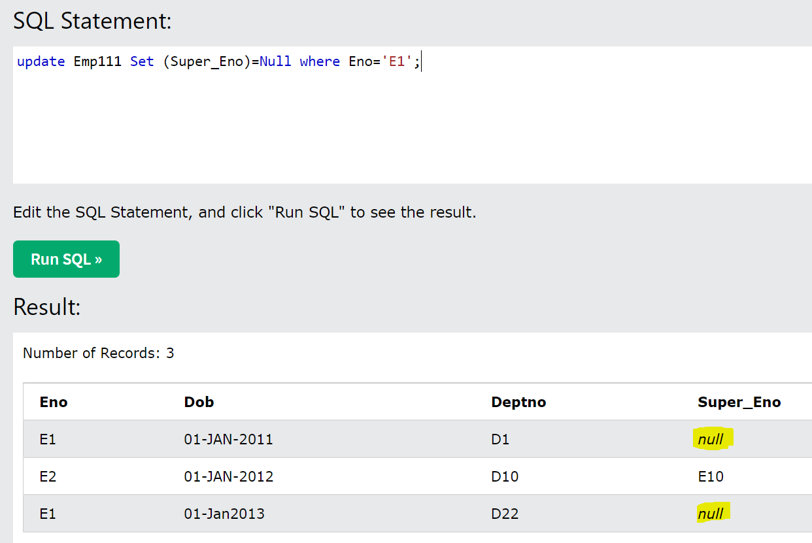

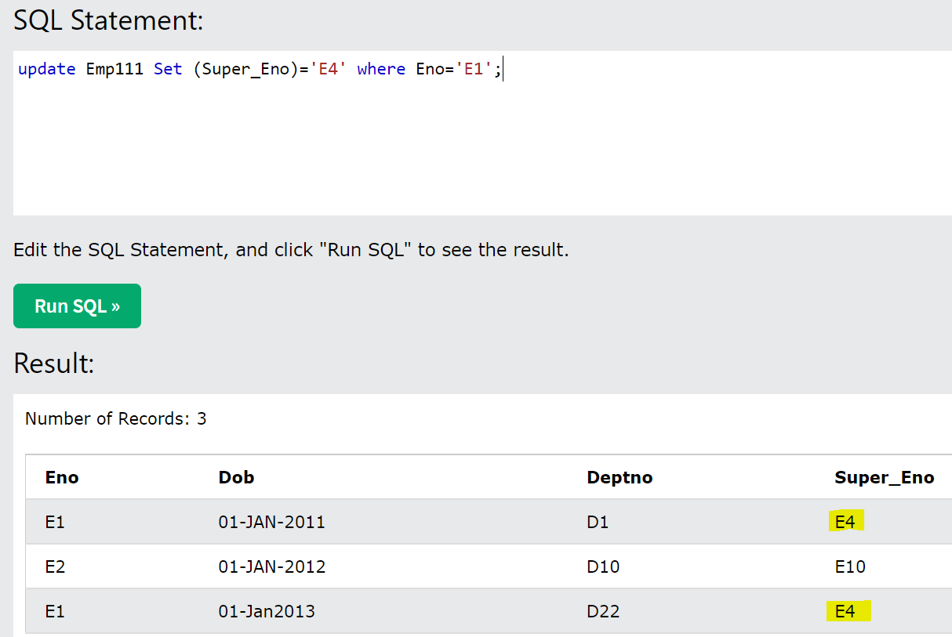

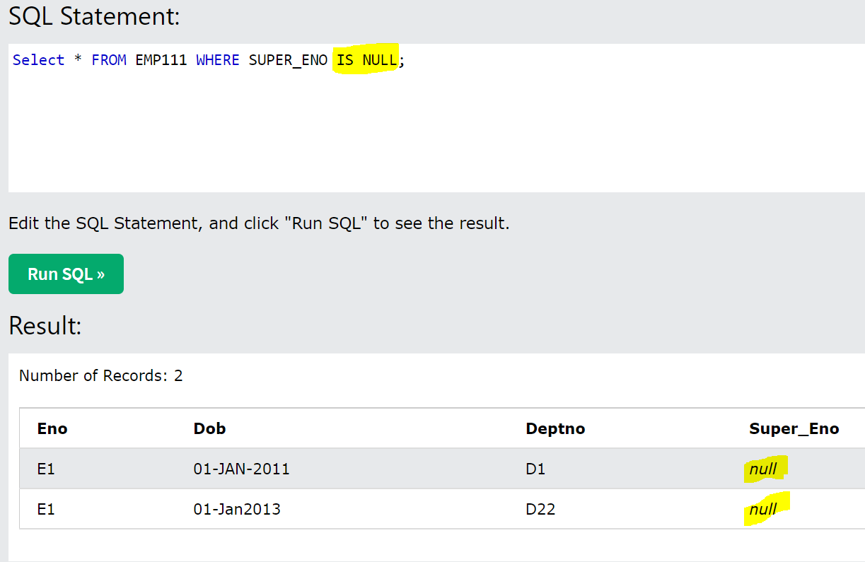

* Specify in single quote if you want to select only null values in a table

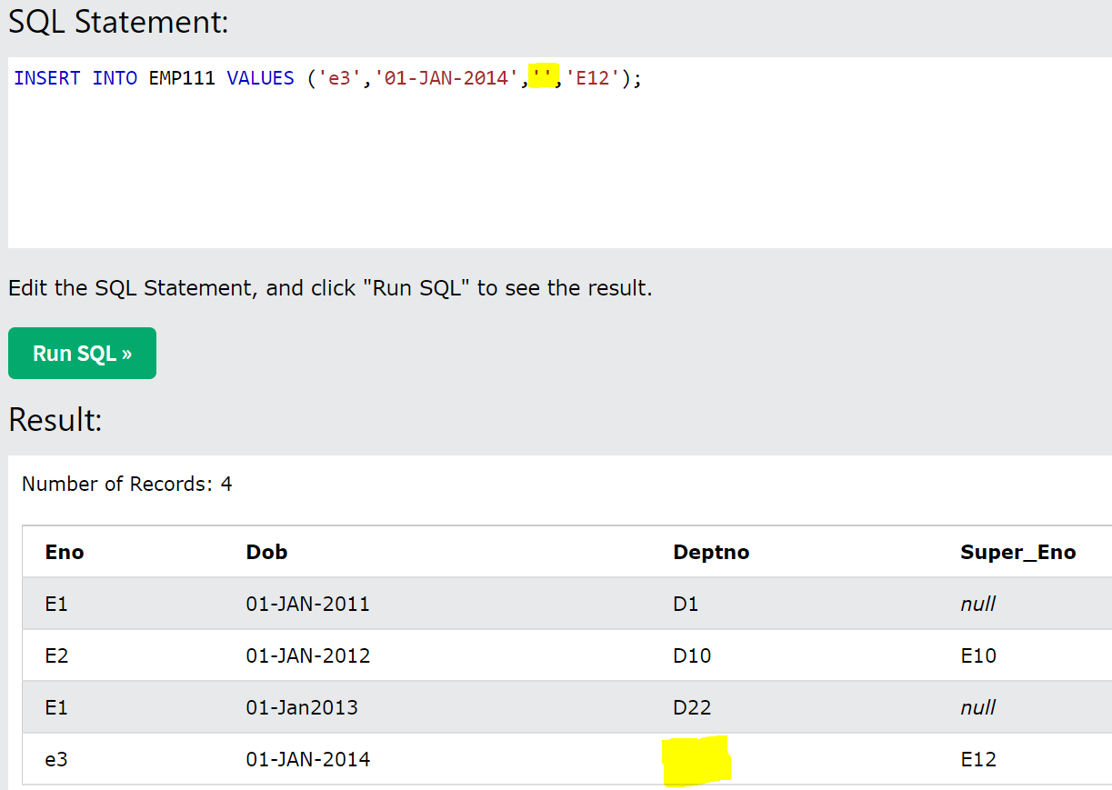

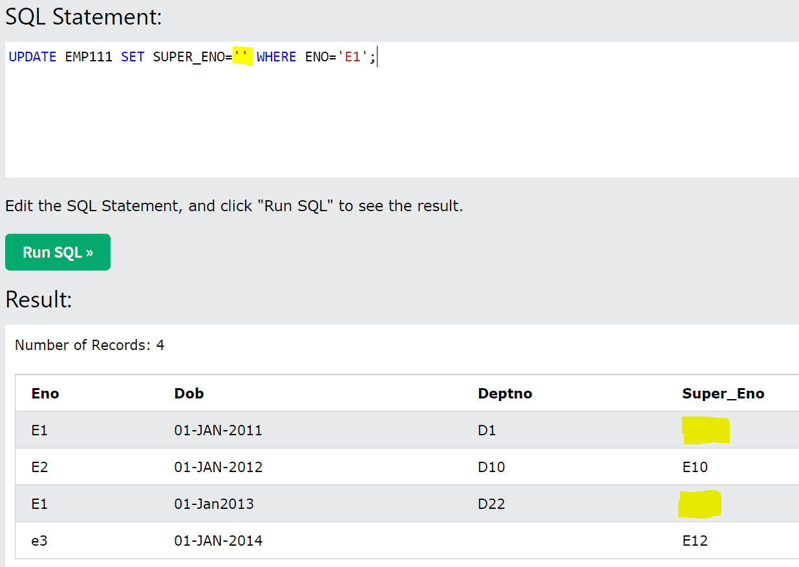

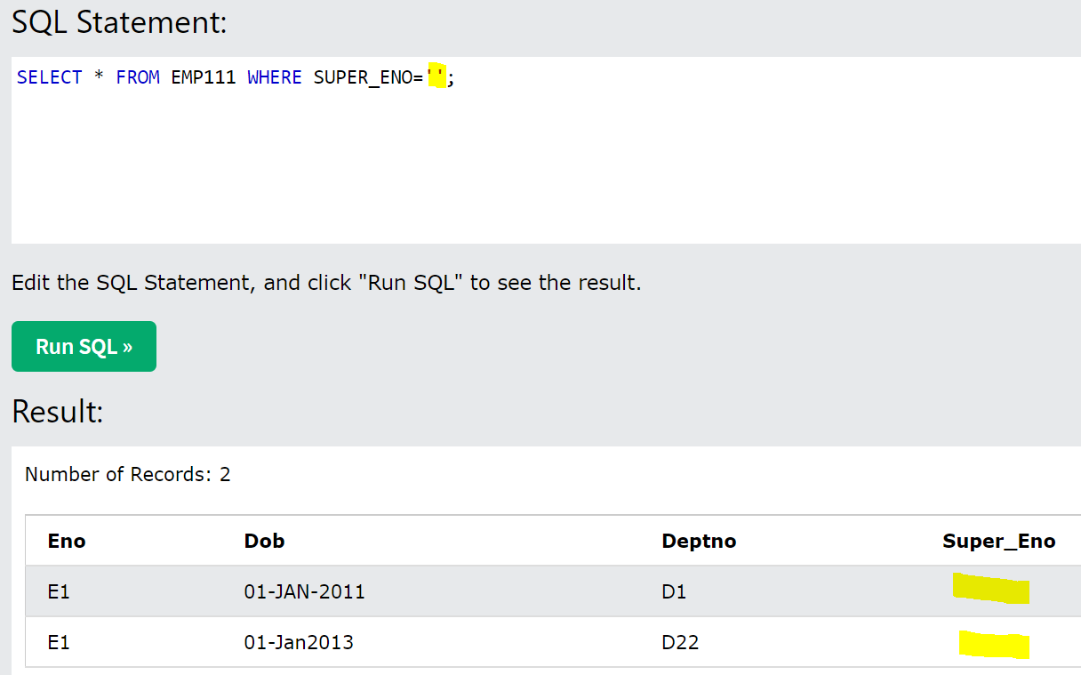

**To get the sum of a column:**

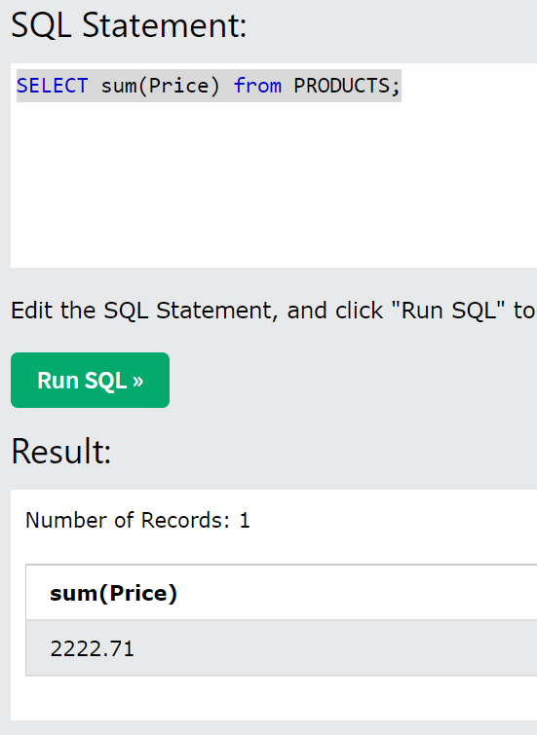

**To select only the count:** The count will fetch the column value count, even though we specify nulls in this column – Count of DOB is count in the no. of elements in the DOB column and if we select ‘Count (*)’, we will get the total no. of rows

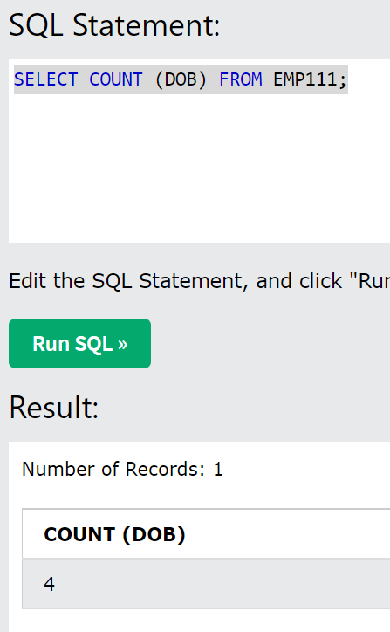

**Max:** to find out the maximum of the column and use Min to get the minimum number in the price column (**Min will not give the null values) – Use AVG for average**

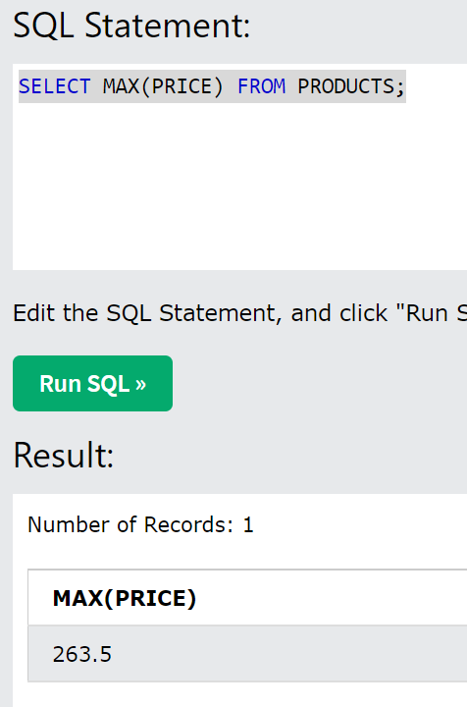

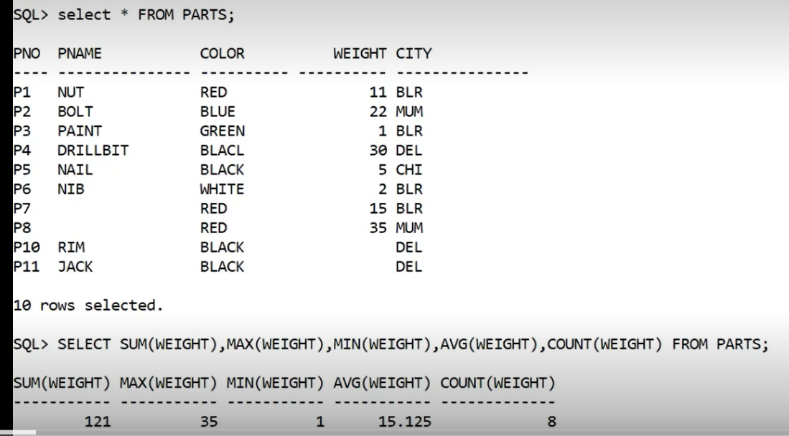

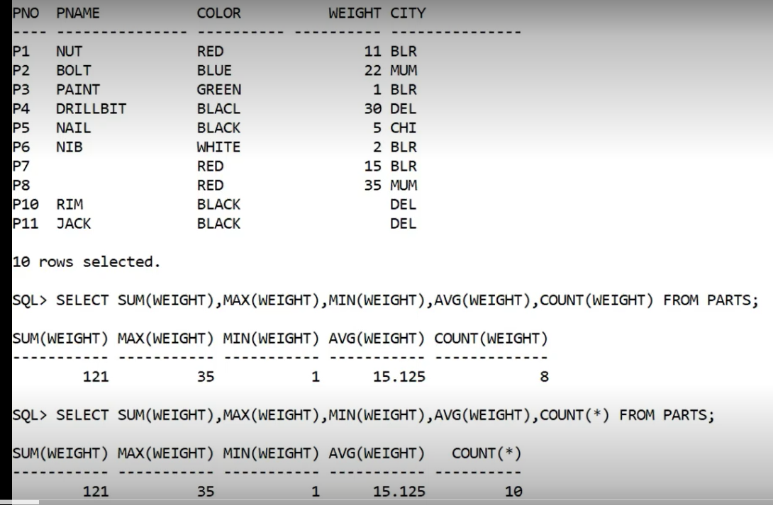

* **NVL Function**: stands for Null VaLued – its going to replace the null values as 0 for computation reasons – it’s a function used in case of null values to effectively perform aggregate operations – it will consider null value as 0

**Syntax:** Select * Avg(NVL(<ColName>,0) from <TableName>;

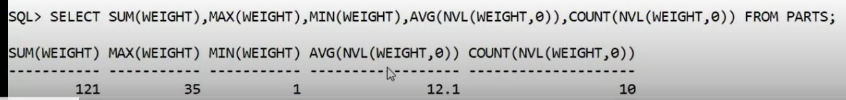

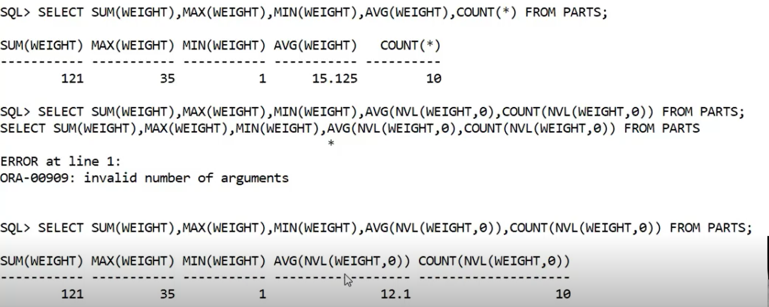

* We can create the alias by using AS operator (its only for display purposes and this is not going to affect the physical storage)

Ex.: SELECT PNo AS PartNumber, Pname “Name” Weight WT FROM Parts;

**3 different ways we can create Alias: See combined screenshot below**

1. As operator
2. Specify in double-quote = Anything specified in double quote is constant
3. Specify alias column name after the actual column name

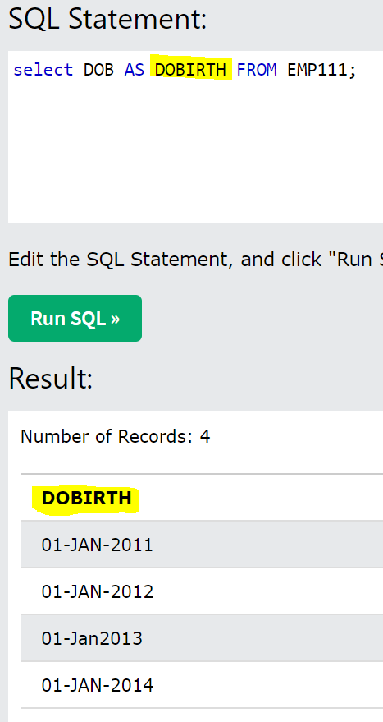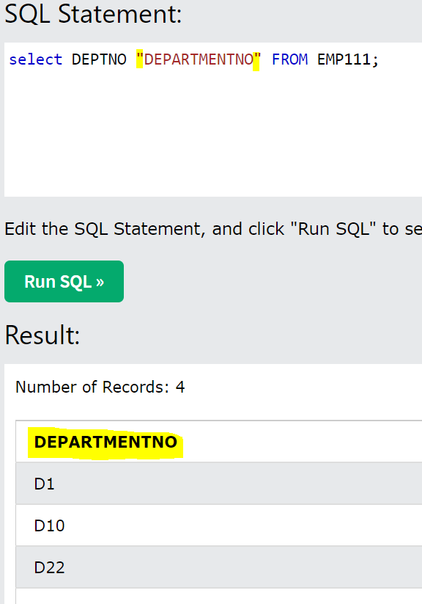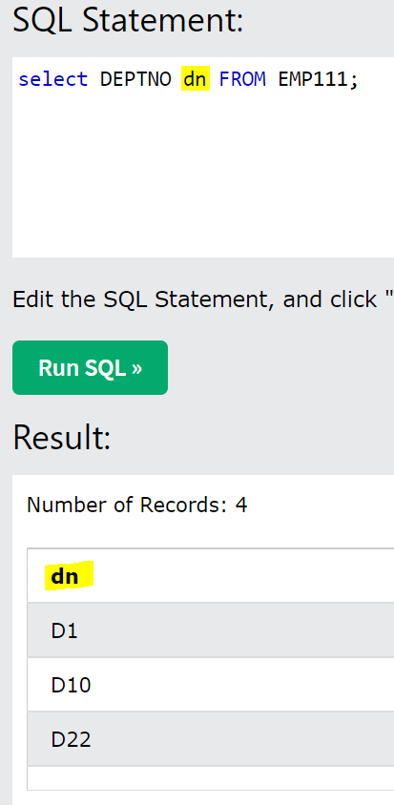

* **Concatenation:**

We can concate any text with the ColumnsNames and prepare the report

**Syntax**: SELECT Col1 || Col2 || Col3 FROM T.Name;

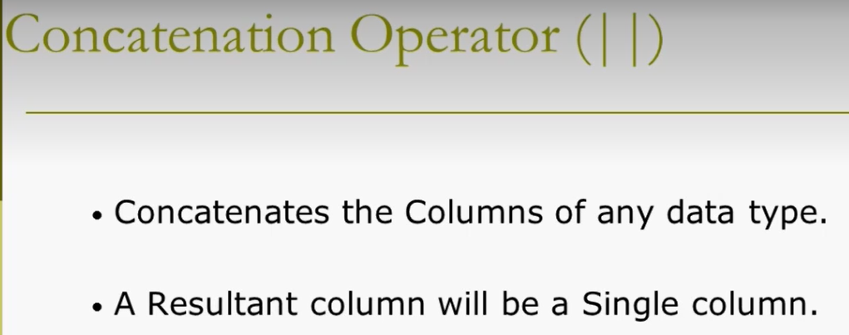

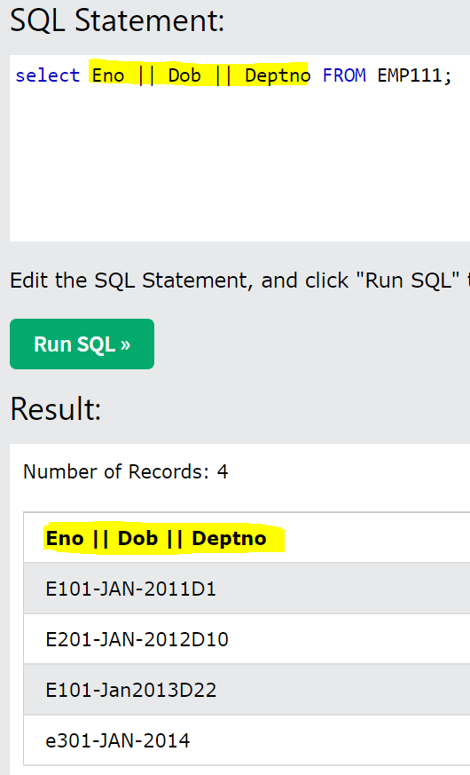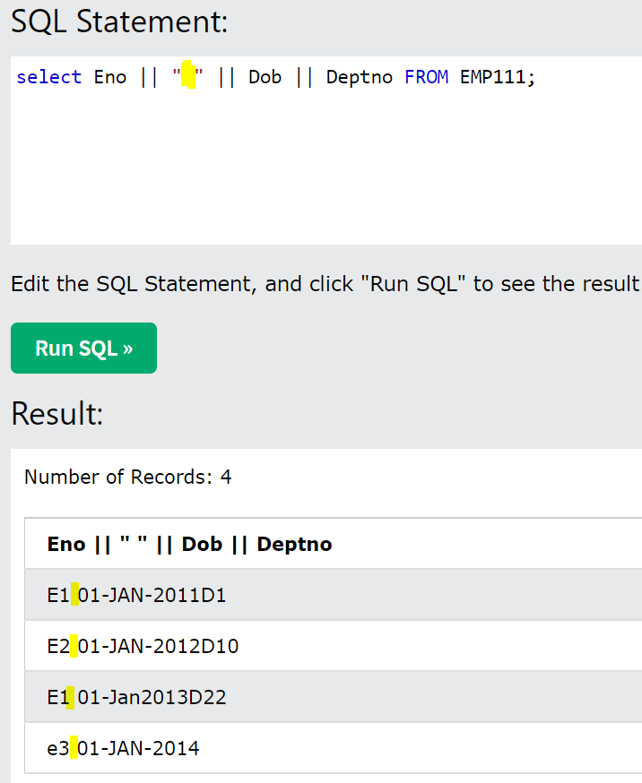

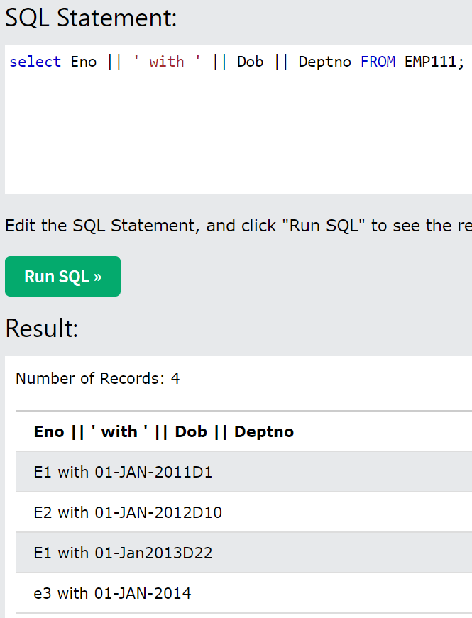

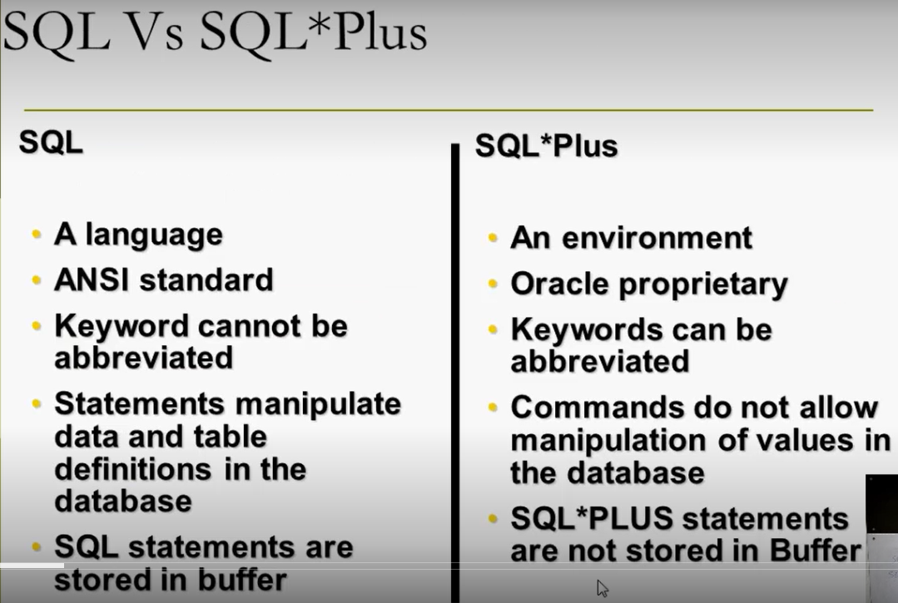

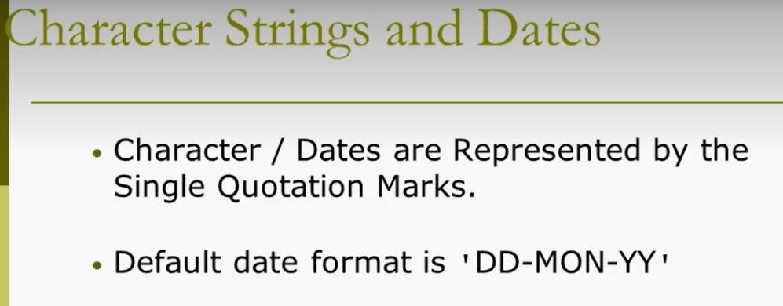

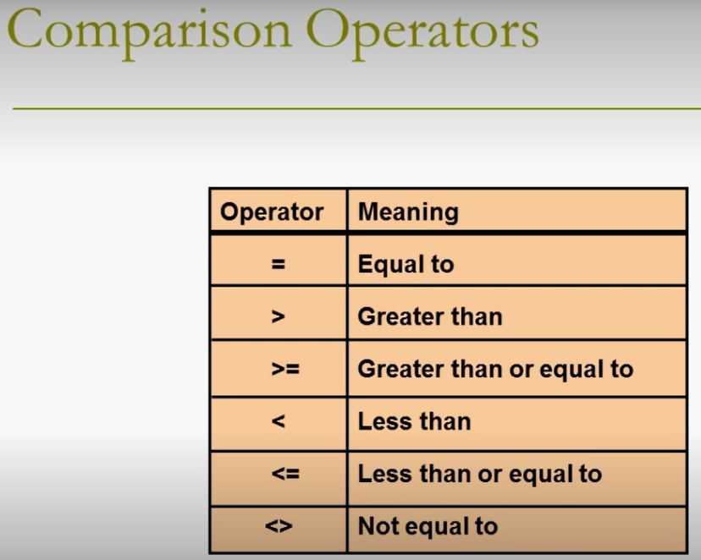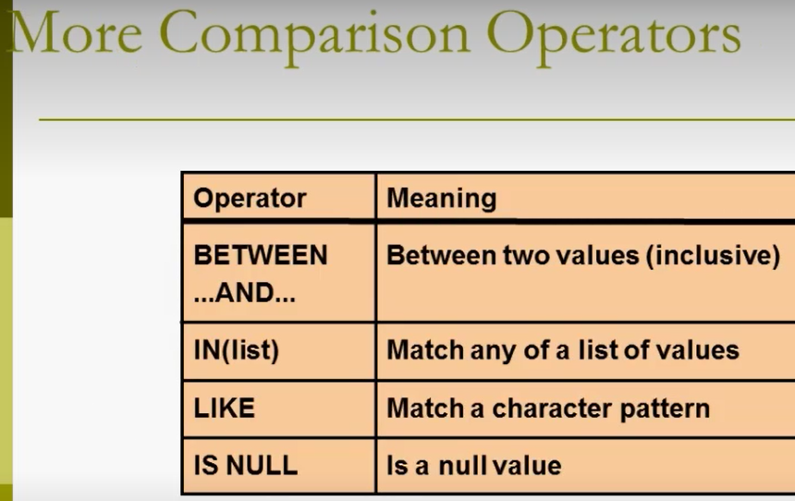

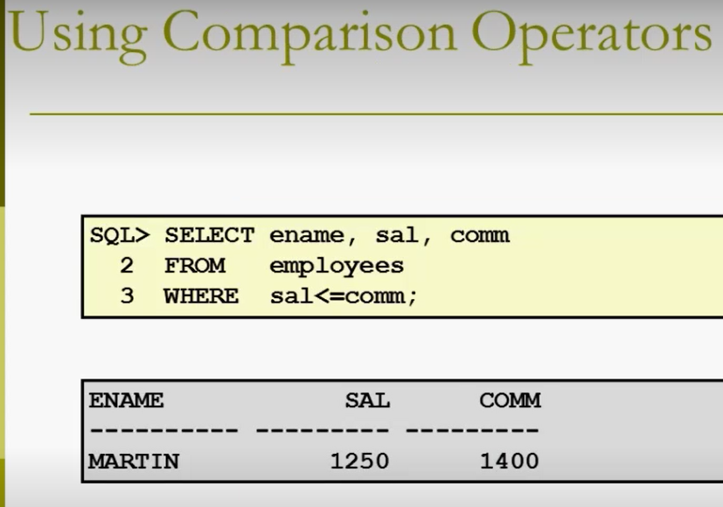

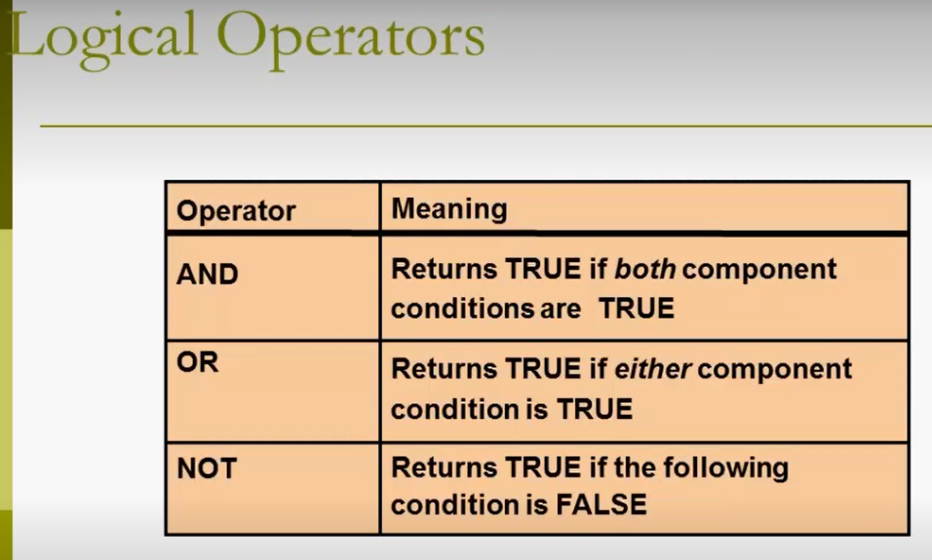

* When the query has SELECT, FROM & ORDER BY clauses, the order of evaluation is FROM, SELECT and last is ORDER BY clause – That’s the reason even though the **Total** **column** is a derived attribute, the order by is successfully performing on the Total column.

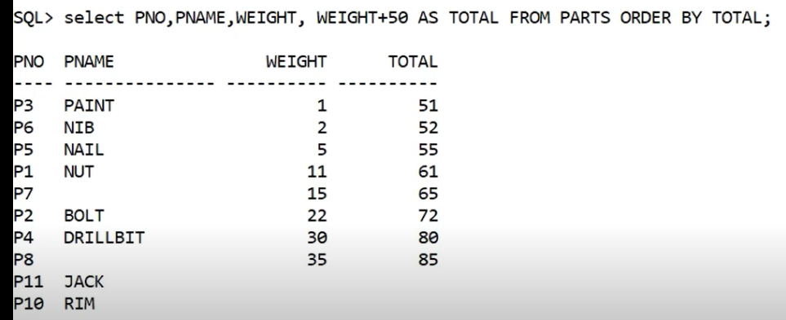

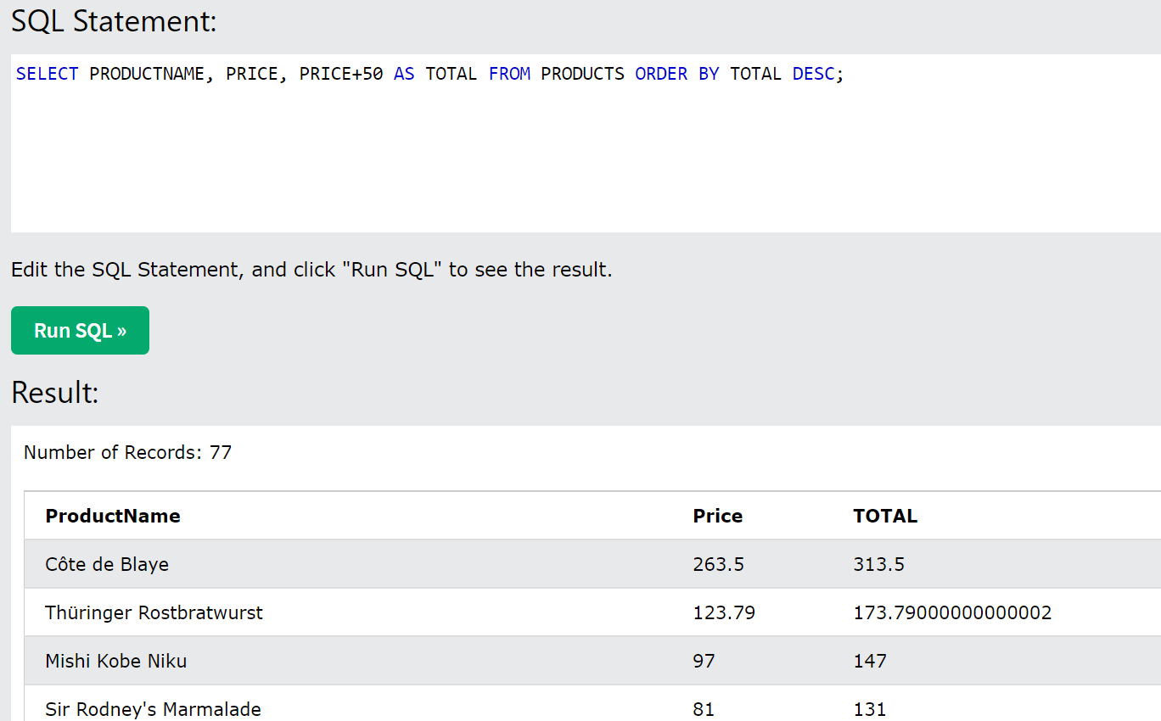

* In The below screenshot, we can also mention the column number (6 in this case) to get the values

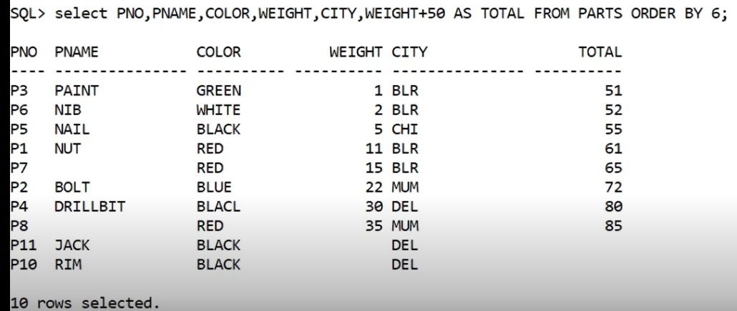

* We can also mention multiple columns in order by – But the only caveat is the second column City is sorted as per the first column – ex. We have 4 blacks and city is sorted in ascending order within this black

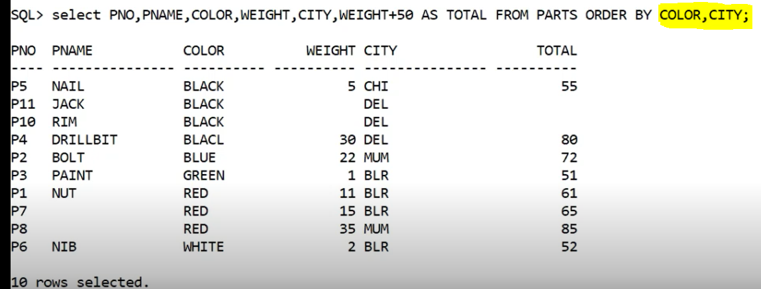

* There are some built-in functions which can be used to perform some routine operations and those functions are 2 types:

1. **Single-row functions**: Functions which operate on/work on single row - Types of single-row functions are listed below
2. **Character Functions**:
3. **Character Conversion Functions**: EX: UPPER, LOWER & INITCAP (initial character will be capital and rest is small) – These can be used either on tables or on any strings as well – INITCAP is not a function in MySQL
4. **Character Manipulation Functions**: EX: CONCAT/||, SUBSTR, LENGTH, INSTR, LPAD, RPAD etc – These are used for reporting purposes only

* **SUBSTR:** Substring – it’s a part of string – it takes 3 parameters (refer screenshot below) – 1st is the string from which you want to extract the part, 2nd is the starting point from where you want to extrack and 3rd parameter is the no. of characters that you want to extract
* **INSTR:** In string – whether a particular character is present in the string – it has 2 parameters (refer screenshot below)
* **LPAD:** it has 3 parameters (the conditions mentioned in the braces) – 1st parameter is String/Attribute – 2nd parameter is the size of the character you want and 3rd parameter is something what should be filled in the vacant positions
* **Length:** it takes only 1 parameter
* **LPAD:** Left aligns the data – 3 parameters – 1ST is the attribute name, 2nd is the max length of the attribute, 3rd is specify the character which has to be padded/added
* **RPAD:** Right aligns the data - 3 parameters – 1ST is the attribute name, 2nd is the max length of the attribute, 3rd is specify the character which has to be padded/added
* **TRIM:** 2 parameters – 1st is column and 2nd is the trimming value

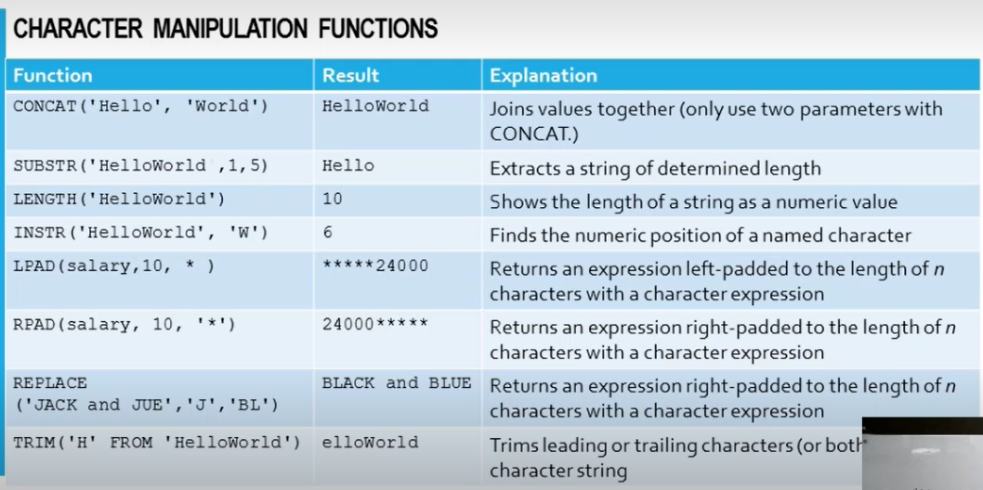

* Its not possible to combine aggregate column (if we use any of the aggregate functions) with the non-aggregate column, it will give an error – we need to use group by function which is a clause that will convert a non-aggregate col into a aggregate column – When we want to combine a non-aggregate with aggregate, we must use group by
* PK attribute cant be group, as it is already unique column
* Grouping should only be done when there is a repetition of values in non-pk column

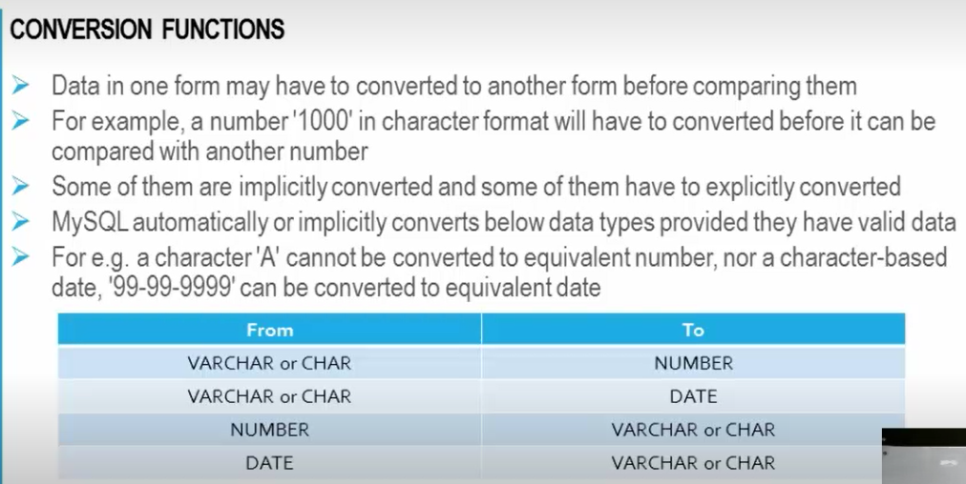

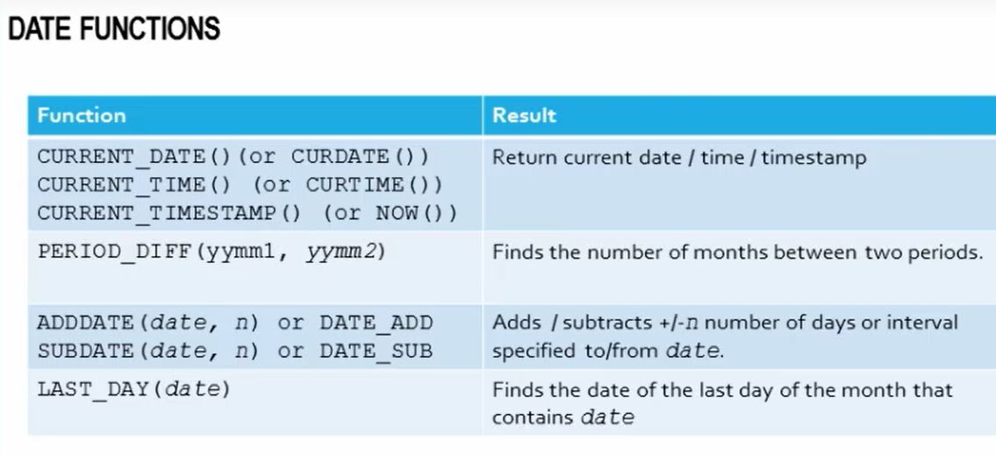

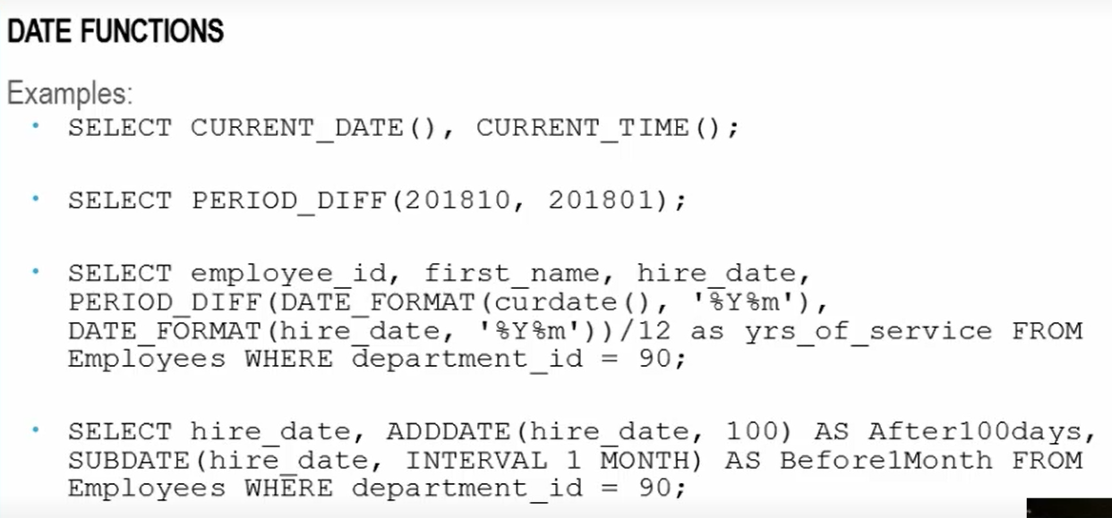

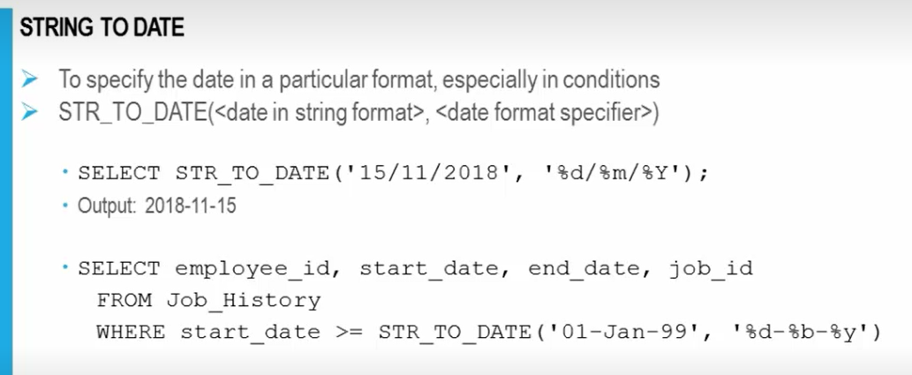

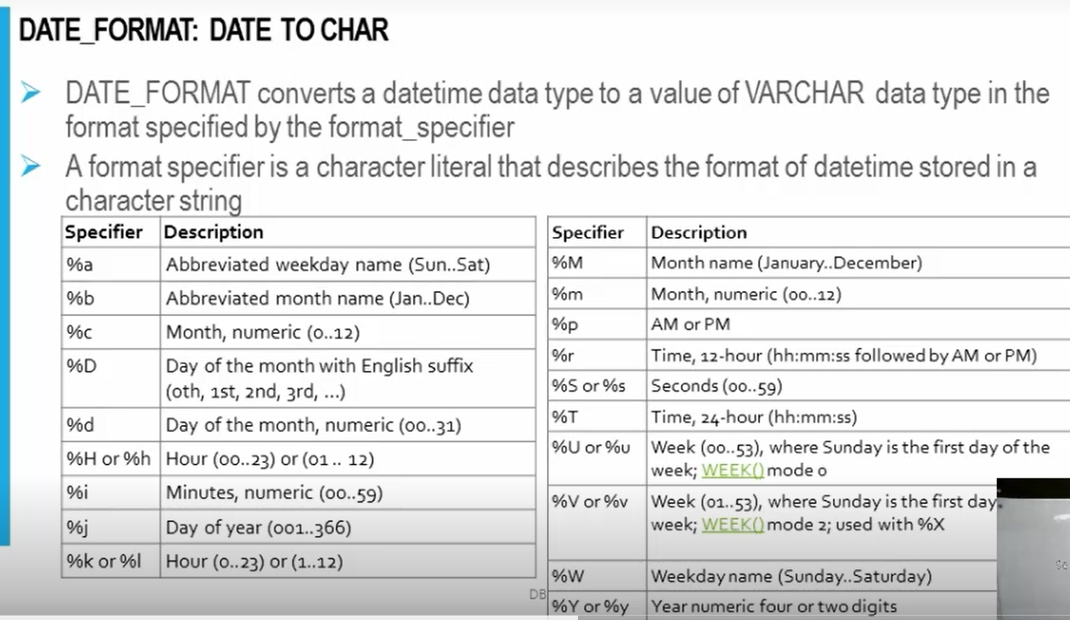

For Oracle, Jane in lower case is not the same as in Upper case, whereas the MySQL is not case-sentitive

1. **Number Functions**: See screenshot below:

* **Round**: has 2 parameters
* **Trunk**: This does not take into account, how close the value is to the next value – its just chop off
* **MOD**:

1. **Date Functions**: See screenshot below
2. **Conversion Functions**:
3. **General Functions**:
4. **Multiple-row functions**: Operate/work on multiple rows

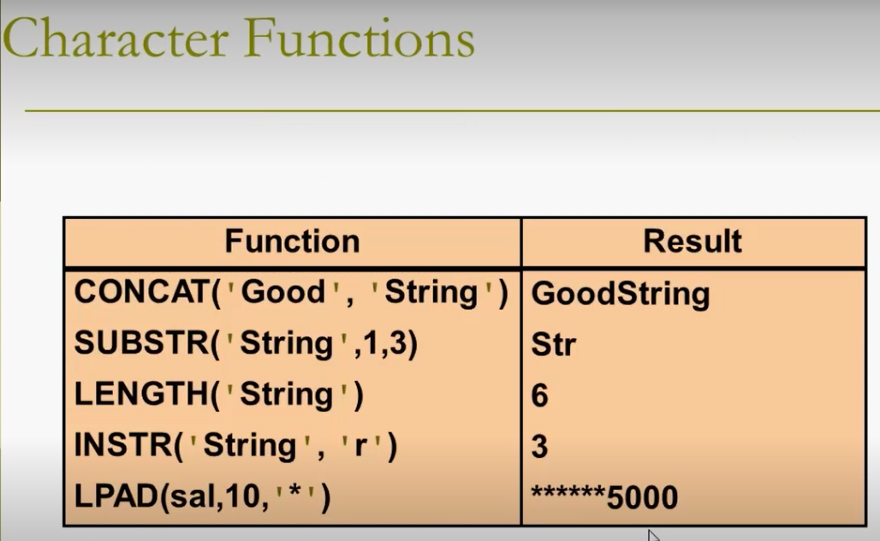

* In Oracle there will be a dummy table called DUEL with 1 row and 1 column with datatype VARCHAR – this table is used to perform any simple/trivial operations (in MySql, there is no need to specify “dual” in the command)

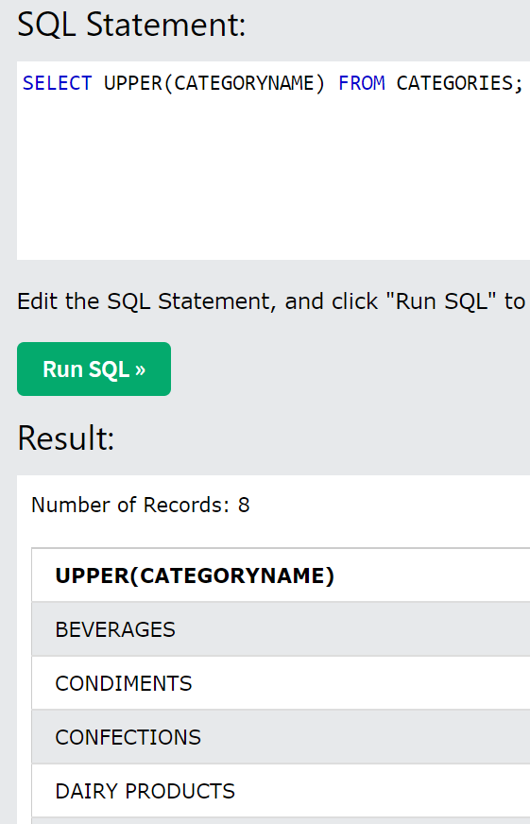

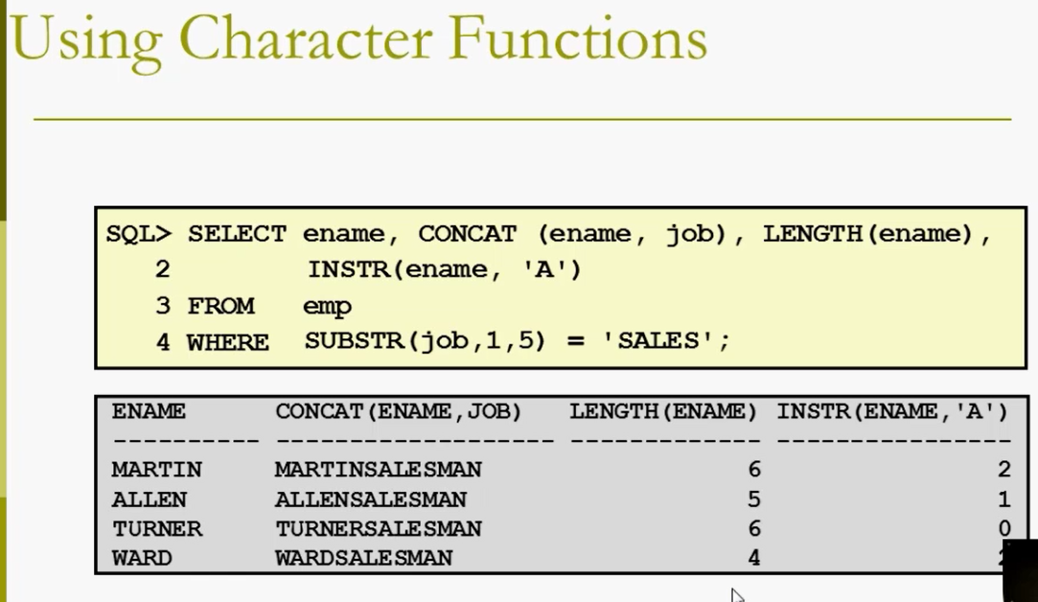

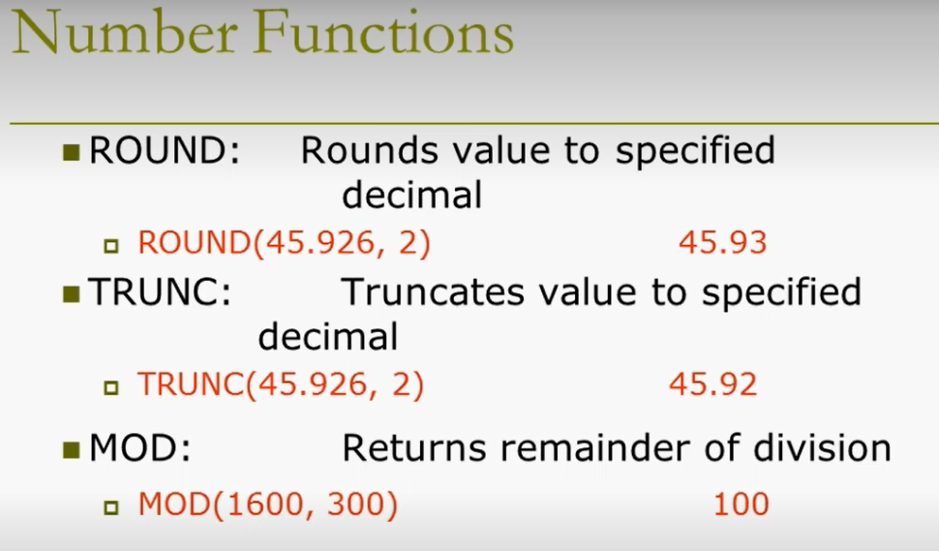

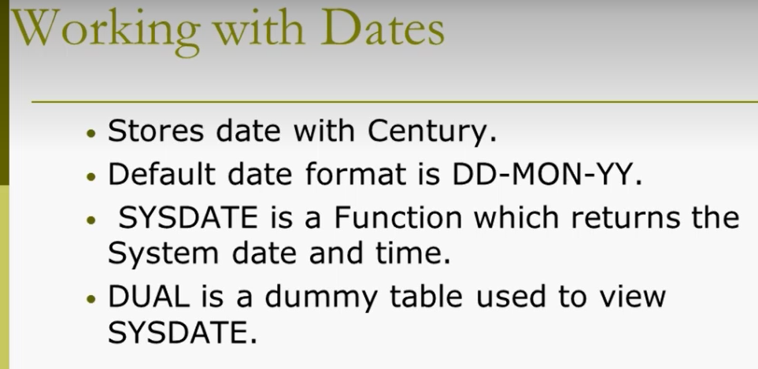

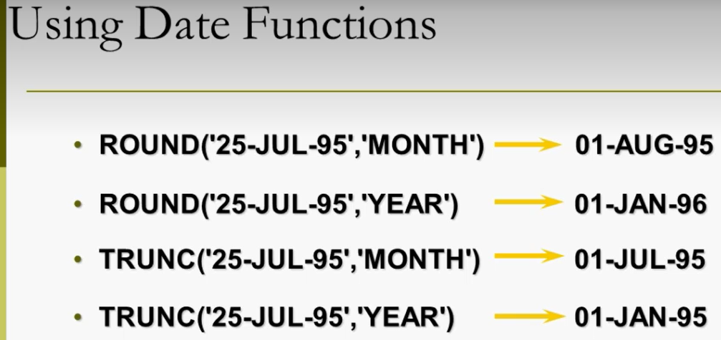

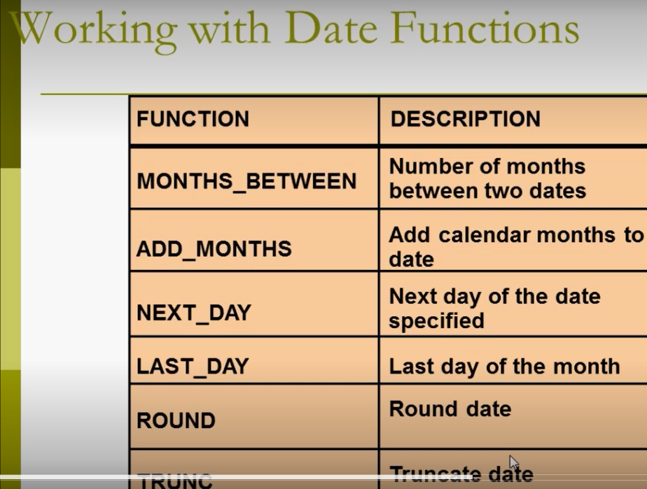

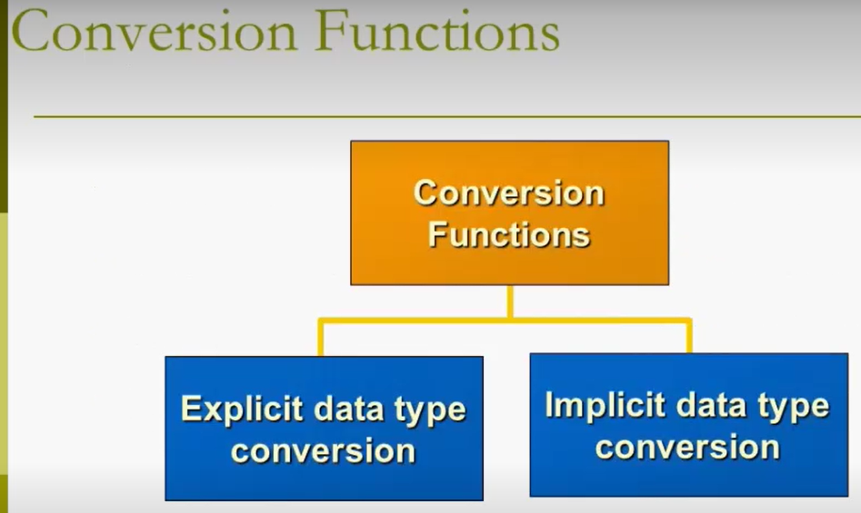

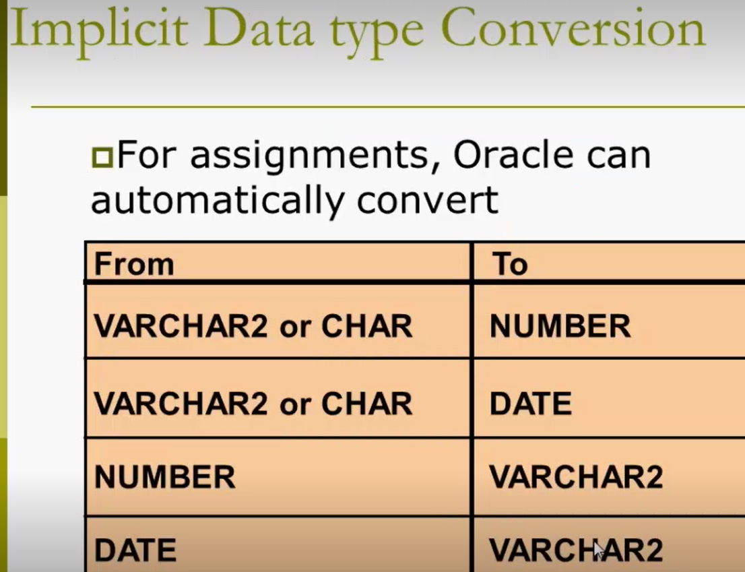

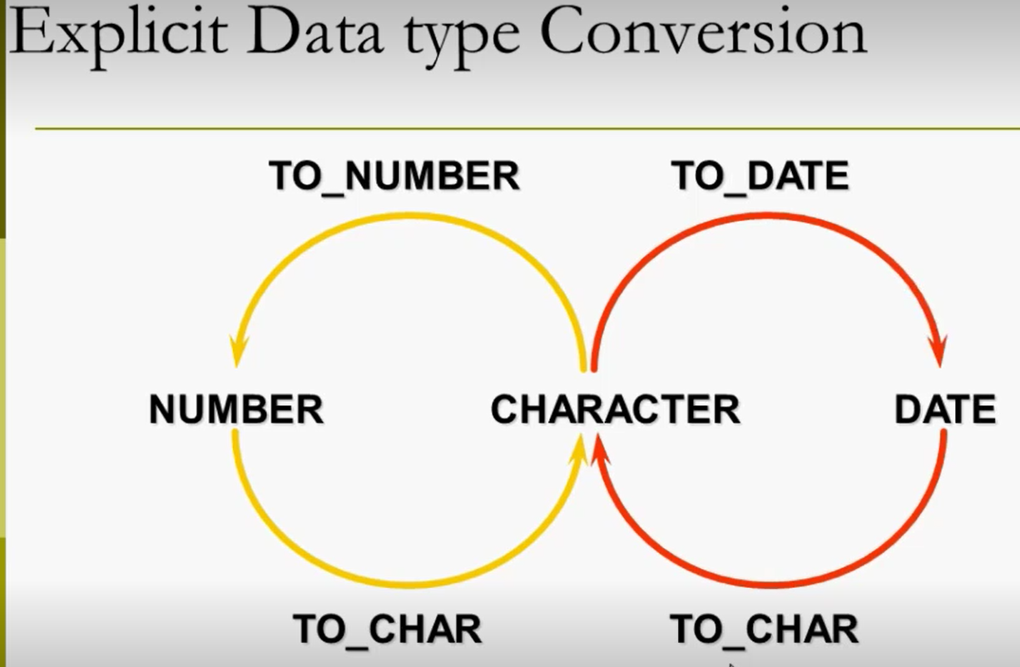

* **Decode Function:** Instead of using multiple OR statements, we use this – there is no decode in case of MySql, for this we can specify using CASE

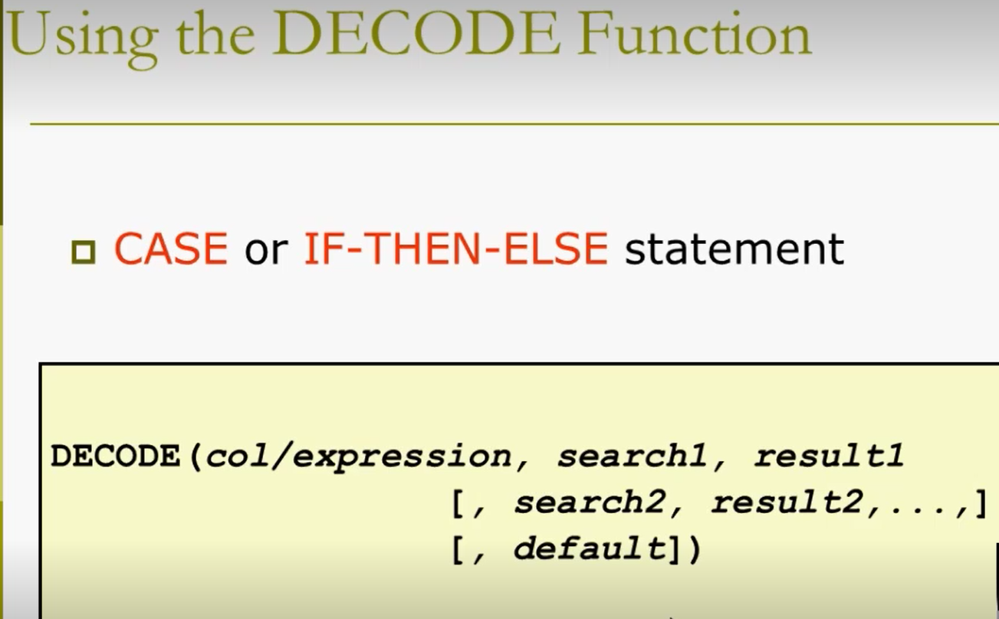

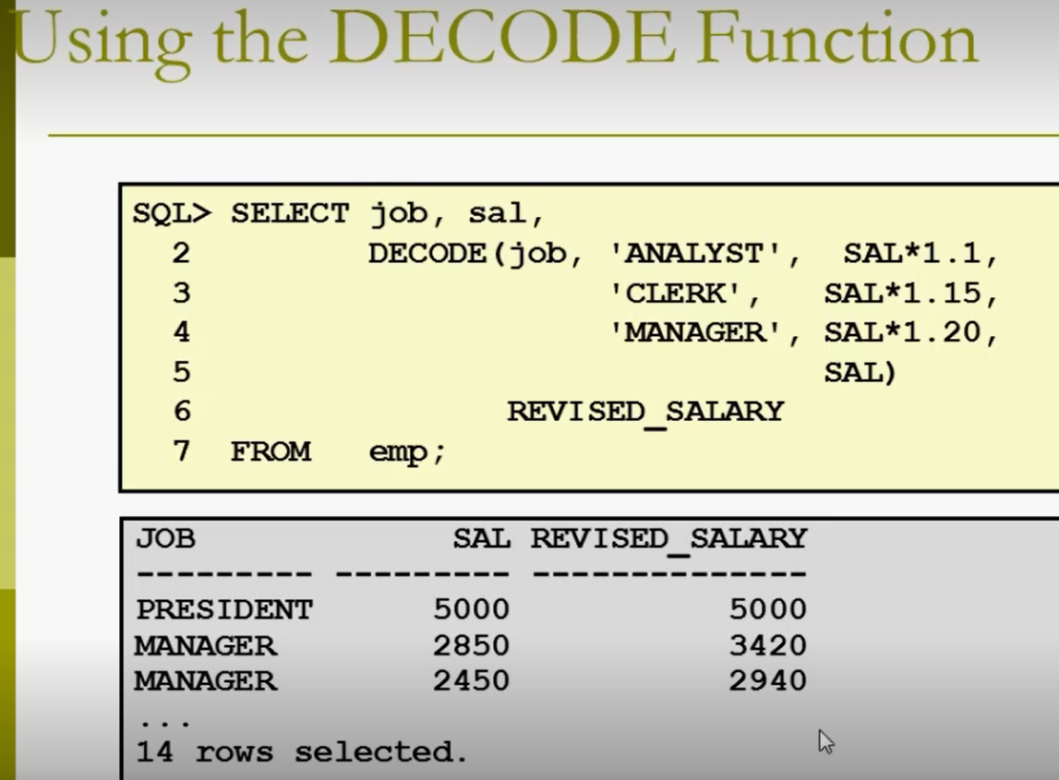

* **Joins**: when its not possible for us to fetch the data from single table, we must join the tables – we use this when the data we want is spread across more than 1 table

Its datatype of 2 columns that defines whether these columns are same or not (not the col name)

The datatype should be same for both the columns to join – but the database guidelines says, we should perform joins based on PK-FK r/s only and if you perform this non-pk-non-fk, it leads to spurious/illogical/invalid tuples

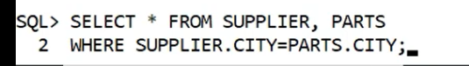

The output for the above select clause is 15 rows

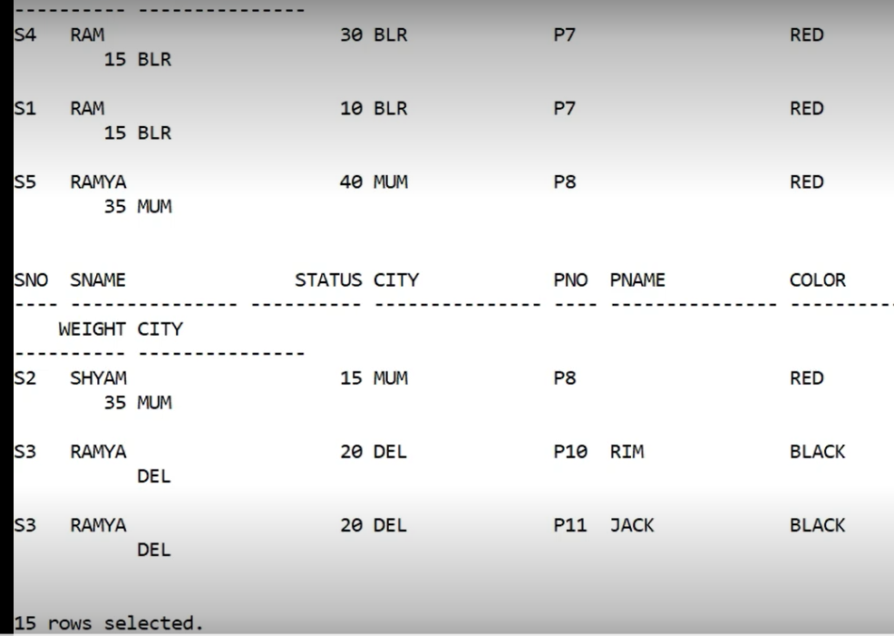

* In the below example, we are joining the 2 tables based on PK and FK
* **If we join the tables based on Non-PK and FK, it gives you illogical values – we call this as Spurious Tuples – in order to join the table, the min requirement is to have a same data type and join the tables based on PK and FK, so all the valid rows will come up**

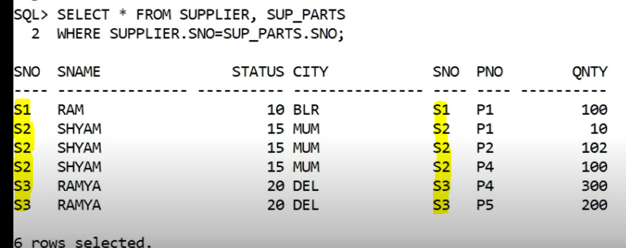

* **Cross Product or Cartician product**: Two tables are clubbed together (not joined ) and giving all the possible combinations – below is the example wherein we are selecting 2 tables, but it will give 50 rows (actually we have only 10 rows in Supplier and 5 rows in Parts table) – Cartician doesn’t require any condition like Where



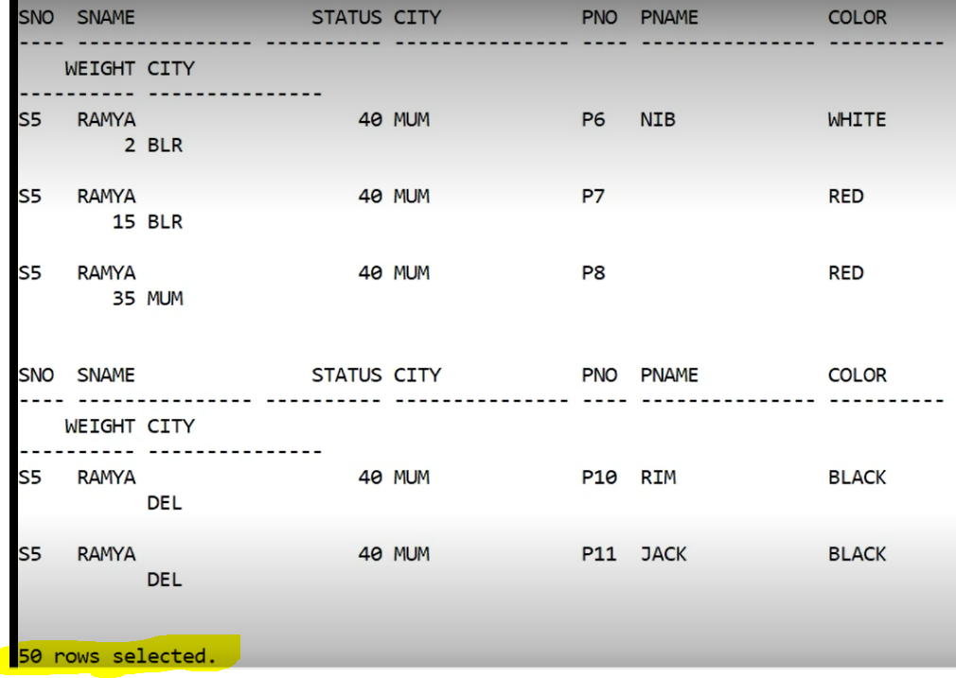

* If you select two tables as shown below, it will merge

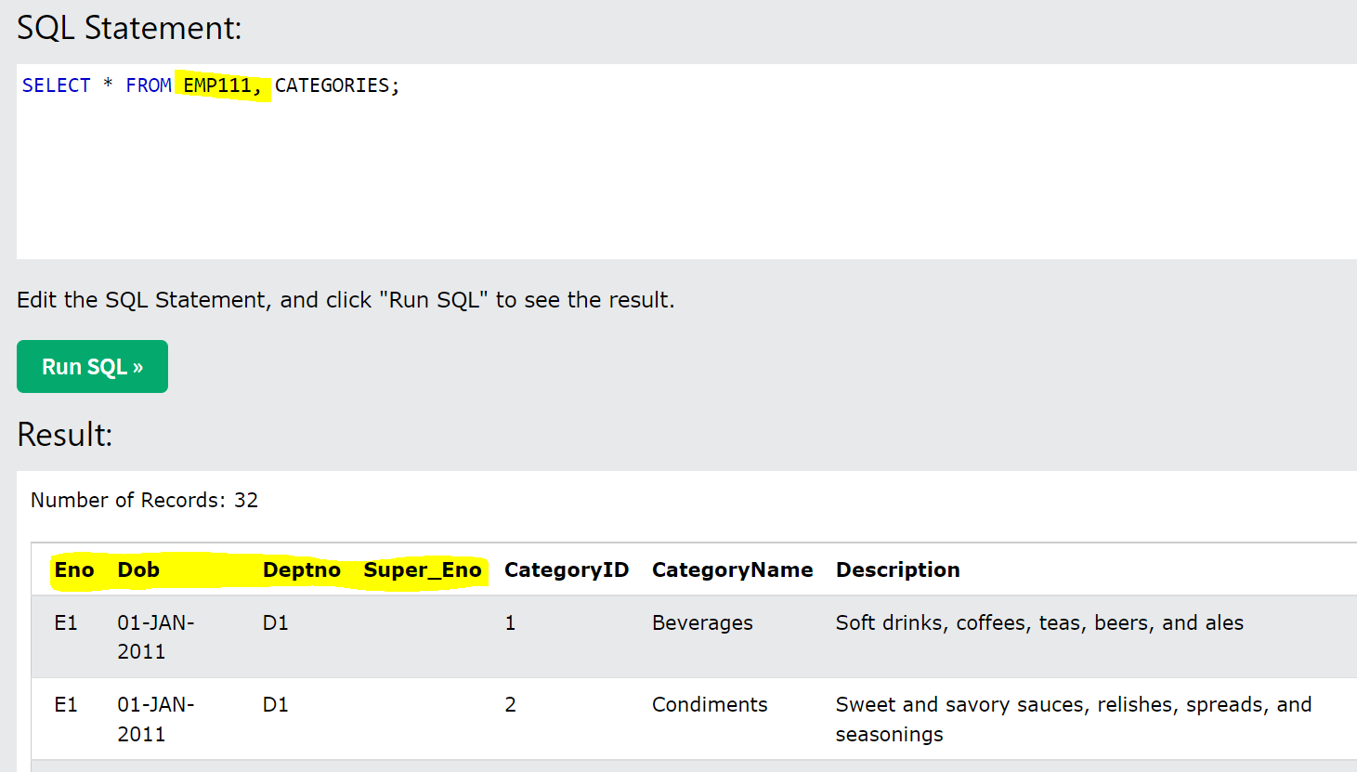

* When you use the Cartician product, you will get like in the below screenshot – no of records are 101528 which is product of 518 and 196 (records in OrderDetails and Orders tales resp.)

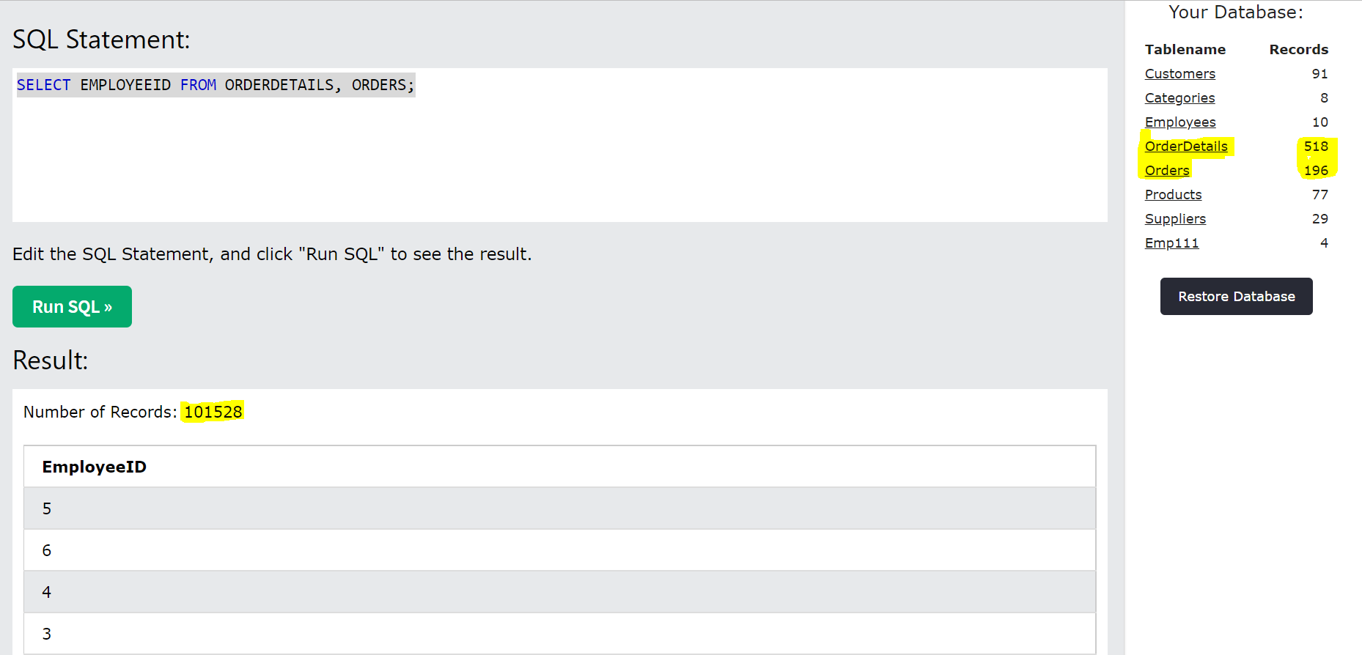

* When you must join two tables and get the values in 1 column, then use the below formula:

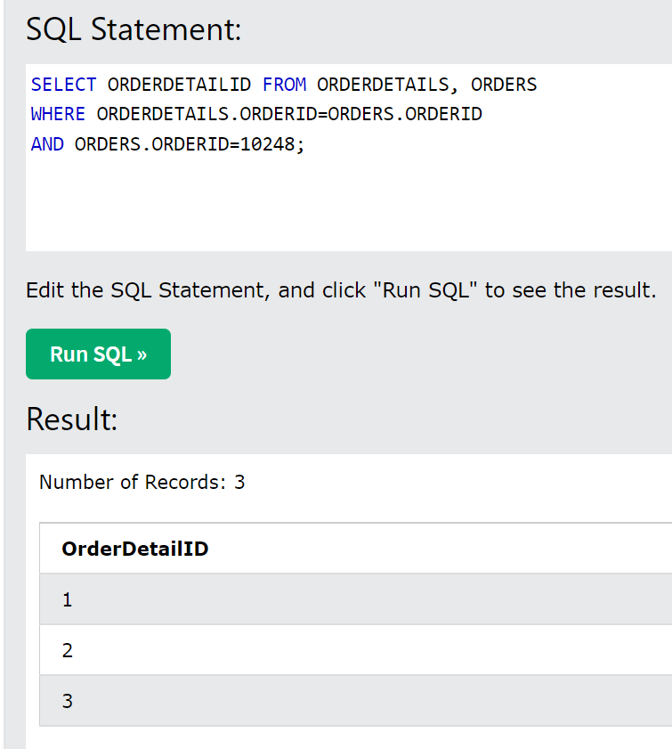

* If you try to insert 5 in the countries table in the below screenshot, it wont accept, because its FK/Child – unless we have 5 in parent (regions table), the Countries table wont accept new value in region_id column (the error wil be ‘Parent Key Not Found’)
* Also, if you remove any value in Region_id column in Regions table, it wont accept because the child cant be orphan in Countries table – if we need to remove value in Region_id, then we need to kill the parent first (remove region-id col in countries table)

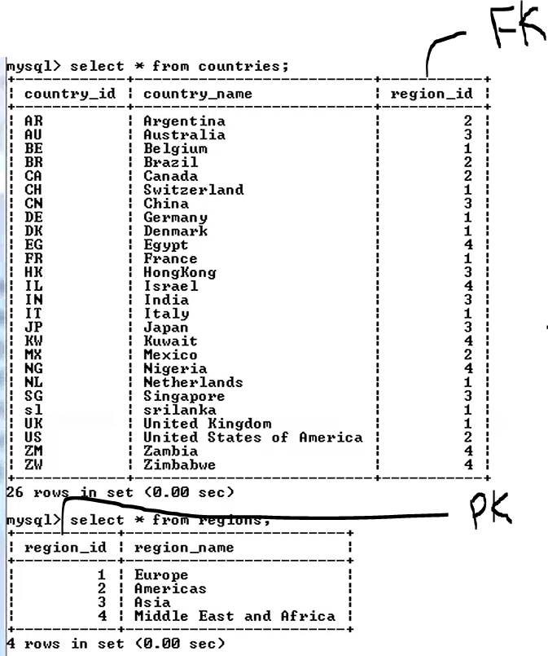

* In the below screenshot, if you want to filter the right table (supplier1), then give condition in ON filter only and later you can give condition on left table by using where.e

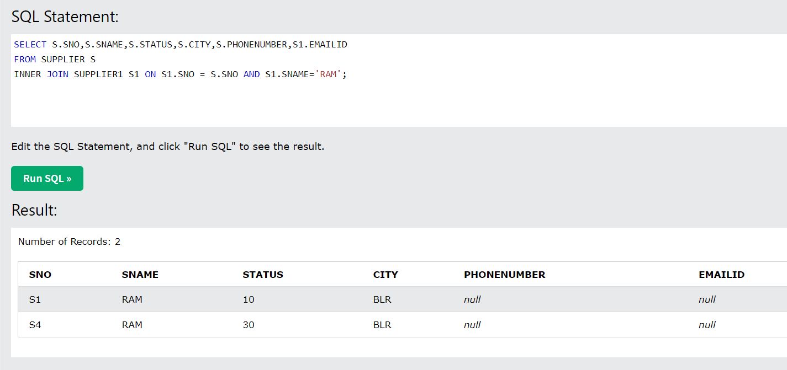

**Database guidelines for Joins:**

* Join the tables based on PK and FK
* Specify the joining condition while joining the tables (based on these conditions we categorize joins into various types)
* Renaming table names with alias

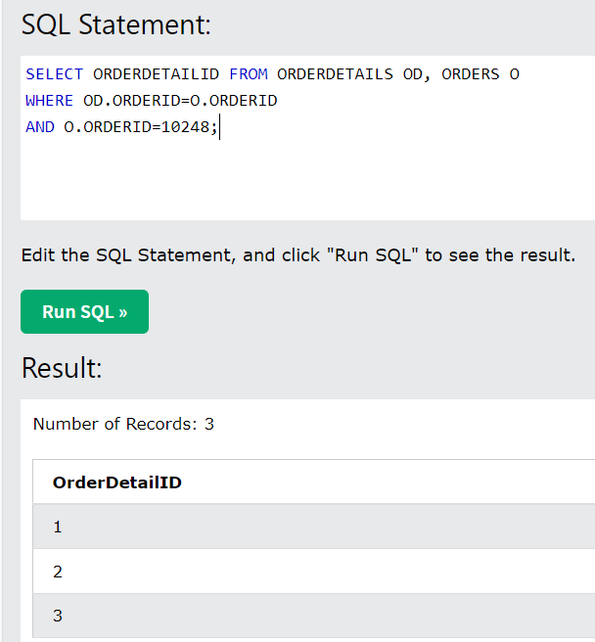

* You can also refer column name like in the below screenshot (instead of giving multiple times) – this is called creating the alias

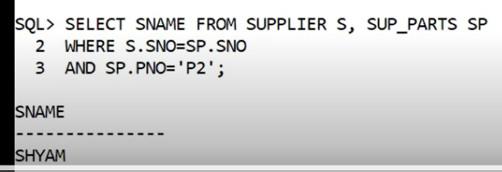

* In the above screenshot, the 2nd line “S.SNO=SP.SNO and SP.SNO=S.SNO” both are not same – Give the column in AND clause that has values that you are looking for after the ‘=’

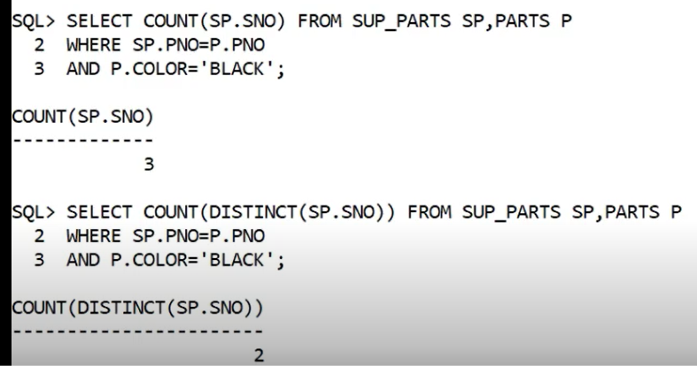

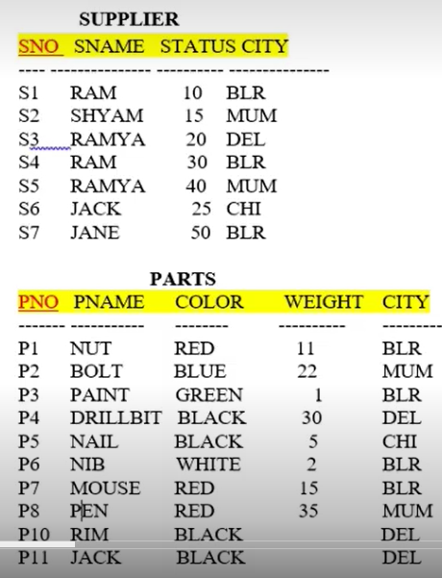

For the above tables, if we need to list the suppliers and parts which have the same name – the join happened in the below screenshot, as those 2 columns have the same data type

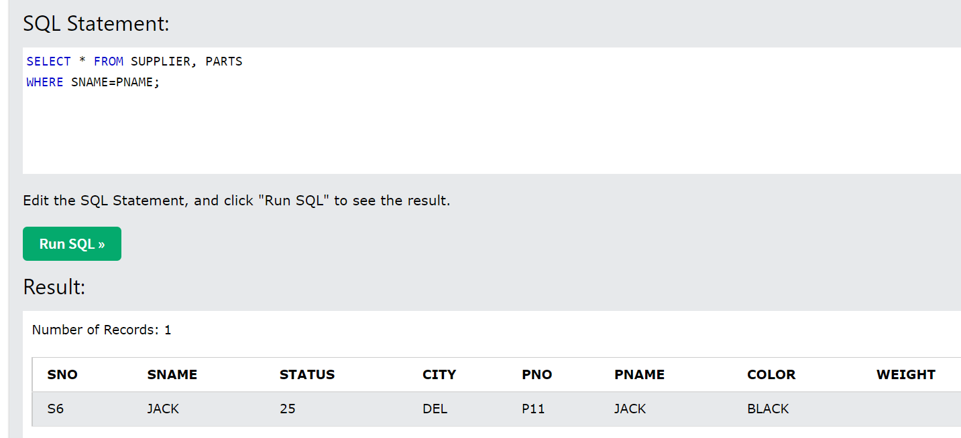

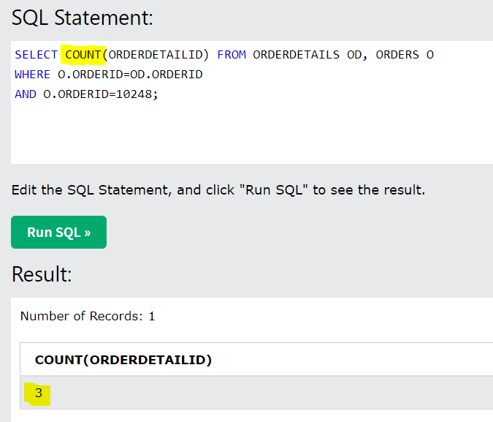

Session 11:

**Session 1 - 23 November 2018 at 09:30:53**

**Classes of Operators in SQL:**

1. **Unary Operators**: We use these operators if we want to retrieve data from only 1 table

**Eg. Select operator**

1. **Binary Operators**: We use these operators if we want to retrieve data from >1 table.

Eg. Join Operators and Set operators (union, intersection, cartician product)

**Whether its unary or binary operators, there are some class of operators that we have to use either of these operators such as Logical (and, or, not), Relational/Comparison (=,<,>,<=..) and Arithmetical operators (add, sub, mul,..)**

**Minimum condition for joining 2 tables:**

1. There should be at least 1 common domain (datatype) attribute existing in both relations (if the datatype is different to join the tables, obviously their values will also not be the same)
2. The logical column names do not play any role
3. When parent and child relationship is not created, then those two tables cant be joined
4. Never join tables based on Non-PK, FK – Join the tables based on PK, FK r/s only (to avoid spurious being generated – this happens when we join non-PK, Non-FK)

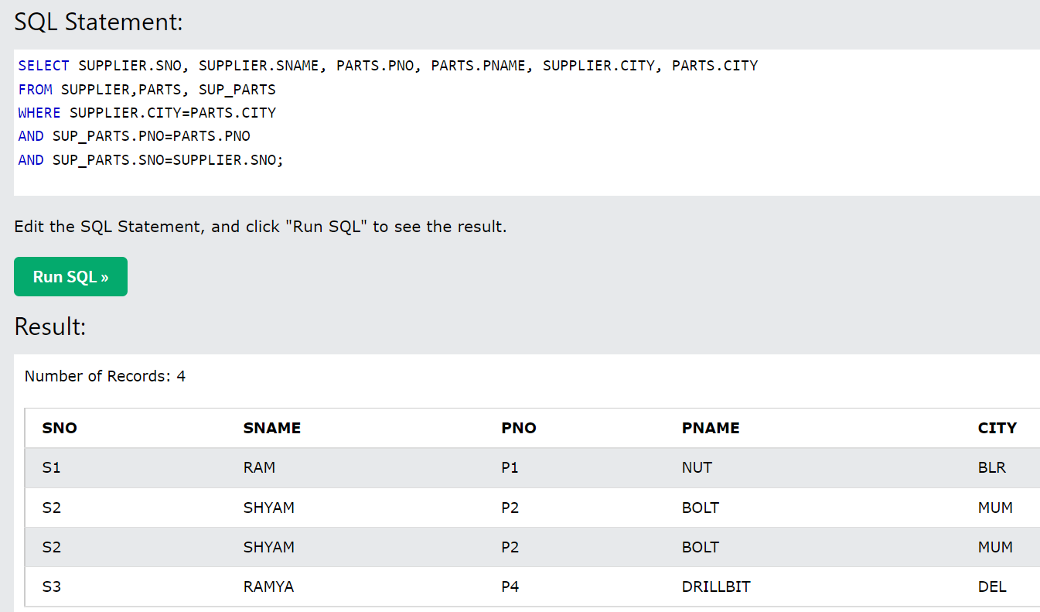

* **Types of Joins:** ways by which we can join tables

🡪 **Natural Join**: This happens on the natural condition that exist b/w 2 tables, that is the PK of 1 table and FK of another table – **we don’t specify a join condition** – Natural join happens based on the first occurrence (a table can have any number of FK’s ) of PK and FK r/s pair – the attribute by which the join has happened will not repeat twice in the output when we use Natural join (instead of giving ‘=’ b/w 2 tables) – In case of any other type of joins, we must specify the Join condition (we specify the condition in the WHERE clause) – We need to specify a join condition except for Natural join (in the join condition, we are comparing 1 column of Table A with another column of Table B and if there is a matching data, then give that row)

🡪 **Equi-join**: If the join condition (in WHERE clause) has ‘=’ operator, we call it as ‘joining 2 tables based on equality condition’ – Natural and Equi joins will give the same result, but the number of columns and time t

🡪 **Non-Eqvi Join**: If we make use of any other operator apart from ‘=’ – we cant use non-equi join as a negation to equi join – this should be used normally on numerical type of data/constants where you want to compare the value – should not take when we compare string type of data

🡪 **Self Join**: Joining a table to itself – whenever we want to compare 2 columns of the same table, we go for self-join – see ex below

🡪 **Outer Join**: Types: Left Outer join and Right Outer Join and Full outer Join – see ex and explanation in session 12

* In order to perform join we need to have 2 tables – once we have 2 tables, we take the col of table 1 (PK) and compare the same with the FK of another table and vice versa
* The first condition in joining the tables is to write JOIN condition in Where clause (E1.empno=E2.empno) – once joining, write actual join condition (E1.DOJ=E2.DOB)

**Command**: **SELECT * FROM** SUPPLIER S, SUP_PARTS SP **WHERE** S.SNO=SP.SNO;

**Execution of above command**: If the Sno in Supplier table equals to SNo in Sup_parts, then, take this row in Sup_parts – For this particular row, its going to iterate with all the rows of Sup_parts table

**Order of execution when we use Order by**: From, Where, Select and Order By (the last command to be executed) and if you are using LIMIT clause also, then Limit is the last command to be executed.

**Command: SELECT * FROM** SUP_PARTS SP, SUPPLIER S **WHERE** SP.SNO=S.SNO;

When it comes to the cost of executing, taking the child comparing with the parent makes more sense (if the supplier table/parent table has 100 suppliers but the sup_parts only has 10 suppliers, the executing of checking each row with the parent takes more cost) – in the below screenshot, the comparison stops till S3, it will not go forward with S4, S5.. – BUT, if we compare with Parent with Child, all the Suppliers (S1 to S100) will be compared with the each row in the child table – The iteration count will be 100*10 when we compare parent with child but when we compare child with parent the iteration count will be 10*10.

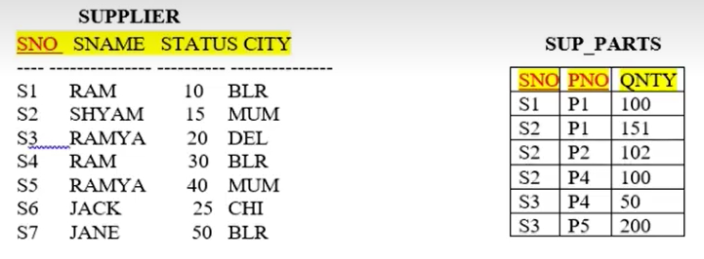

1. **Natural Join ex:** Totally there are 7 columns in both supplier and sup_parts tables but when we perform natural join, we got 6 columns

* For the below emp and dept tables, when we write the command **Emp Natural Joins Dept**, first its going to look for PK and FK pair – it will find the first column ‘Emp Number - PK’ and checks all the columns if that’s is FK – Picks up the Dept# (as this is the FK) and as all the attributes of emp table are exhausted, it will now start with the Dept table – takes the first attribute DNo, checks whether this col is PK, Yes – the matching FK column has already been picked up and the first occurrence of PK and FK match is found, so it joins the table based on DeptNo. Column – (although empno is a PK, the join doesn’t happen based on empno, because the matching FK is not yet found) - its like saying ‘Employee.DeptNo=Dept.Dept#’ – this is give which employee is working for which dept – if there are 10 emp in the company, this query gives you 10 rows
* In case of **Dept Natural joins Emp** table, it starts with the Dept table – takes the first attribute of dept, DNo is a PK and it will find the matching FK – goes to MgrEmp# which is a FK – Now goes to Emp table – in the emp table, it picks up the first attribute i.e, EmpNo which is the matching PK, so the match/first occurrence of PK and FK has been found, so it joins the table based on Emp# (Although we said to join Dept to Emp, we will empno first, because the join has happened based on the Emp#) – its like saying ‘Dept.MgrEmp#=Employee.ENo’ (opp is the case with the first scenario – Employee.DeptNo=Dept.Dept#) – this will give mgr details who are managing the depts (if there are 3 depts, you will get 3 rows if you write the below command)

**Cmd**: Select * from Employee, Dept where Dept.MgrEmp#=Employee.ENo’;

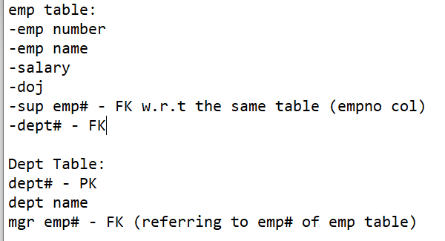

**Supplier join Sup_parts**

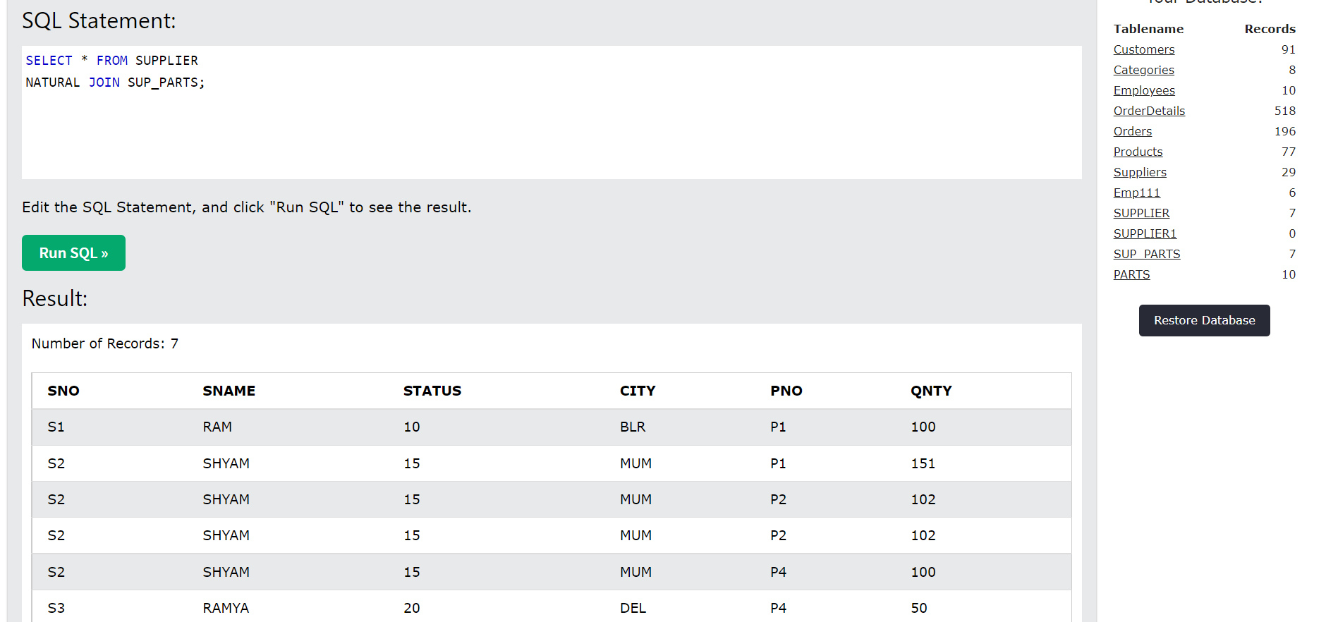

**Sup_parts join supplier**

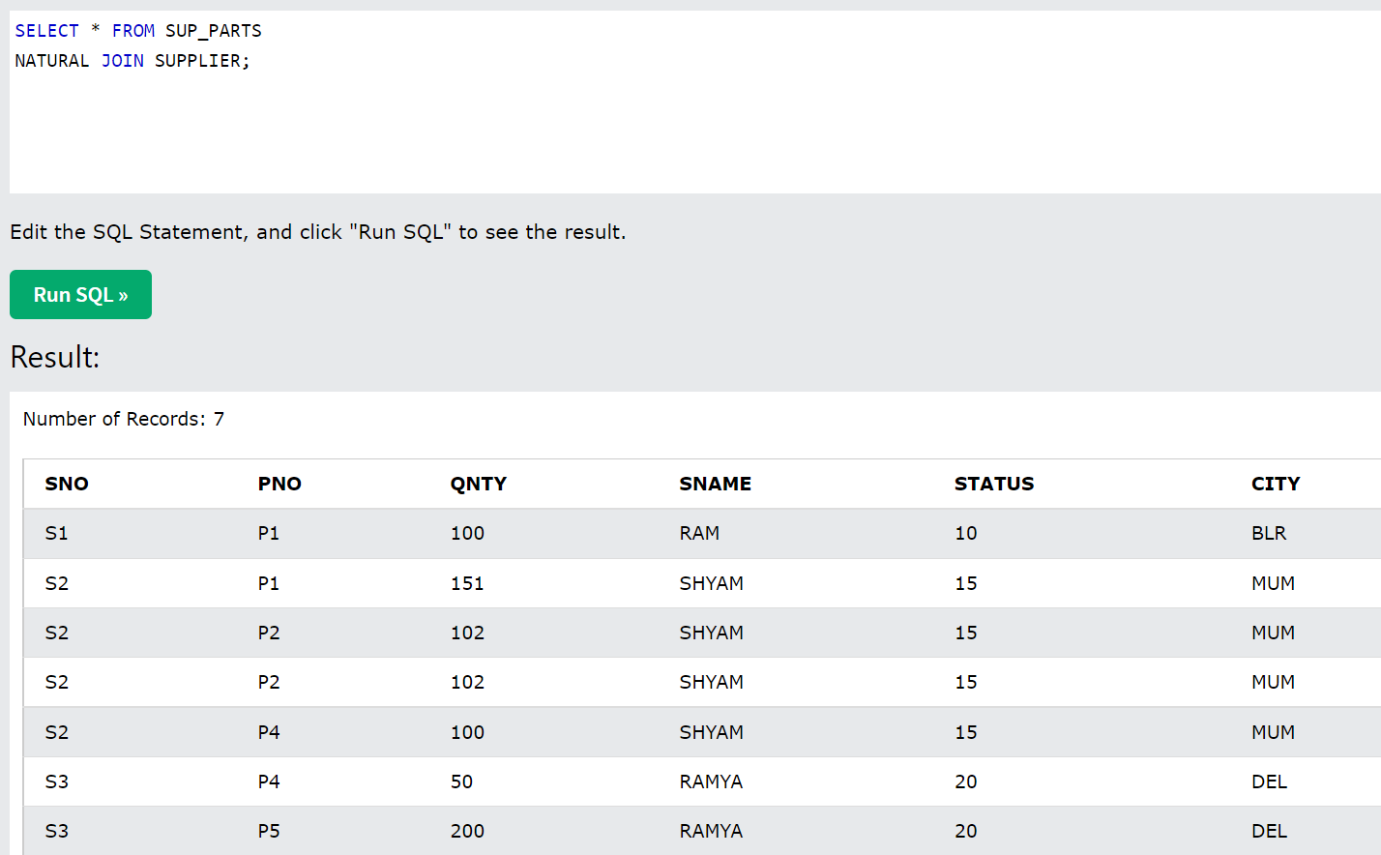

**Sup_parts join Parts**

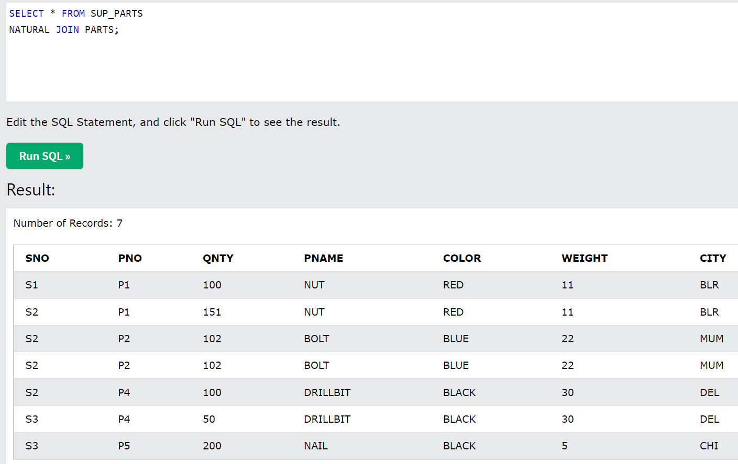

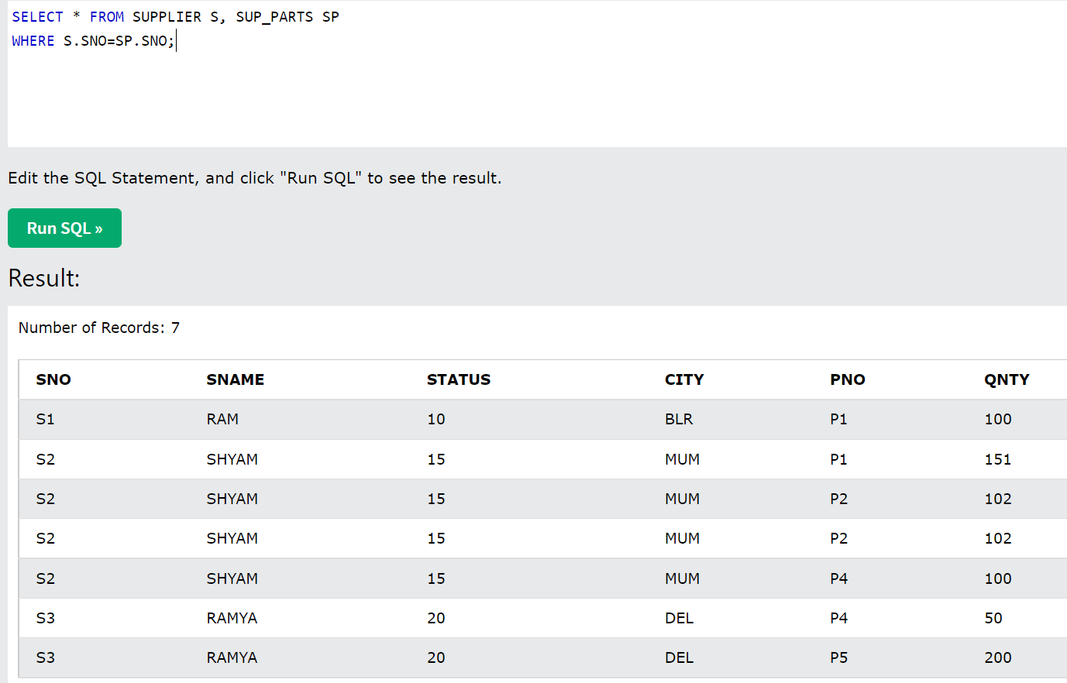

* When you use non-equi join, you will see incorrect records – see the screenshot below – it takes the Sno of supplier table (ex S1) and compares with the each and every row of Sup_parts table – After not taking S1 from the first row of Sup_parts table, it will go to row 2 of Sup_parts table and takes all the non-S1 rows from the sup-parts table – To get rid of incorrect records that we get while using <>, we need to use Sub-queries (query inside a query) – See the second screenshot below:

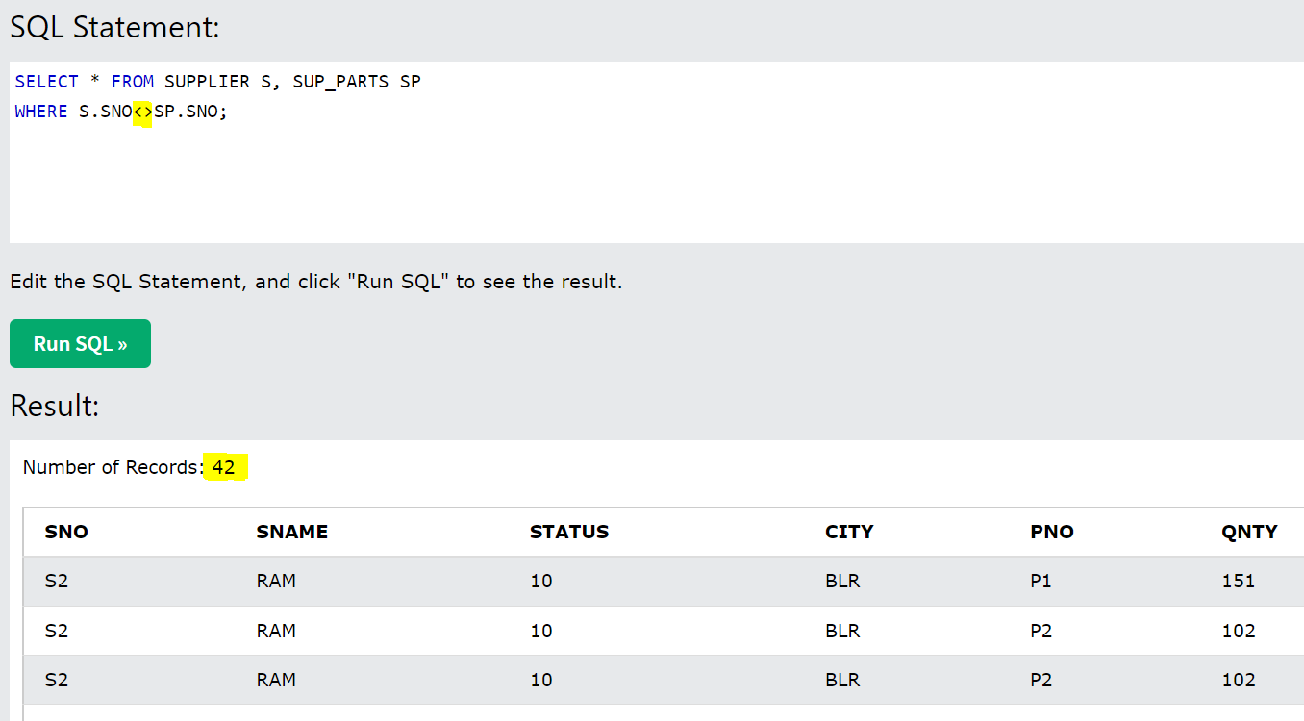

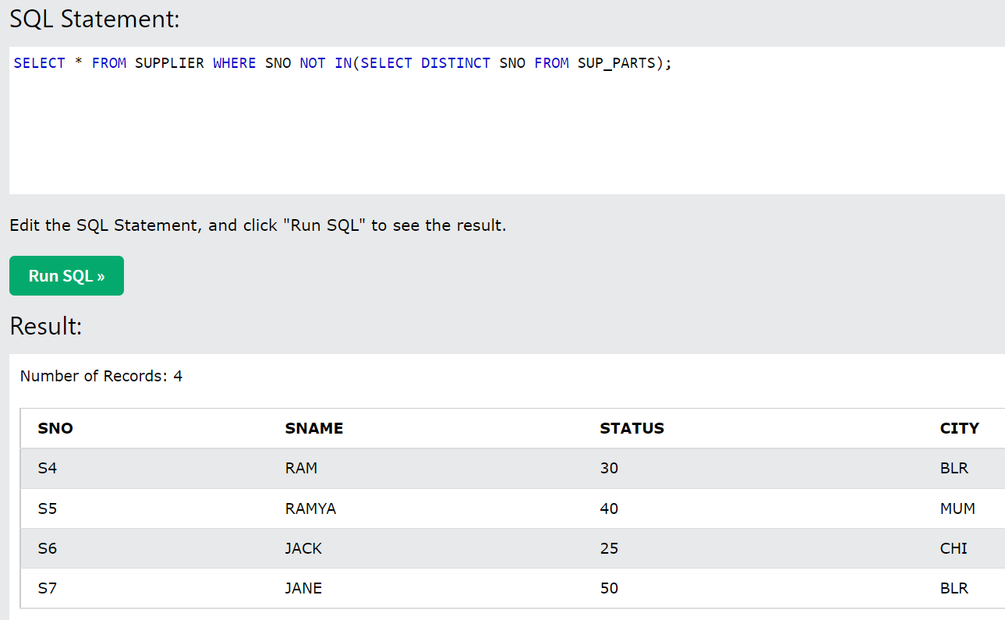

**Session 12:**

Self-Join Example for the below table:

Although we are creating employee2 table, the EmpNo in this new table is not logically the FK of the table 1

**Command**: Select E1.Empname from Employee E1, Employee E2 (E1 and E2 is the alias for the same employee table – E2 will create a new table with the same values and columns) Where E2.supempno=E1.Empno;

**Query**: To get the supervisor names (based on the supempno, we need to compare this with Empno and get the Empname column values)

**Evaluation**: is 11 in Supempno equals to 1 in EmpNo, is 22 in 5th column = empno in 1st column… if it matches, it will fetch that particular column’s value – compares supempno with PK and if its matching gets the corresponding value

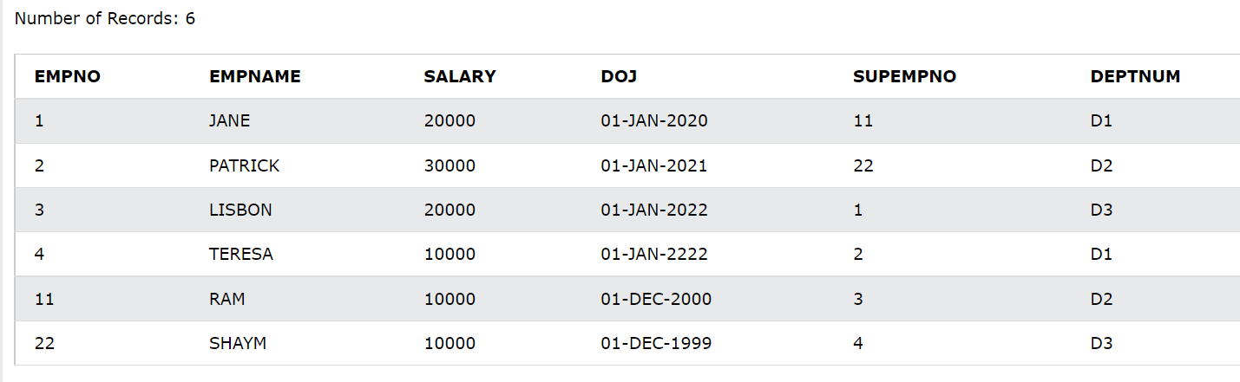

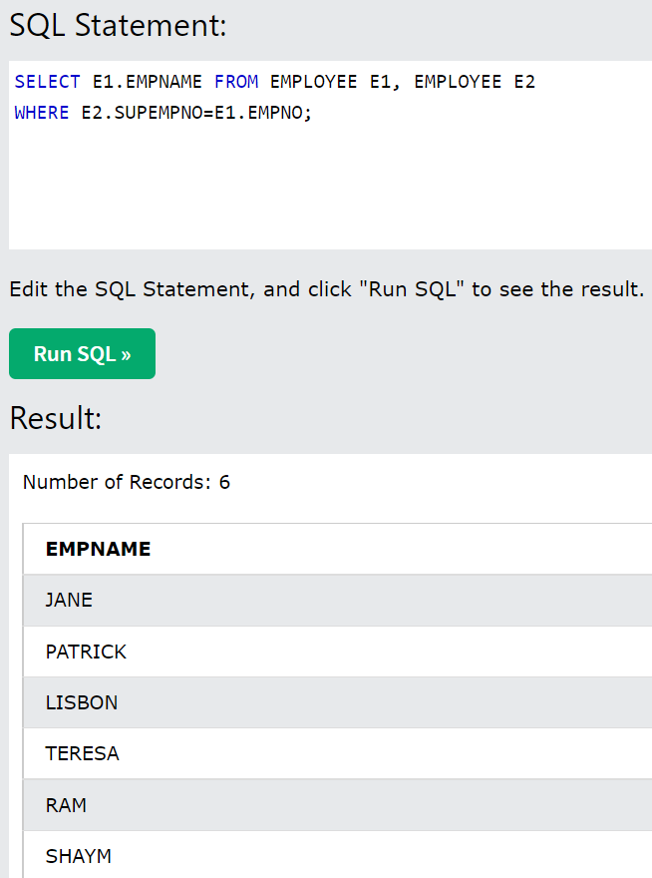

* When we want the list of employees who are not mgrs. Of any dept

Command: SELECT * FROM EMPLOYEE E, DEPT D

WHERE E.DEPTID = D.DEPTID (now we’ve joined the tables)

AND E.EMPID NOT IN (SELECT MGRID FROM DEPT);

* **Outer Join**: Outside the join condition –

This is going to give you the…

* list of rows that satisfy the given join condition (we say it as the rows that lay inside the join condition) as well as
* list of rows that do not satisfy the given join condition (rows that lie outside the join condition) – We call these rows as Dangling Tupils/rows (Dangling rows are those rows in the resultant table that do not satisfy the given join condition but still are present in the resultant table – as blanks in the rest of the columns)

**Query:** list the supplier who supplied some parts

**Command**: Select S.Sno, S.Sname from Supplier S, Sub_parts SP

Where SP.Sno=S.Sno

* In case of left outer join, I want the dangling tuples on the left hand side relation and in case of right outer join, I want the dangling tuples on the right hand side of the relation
* **Left Outer Join:**

**Cmd**: SELECT * FROM SUPPLIER S, SUP_PARTS SP WHERE S.SNO=SP.SNO(+);

* **Right Outer Join:**

**Cmd:** SELECT * FROM SUPPLIER S, SUP_PARTS SP WHERE S.SNO(+)=SP.SNO;

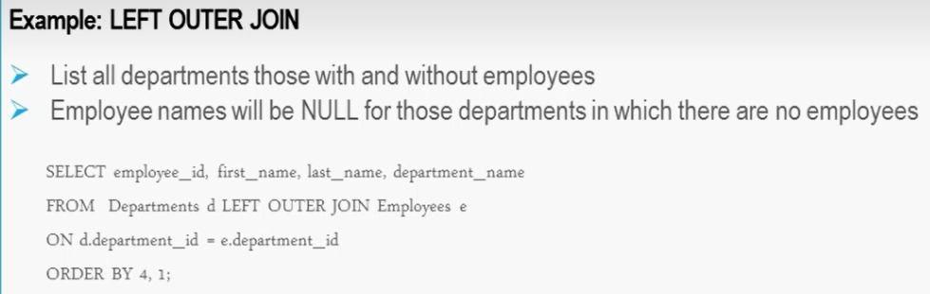

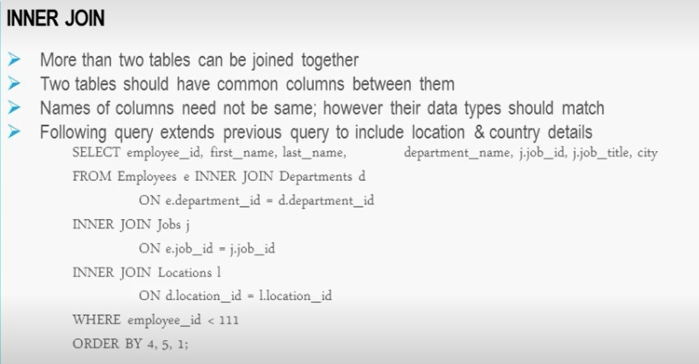

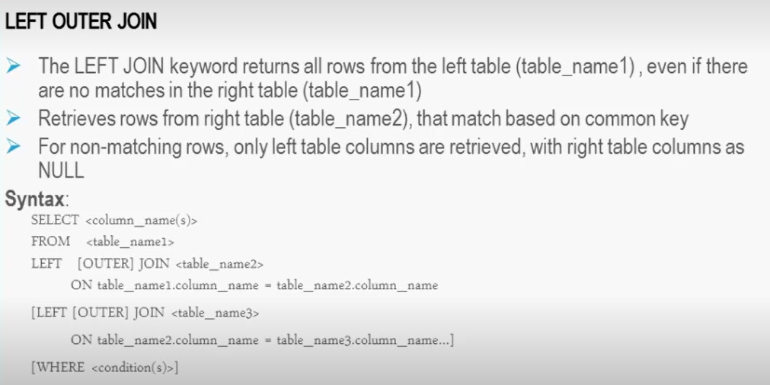

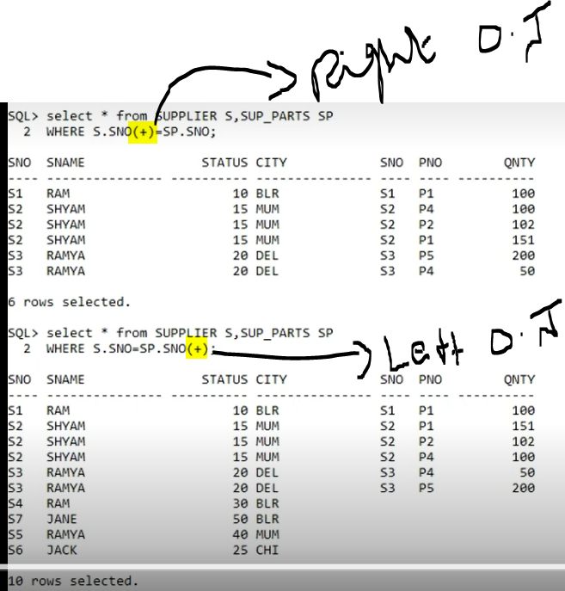

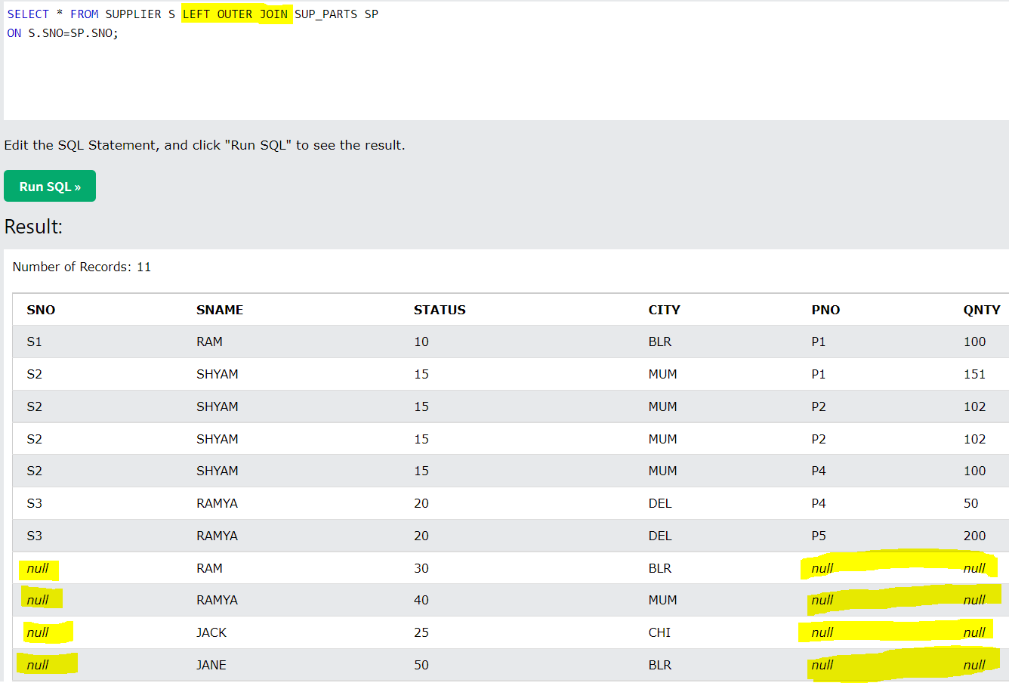

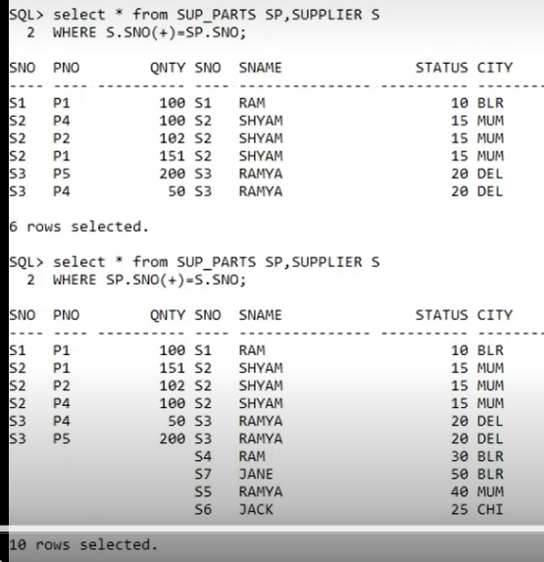

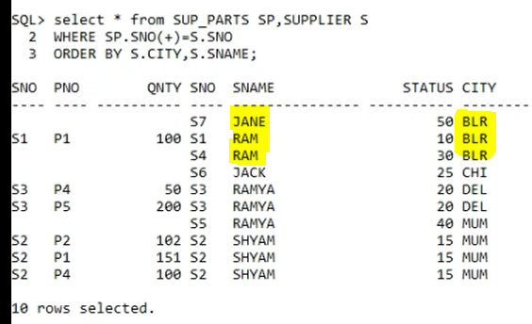

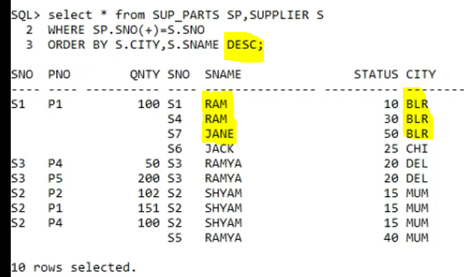

* Whenever you have to join 2 tables that do not have PK and FK r/s , we must join these unrelated tables with the help of the table that r/s with both of the tables – see the below screenshot where we joined Supplier table and Parts table with the help of sup_parts table to get the **list of supplier supplying parts of the same city** – Since there is no direct PK and FK r/s between Supplier and Parts table, we have to join through Sup_parts table, because none of the tables in the database exist in isolation.

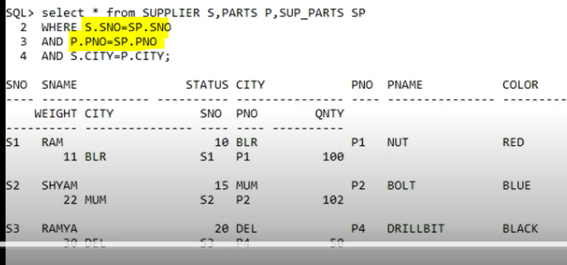

* To find the list of part that has been supplied most – Group the data by parts
* To find the list of supplier that has been supplied most – Group the data by supplier

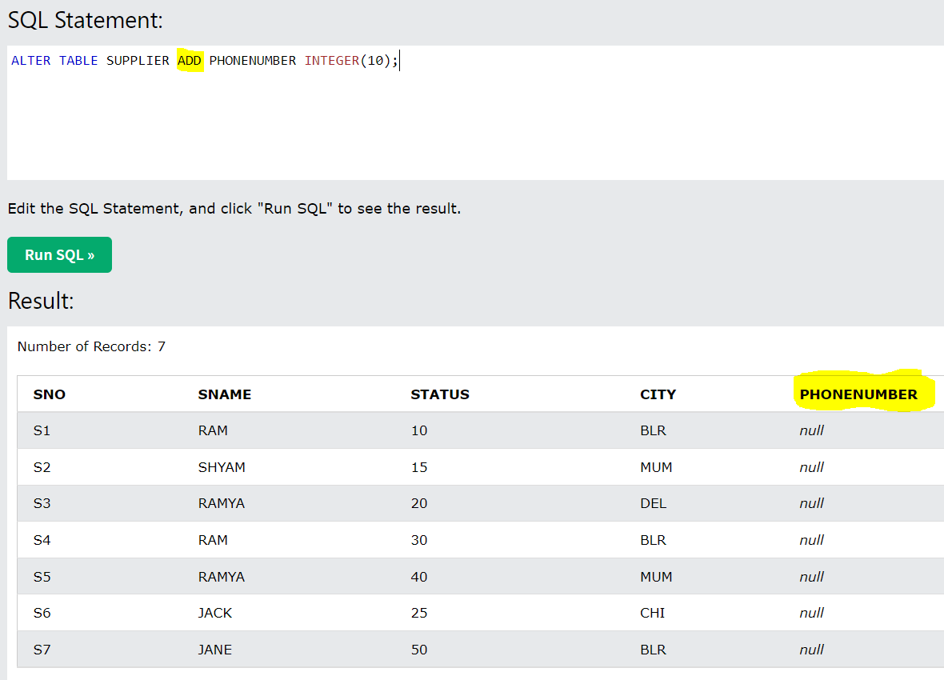

**Session: 13**

**Session 3-26 November 2018 at 13:29:04**

* **Sub-Queries**: Query within a query or Nested Query – this will give you the condition for the outer query – since we don’t know the value of the inner query, we have to find the value for inner query and using this, we need to find the outer query – When the value for comparator is not known to us, in this case we use sub-query – we use this sub-query, when we don’t know the value to be compared in the WHERE clause (like list all the emp whose salary > Steven <here we didn’t know the salary value of steven>)

**Query**: List the suppliers who are from the same city as Ram (for this the inner query should find the city of Ram and use this value to get the name of others who are from the same city)

**Cmd for finding the city of Ram – Inner query**: Select city from Supplier where name=’Ram’

The result that we get from the above inner query will be used as the comparator/condition/predicate for below outer query

**Outer Query command**: Select * from Supplier where City=’BLR’

**The order of Execution**: First the inner query is executed, the result of inner query will be given as the condition for the outer query.

Where clause is going to accept the columns that are present in the table (it wont take functions – see below command) – In the below command, the Where clause has the function, but not the attribute – Where clause cant execute aggregate function

**Command**: SELECT DEPTID, AVG(SALARY) FROM EMPLOYEES WHERE AVG(SALARY)>10000;

Important aspect is.. if we are using some attribute in your **where** clause of outer query, the sub-query should also have the same **attribute (also its data types)**

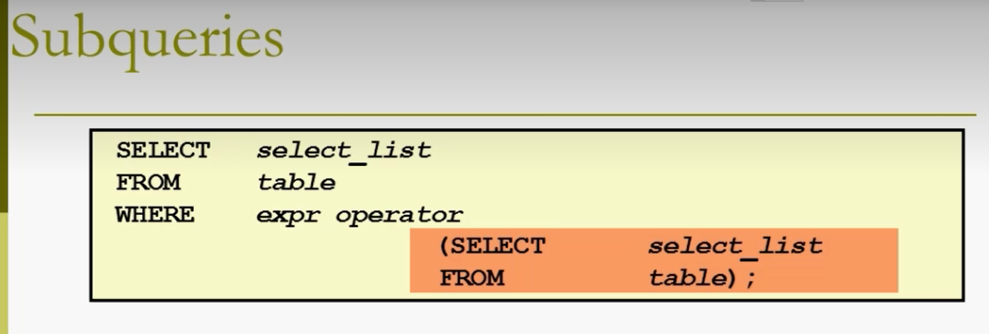

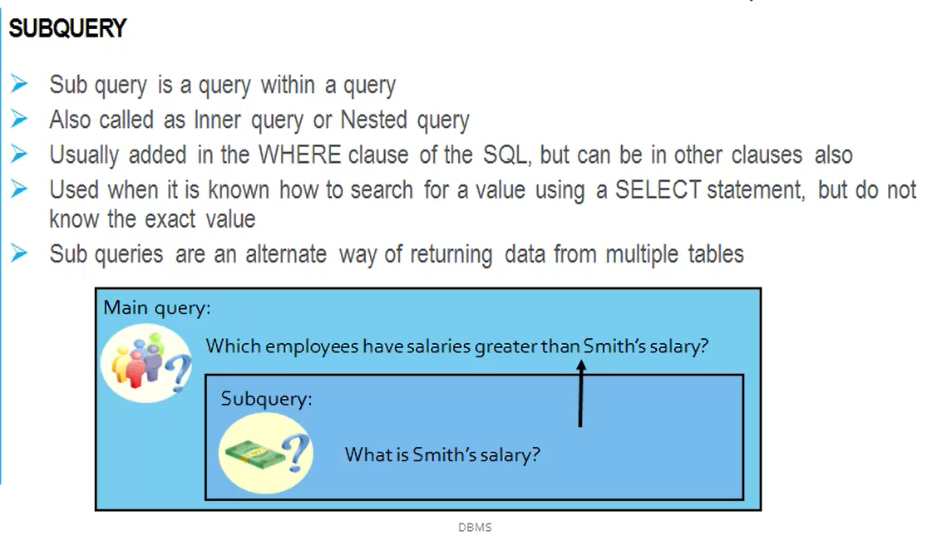

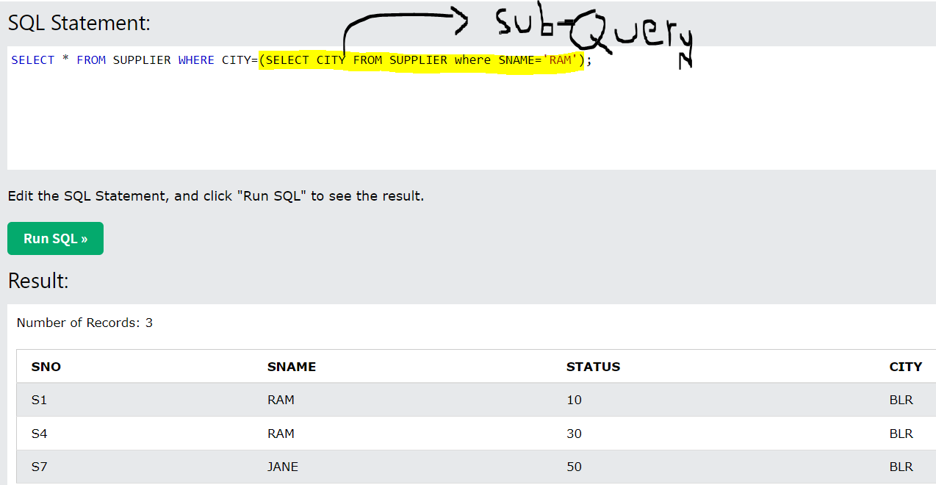

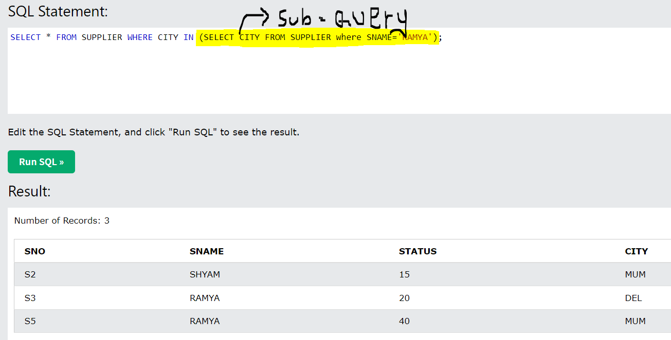

The above IN operator gives the columns from supplier table of all the people whose city is same as Ramya’s (see the full table of supplier)

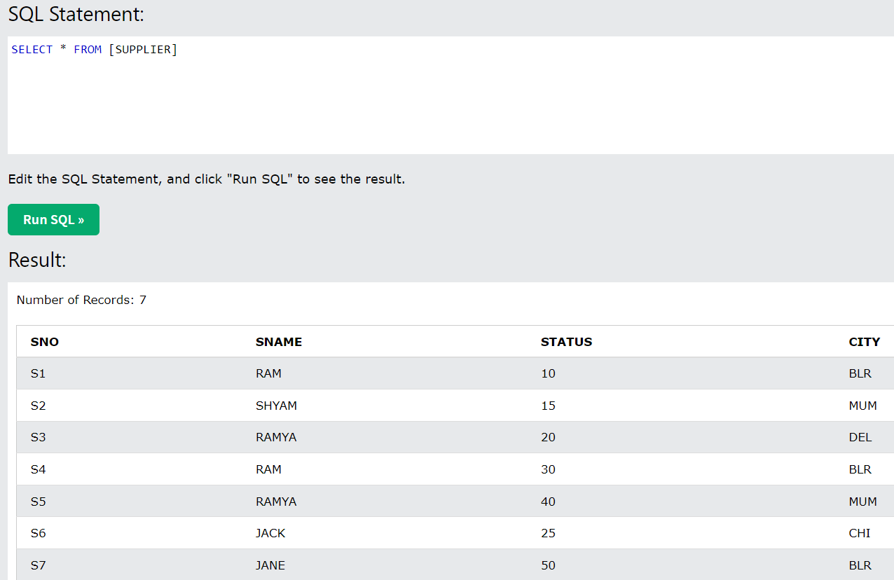

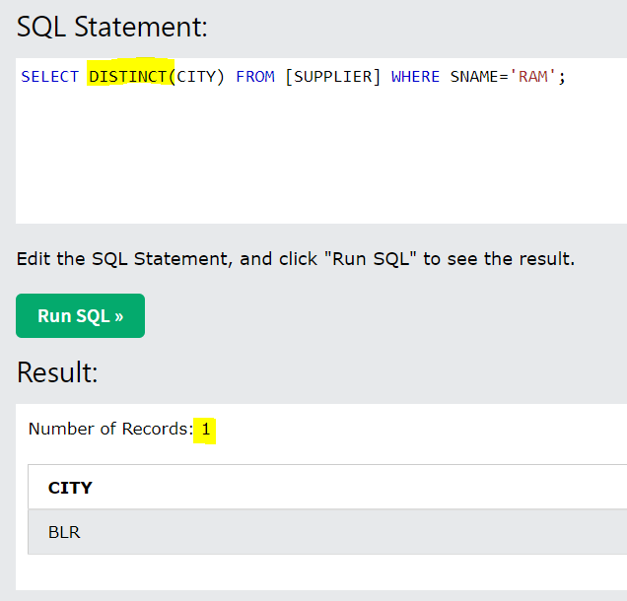

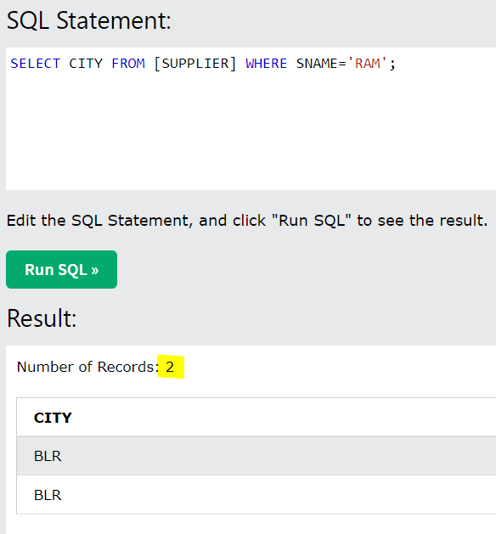

* **Multi-valued comparators**:
* IN (specifies the list of values),
* =All (the left hand side value must be equal to all the values on the right hand side) ,
* =Any (like an OR operator – if the left hand side value is equals to any one of the values in the column, it will select that row)

We have to use multi-values comparators for multi-row sub queries and single-row operators (like =) for single-row sub-queries.

* **Multi-column subquery**: Its possible to compart more than 1 column – if you are specifying 2 columns in outer query, the same columns should be there in sub-query as well.

Syntax:

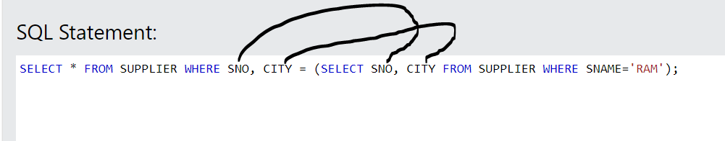

* **Set Operators:** Joins and set operators are binary type of operators – Binary: we need min 2 tables to perform these operations – In case of d/b you cant perform the Set Operators similar to performing on Mathematical sets (see the ex below) – these happen b/w corresponding columns (the 1st col of 1st table will be union with 1st col of 2nd table…) – We use Set operators when we want to compare 2 columns and either get the common value or distinct value

**2 Union compatibility Conditions**:

* The condition to perform these operators is that both tables must have **same number of columns** – if the columns are not matching, then it will give an error
* The data types of the corresponding columns must be the same

1. **Union:** It combines the elements of 2 tables and eliminates the duplicates – Union will happen b/w the columns (the 1st col of 1st table will be union with 1st col of 2nd table…)

**Ex:**

**TableA = 1,2,3,4**

**TableB = 2,4,6**

TableA Union TableB = 1,2,3,4,6 (All elements of set A and B minus the duplicates)

1. **Intersect:** Gets the common values

A Intersection B – 2,4

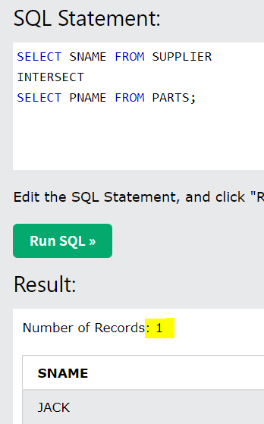

1. **Minus:**

A minus B – 1,3

B minus A – 6,

1. **Cartician Product**: never used operator in d/b – this doesn’t need any condition to get the data – In general, we cant join the tables with different data types of corresponding columns, but if we want to join the tables even though the data types are different, only then, we will use this Cartician product – this consumes enormous resources

A cross B – 1 2, 1 4, 1 6, 2 2, 2 4, 2 6, 3 2, 3 4, 3 6, 4 2, 4 4, 4 6

* Union:

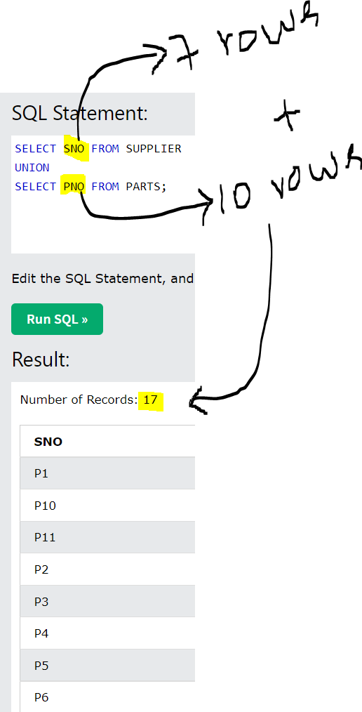

* **Boolean Operators**: Used in Sub-queries – Boolean means True or False
* **Exist**: When you specify a condition in WHERE clause for sub-query, if this sub-query has any value or does not have any value, in this case we use Exist – If the sub-query returns at least 1 value, then execute the Main query – in other words, if the sub-query returns any value is true, then execute the main query
* **Not Exist**: If the sub-query doesn’t return any value, execute the main query - in other words, if the sub-query does not return any value is true, then execute the main query
* If subquery is returning a true, then execute the outer query and if subquery doesnot return any value, then do not execute the outer query
* **Co-related sub-query**: For every one row result of inner query, the outer query is evaluated once. If a sub-query returns 3 rows and each of these rows executes the outer query once… - if the inner query is associated with the outer query, we call this as co-related sub-query
* **Rank Over Function**: With Rank, you have to use Over, if you use Over you have to use Partition (this is going to physically store the data, whereas Group will only create logical table)

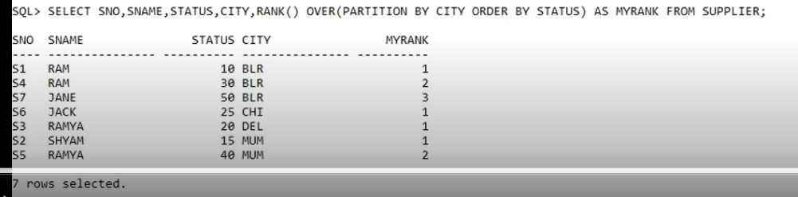

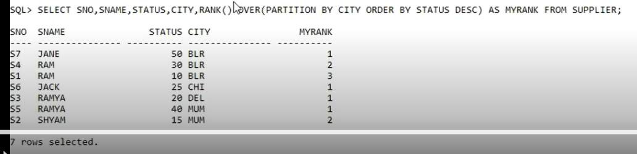

* In case of Databases, there is no concept of Turnery Degree (1 r/s being associated with multiple entities)

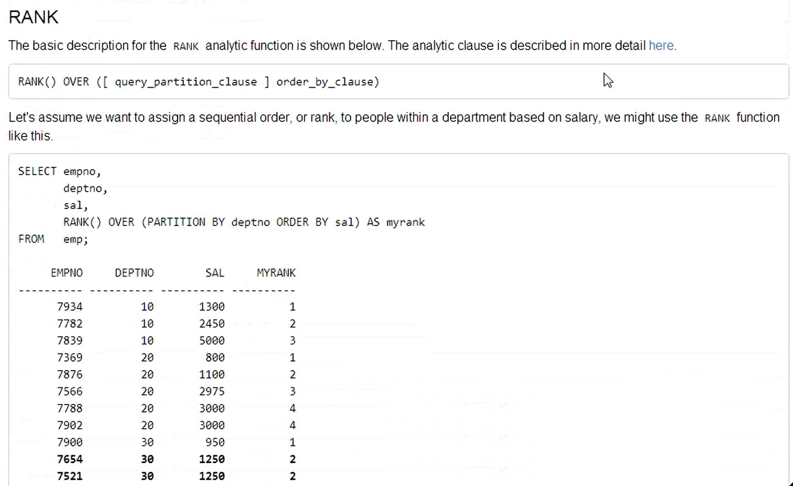

**Session 2 - 12 January 2019 at 13:09:10**

**Session 15:**

**Normalization: It’s a purification process of the design – A set of well-defined rules are called Normal Forms – we perform up to 3NF only (as we go for BCNF, 4nf and 5nf, the no. of tables will increase exponentially)**

1. Checking the quality of design
2. Eliminating any anomalies or inconsistencies or redundancies
3. Removing any impurities in the design

**Functional Dependency**: Dependency of non-pk fields on PK for identification (son <non pk> is functionally dependent on Father<PK field> for his identification) – Determinant is PK field and non-pk fields are Dependents – When we group the attributes together, the fields should be having dependency or determination.

**Types of Functional Dependency:**

1. **Full-functional dependency**: Attributes that are fully dependent on PK/C.PK
2. **Partial functional dependency**: All the attributes that are partially dependent on the C.PK
3. **Transitive dependency**: Indirect dependency – Attributes that are not dependent on PK/C.PK but dependent on the non-pk field – when PK is determining some attribute X and this attribute X in turn determines some other attribute Y, then the kind of relationship exist b/w Y and PK/Cpk is called Transitive dependency – This Y has indirect dependency on PK or C.PK

|  |  |  |  |  |  |  |  |  |
| --- | --- | --- | --- | --- | --- | --- | --- | --- |
|  | **C.pk** |  |  |  | **C.pk** |  | **Full. Dep on CPK** |  |
|  | **USN** | **Name** | **DOB** | **Gender** | **Course No.** | **Course Name** | **Marks** | **Grade** |
| **Dependency** |  | Partial Dep. | Partial Dep. | Partial Dep. | Partial Dep. | Partial Dep. | Full dep. | Transitive Dep. |

**Session 17:**

**Session 1 - 13 January 2019 at 08:59:28 (copy)**

* **2 Types of columns:**
* **Physical Column:** Column that is existing in the table in the d/b
* **Logical Column:** Created at the time of display (when we use SELECT clause “PhysicalColName * 12 AS LogicalColName”**)**
* In the below screenshot, (as there is no NOT operator – which executes first), AND will perform its operation by getting/finding both D1 and D2 in DeptNum column and it will make an union and this would be handed to Where clause
* **Limit Clause**: MYSQL has limit clause – limit the no. of values that must be displayed to user

**Session 18:**

**Session 2 - 13 January 2019 at 10:43:54**

* Numeric Functions: Round, Truncate, modulus = functions which operate on number type of data – we can use these functions on tables and also on the values (non-table numbers)
* Character Function: Case conversion functions (from upper to lower) – only for reporting purposes – not affect the physical data in d/b
* **Having Clause**: Conditions on aggregate functions must be specified only with the having clause – Where clause cant take the aggregate conditions – see the ex below – clause used to filter the rows based on aggregate condition

Where clause is going to accept the columns that are present in the table (it wont take functions – see below command) – In the below command, the Where clause has the function, but not the attribute – Where clause cant execute aggregate function

* **Command**: SELECT DEPTID, AVG(SALARY) FROM EMPLOYEES WHERE AVG(SALARY)>10000;

**Order of execution:**

* **When we use Group by**: From, Where, Group By, Select and Having (the last command to be executed) –
* **If there is WHERE clause**: From, Where, Group BY, Select and Having
* **If there is Order By clause**: From, Where, Group BY, Select, Having and Order By (always the last command to execute)

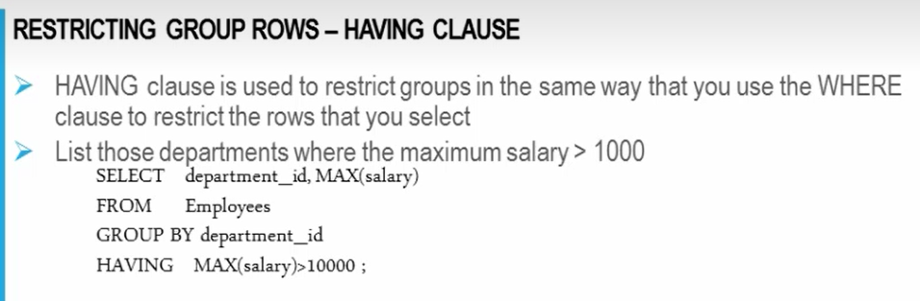

* **Analytical Functions**: **None** of these analytical/aggregate functions should be specified with the Where clause – these functions must be used with the SELECT clause

1. **Rank**: It will group the data and order the data and then award the rank - follows the Olympic award approach (if gold awardees have tied, then they will give 2 gold awards to those two but no silver will be given and bronze will be given) – ex. 1,1,3,4,5 (if top 2 people have tied)
2. **DenseRank**: 1,1,2,3,4 (if top two people have tied)
3. **First**
4. **Last**

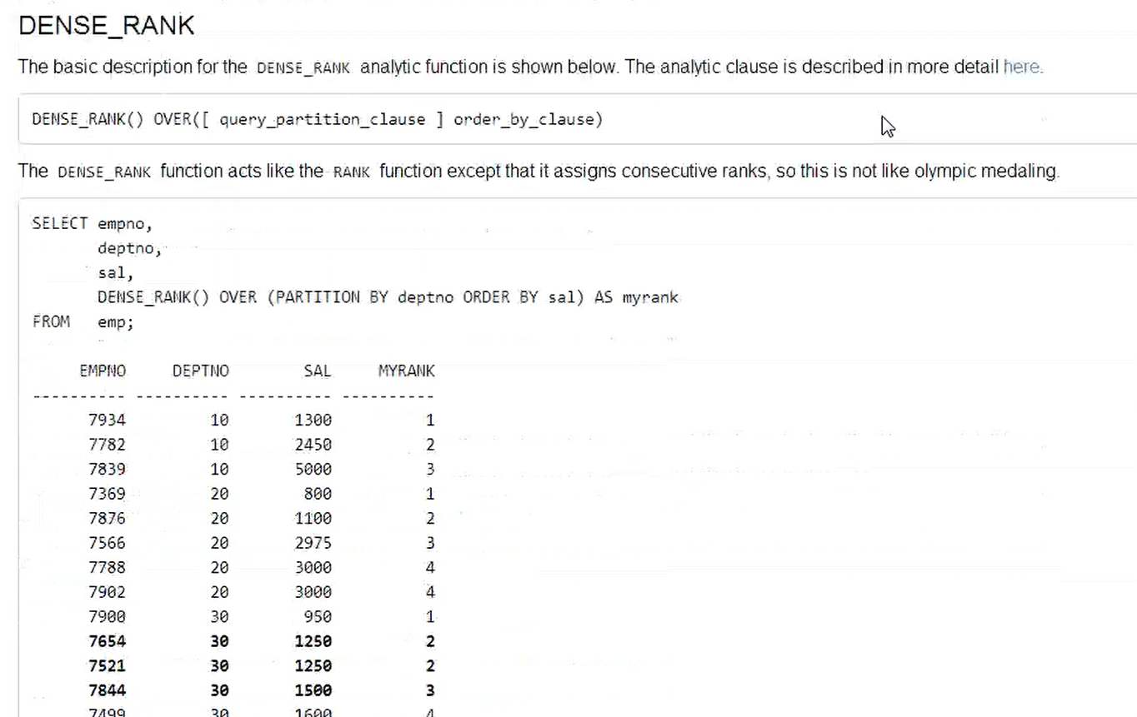

**Session 19:**

**Session 3 - 13 January 2019 at 13:03:44**

**Join Types:**

1. **Natural Join**:

If we write the below command to join countries and region tables (see screenshot), then we will get the below columns

**Command**: SELECT * FROM REGION R, COUNTRIES C WHERE R.REGION id=C.REGION ID

**Result: You will see 5 columns when we execute the above command – we call this as Equi Join (see natural join ex below)**

|  |  |  |  |  |
| --- | --- | --- | --- | --- |
| **Region ID** | **Region Name** | **Country id** | **Country Name** | **Region id** |

* **Ex of Natural Join:** Taking the same above tables, if we join the tables using **Regions Natural join Countries**, then the result will be as below. You will only see the 4 columns as it excludes the region id column -

|  |  |  |  |
| --- | --- | --- | --- |
| **Region ID** | **Region Name** | **Country id** | **Country Name** |

If there is a natural condition existing b/w the tables you want to join, its going to perform natural jon and the no. of clumns would be sum of columns of table 1 and table 2 minus 1 (this minus is the common pk, fk r/s col) – wherever there is no PK, FK r/s b/w 2 tables, there is no PK, FK, then its going to perform **Cartician Product**

**We don’t specify a condition (where clause) for Natural join (but for every other type of join, we specify the condition).**

* **Equi Join**: Joining 2 tables based on equality condition

Once you specify 2 tables in From clause, the first condition in the Where clause is to specify the joining condition – In the Join condition, if we use = operator, we call this as Equi join and if we are using any other operator in the condition, we call it as Non-equi join

We cant use equi join and non-equi join as nagation

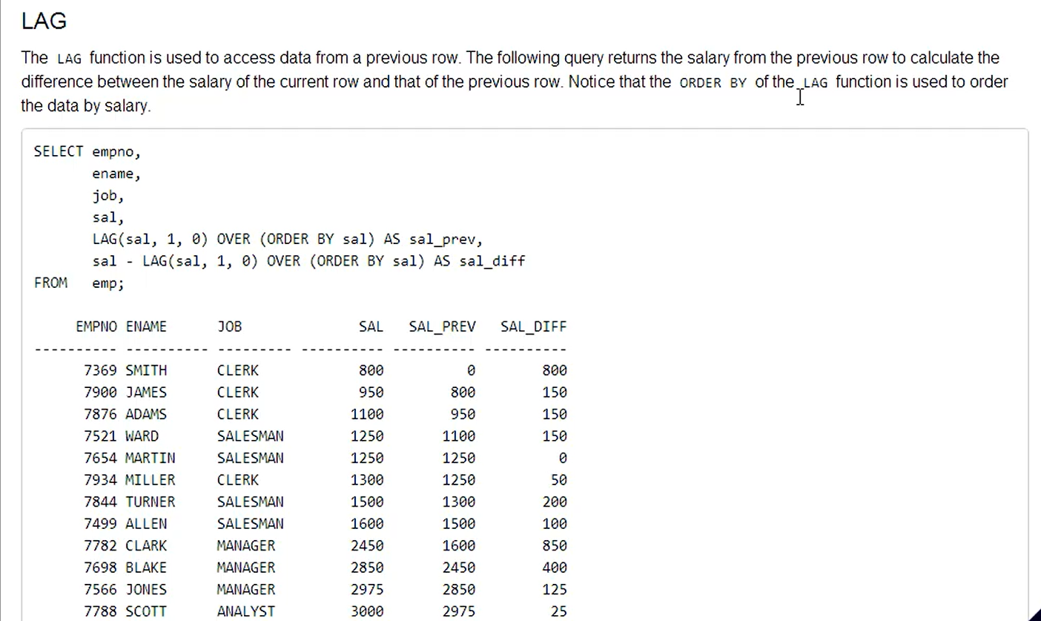

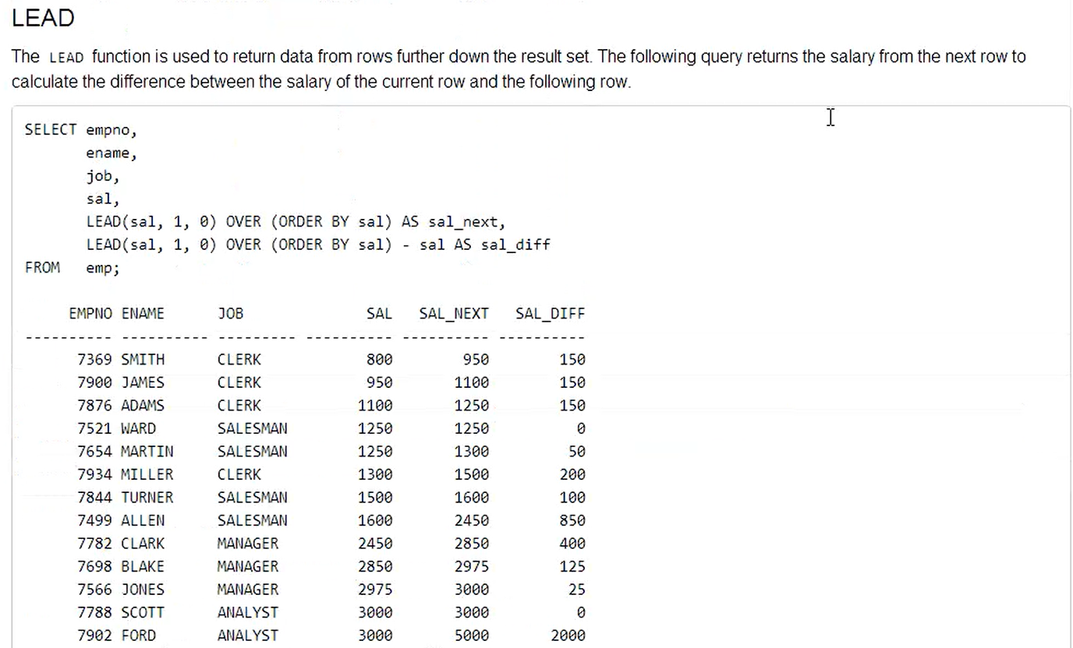

**Recordings Status**:

Session 1- 19 November 2018 at 08:45:46 – Completed - 1

Session 2 - 19 November 2018 at 11:33:53 – Completed - 2

Session 3 - 19 November 2018 at 14:21:58 – Completed - 3

Session 4- 19 November 2018 at 16:05:33 – Completed - 4

Session 1- 20 November 2018 at 09:02:07 – Completed - 5

Session 1- 20 November 2018 at 08:55:02 – Another Coach

Session 2- 20 November 2018 at 11:24:34 – Completed - 6

Session 2- 20 November 2018 at 12:57:27 – Another Coach

Session 3- 20 November 2018 at 13:37:39 – Completed - 7

Session 3- 20 November 2018 at 15:42:12 – Another Coach

Session 1- 21 November 2018 at 08:52:17 – Completed – 8

Session 2- 21 November 2018 at 11:16:48 – Completed - 9

Session 2- 21 November 2018 at 11:16:48 (copy)

Session 3- 21 November 2018 at 13:28:38 – Completed - 10

Session 3- 21 November 2018 at 13:28:38 (copy)

Session 1 - 23 November 2018 at 09:30:53 – Completed - 11

Session 1 - 23 November 2018 at 09:30:53 (copy)

Session 1- 26 November 2018 at 08:55:58 – Completed - 12

Session 2- 26 November 2018 at 11:32:11 – only 1 min

Session 2- 26 November 2018 at 11:32:11 (copy) – only 1 min

Session 3-26 November 2018 at 13:29:04 – Completed – 13

Session 1 on 12th Jan is missing - 14

Session 2 - 12 January 2019 at 13:09:10 (copy) – Completed - 15

Session 3 - 12 January 2019 at 15:36:23 (copy) – No audio - 16

Session 1 - 13 January 2019 at 08:59:28 (copy) – Completed - 17

Session 2 - 13 January 2019 at 10:43:54 (copy) - Completed - 18

Session 3 - 13 January 2019 at 13:03:44 – Completed- 19

**Session 1- 11 March 2019 at 09:12:48 -29 mins - 20**

Session 2- 12 March 2019 at 11:05:17 – only 3 seconds

**After the end of the course, prepare the Index list and remember all the list by creating the story/any ETR code**

**Not working in SQL:**

1. **Constraint**
2. **Empty values in a row**
3. **Drop command in alter command**
4. **INITCAP**
5. **Dual table**
6. **Right and Left outer join:** SELECT * FROM SUPPLIER S, SUP_PARTS SP WHERE S.SNO=SP.SNO(+);
7. **TRUNCATE**
8. **LPAD & RPAD**
9. **Rename**

[MySQL :: MySQL 8.0 Reference Manual :: 12 Functions and Operators](https://dev.mysql.com/doc/refman/8.0/en/functions.html)